

DG TAXUD
BPM L4 Process Description
ICS2
Date: 30/06/2026
Doc. Version: 3.20

Document Control Information

Settings | Value
Document Title: | Business Process Description
Project Title: | ICS2
Document Author: | DG TAXUD
Project Owner: | DG TAXUD
Doc. Version: | 3.20
Sensitivity: | Basic
Date: | 30/06/2026

Document Approver(s) and Reviewer(s):
NOTE: All Approvers are required. Records of each approver must be maintained. All Reviewers in the list are considered required unless explicitly listed as Optional.
Name | Role | Action | Date
ECCG |  | Approve
RIMSCO |  | Review

Document history:
The Document Author is authorized to make the following types of changes to the document without requiring that the document be re-approved:
- Editorial, formatting, and spelling
- Clarification

To request a change to this document, contact the Document Author or Owner.
Changes to this document are summarized in the following table in reverse chronological order (latest version first).
Revision | Date |  | Created by |  | Short Description of Changes
0.5 | 3/10/2017 |  | DG TAXUD |  | Version submitted to MS for review
0.6 | 30/01/02018 |  | DG TAXUD |  | Implementing review comments
1.0 | 07/05/2018 |  | DG TAXUD |  | Change in L4-ICS2-03 sub-process, L4-ICS2-05 sub-process, L4-ICS2-02-01 sub-process, L4-ICS2-02 sub-process
1.10 | 15/10/2018 |  | DG TAXUD |  | Implementing the change requests for Release 1.
1.11 | 08/11/2018 |  | DG TAXUD |  | Change in L4-ICS2-02 and L4-ICS2-09 sub-processes in order to enable OMS parameters also for PLACI house consignments
1.12 | 07/12/2018 |  | DG TAXUD |  | Section 2.1.2.3.9 updated
1.13 | 26/04/2019 |  | DG TAXUD |  | Section 4.3 updated
1.14 | 29/11/2019 |  | DG TAXUD |  | Section 2.1.4 updated with RfC190053
1.20 | 07/06/2019 |  | DG TAXUD |  | Implementing the change requests for Release 2
1.22 | 31/03/2020 |  | DG TAXUD |  | Implementing the second package of change requests for Release 2
1.23 | 17/07/2020 |  | DG TAXUD |  | Implementing the third package of change requests for Release 2
1.24 | 19/03/2021 |  | DG TAXUD |  | R2 RfC’s from MS CAB 7 29/01/2021 and KELv0.09 implemented.
1.30 | 31/03/2021 |  | DG TAXUD |  | R3 RfC’s from MS CAB 7 29/01/2021 implemented
2.00 | 30/07/2021 |  | DG TAXUD |  | RfC’s from MS CAB8 08/07/2021 implemented.  R2 and R3 functionality incorporated in the current version.
2.01 | 23/05/2022 |  | DG TAXUD |  | KEL entry 172 (G-03-17 removed) implemented.  “RfC220001 - SSA Enrichments consolidation in CR” implemented.
2.02 | 07/11/2022 |  | DG TAXUD |  | Process “L4-ICS2-05 – Process presentation of goods” updated as per KEL entry 249 for the necessary updates in the national presentation systems for the presentation of goods part of combined transit declarations.
2.03 | 15/12/2023 |  | DG TAXUD |  | The following RfC’s implemented MS CAB09, 27/04/2023:  “RfC220006 - R2 - ENS Consultation per receptacles”  “RfC220007 - R2 - Air - Notifications to be added for F25”  “RfC230001 - R3 - Rail - New ENS filing type F52 for partial master information”  “RfC230002 - R3 - Rail - New ENS filing type F53 for house level information”  “RfC230003 - R3 - Rail - New ENS filing type F54 for partial house level information”  “RfC230004 - R3 - Rail - New ENS filing type F55 for goods shipment information”  KEL entry 259 implemented.  The descriptions of G-03-22 “e-risk analysis timer to be stopped automatically?”, G-03-23 “Stop timer for completion of e-risk analysis?”, T-03-34 “Stop timer for completion of e-risk analysis” and T-03-35 “Stop timer for completion of e-risk analysis” added.
3.00 | 15/11/2024 |  | DG TAXUD |  | The following RfC’s implemented MS CAB11, 01/10/2024:  “RfC240001 - Control results information storing”  “RfC240002 - ICS2 Control notification in the arrival process”  “RfC240003 - ICS2 Validate and forward referral requests”  “RfC240004 - Road - New ENS filing type F56 master information”  “RfC240005 - Road - New ENS filing type F57 for house level information”  “RfC240006 - Road - New ENS filing type F58 for partial house level info”  “RfC240007 - Road - New ENS filing type F59 for goods shipment info”  The KEL entries 307 and 319 implemented.
 | 3.20 | 30/06/2026 |  | DG TAXUD | The following RfC’s implemented from MS CAB13, 03/02/2026:  RfC250006 - New CR messages for IE4Q04 IE4Q05 notifications  RfC250007 - Notify traders of missing ENS filings  RfC250008 - Pre-arrival risk analysis timers triggering  RfC250010 - Whitelisting combinations of stop words  The KEL entries 255 (updated), 327 and 330 implemented.

TABLE OF CONTENTS
1 Introduction 11
1.1 Purpose 11
1.2 Scope 11
1.3 Target Audience 11
1.4 Structure of this document 11
1.5 Reference and applicable documents 12
1.5.1 Reference Documents 12
1.5.2 Applicable Documents 12
1.6 Abbreviations and Acronyms 12
2 L4 ICS2 Master process 14
2.1 Sub-processes 15
2.1.1 L4-ICS2-01 - Register filing 15
2.1.2 L4-ICS2-02 - Prepare ENS for risk analysis 21
2.1.3 L4-ICS2-02-01 – Relate ENS with House consignments 37
2.1.4 L4-ICS2-02-02 – SSA MS Involvement list 42
2.1.5 L4-ICS2-02-03 – SSA Enrichment 46
2.1.6 L4-ICS2-02-04 – Late enrichment response 49
2.1.7 L4-ICS2-03 – Perform risk analysis 54
2.1.8 L4-ICS2-03-01 – Send referral 74
2.1.9 L4-ICS2-04 – Process arrival of the means of transport 89
2.1.10 L4-ICS2-05 – Process presentation of goods 104
2.1.11 L4-ICS2-06 – Process control decision and results 111
2.1.12 L4-ICS2-06-01 – Handle AEO notification 116
2.1.13 L4-ICS2-07 – Amend filing 121
2.1.14 L4-ICS2-08 – Invalidate filing 130
2.1.15 L4-ICS2-09 – e-Screening by OMS 136
2.1.16 L4-ICS2-10 – Update risk analysis result 144
2.1.17 L4-ICS2-11 – Update e-Screening assessment 149
2.1.18 L4-ICS2-12 – Revoke presentation of goods 154
2.2 Events 158
2.2.1 E-00-01 – ENS filing received 158
2.2.2 E-00-02 – Amendment of ENS filing received 158
2.2.3 E-00-03 – Timer for completion of linking expired 158
2.2.4 E-00-04 – Entry process completed 158
2.2.5 E-00-05 – Invalidation request received 158
2.2.6 E-00-06 – 200 day timer expired 158
2.2.7 E-00-07 – ENS filing invalidated 158
2.2.8 E-00-08 – Risk analysis was re-triggered 159
2.2.9 E-00-09 – Risk analysis result updated 159
2.2.10 E-00-10 – Arrival notification received 159
2.2.11 E-00-11 – Arrival notification processed 159
2.2.12 E-00-12 – Goods presented 159
2.2.13 E-00-13 – Erroneous presentation of goods 159
2.2.14 E-00-14 – Goods presented and controlled 160
2.2.15 E-00-15 – State of House consignments rolled back 160
2.2.16 E-00-16 – e-Screening hit assessment was updated or submitted out of time 160
2.2.17 E-00-17 – e-Screening updated or completed 160
2.2.18 E-00-18 – Involvement in e-Screening requested 160
2.2.19 E-00-19 – e-Screening completed 160
3 Supporting processes 161
3.1.1 L4-ICS2-13 – Consult ENS 161
3.1.2 L4-ICS2-14 – Query ENS 167
4 Annexes 172
4.1 Annex 1 – ENS filing types 172
4.2 Annex 2 – Information exchange messages 174
4.2.1 External domain 175
4.2.2 Common domain 176
4.3 Annex 3 – Entities and states 179
4.3.1 ENS 179
4.3.2 ENS filing 179
4.3.3 House consignment 179
4.3.4 PLACI House consignment 180
4.3.5 Air pre-loading risk analysis 180
4.3.6 Full risk analysis 180
4.3.7 Arrival notification 180
4.3.8 Goods shipment 180
4.3.9 HRCM Screening Result 181
4.3.10 Master consignment 181
4.3.11 e-Screening request 181
4.3.12 e-Risk analysis request 181
4.4 Annex 4 – IE4N04 Assessment complete notification content 181
4.4.1 Postal 181
4.4.2 Air cargo general 182
4.4.3 Express 183
4.4.4 Maritime (Pre-arrival) 184
4.4.5 Rail (Pre-arrival) 185
4.4.6 Road (Pre-arrival) 185

TABLE OF FIGURES
Figure 1: L4 ICS2 Master Process 15
Figure 2: L4-ICS2-01 Register filing sub-process 17
Figure 3: L4-ICS2-02 Prepare ENS for risk analysis sub-process 23
Figure 4: L4-ICS2-02-01 Relate ENS filings sub-process 39
Figure 5 L4-ICS2-02-02 SSA MS Involvement list 44
Figure 6 L4-ICS2-02-03 SSA Enrichment 48
Figure 7 L4-ICS2-2-04 Late enrichment response 51
Figure 8: L4-ICS2-03 Perform risk analysis sub-process 56
Figure 9: L4-ICS-03-01 Send referral sub-process 76
Figure 10: L4-ICS2-04 Process arrival of the means of transport sub-process 91
Figure 11: L4-ICS2-05 Process presentation of goods sub-process 106
Figure 12: L4-ICS2-06 Process control decision and results sub-process 113
Figure 13: L4-ICS2-06-01 Handle AEO notification sub-process 118
Figure 14: L4-ICS2-07 Amend filing sub-process 123
Figure 15: L4-ICS2-08 Invalidate filing sub-process 132
Figure 16: L4-ICS2-09 e-Screening by OMS sub-process 138
Figure 17: L4-ICS2-10 Update risk analysis result sub-process 146
Figure 18: L4-ICS2-11 Update e-Screening assessment sub-process 151
Figure 19: L4-ICS2-12 Revoke presentation of goods sub-process 156
Figure 20: L4-ICS2-13 Consult ENS sub-process 163
Figure 21: L4-ICS2-13 Query ENS sub-process 169

TABLE OF TABLES
Table 1: Reference documents 13
Table 2: Applicable documents 13
Table 3: Abbreviations and acronyms 14

Introduction

Purpose
This document provides mapping of the business processes and data to the ICS2 IT components and definition of the interfaces between those components.
The aim of this document is to bring forward sufficient level of descriptions to support the understanding of processes in the context of the ICS2 IT components.

Scope
This document covers:
- Specifications of the ICS2 Master process with underlying sub-processes to be implemented by the components of the ICS2 system: Trader Interface (TI), Common Repository (CR), National Entry System (NES).
- Supporting processes which will offer additional functionalities to the Member States and the Trade, such as the query for ENSs by the Member State Administrations and the consultation for specific ENS filings by the Trade.
The document does not cover:
- Specifications for the customs declarations containing ENS particulars as per Art. 130 UCC.

Target Audience
The intended audience for this document are the representatives of the Member States.

Structure of this document
The present document contains the following chapters:
- Chapter 1 – Introduction: describes the scope and the objectives of the document;
- Chapter 2 – L4 ICS2 Master process: describes the ICS2 BPM L4 Master process and underlying sub-processes, their tasks, events and gateways (where applicable);
- Chapter 3 – Supporting processes – describes other processes supporting the ICS2 Master process.
- Annex 1 – ENS filing types – provides a list of the types of the ENS filings.
- Annex 2 – Information exchange messages – provides a list of the Information exchange messages.
- Annex 3 – Entities and states provides a list of the states of the entities.
- Annex 4 – IE4N04 Assessment complete notification content provides details for the assessment complete notification.

Reference and applicable documents

Reference Documents
Ref. | Title | Reference | Version | Date
R02 | ICS2 Information exchanges |  | 3.20 | 30/06/2026
R03 | ICS2 Business rules dictionary |  | 3.2.0 | 30/06/2026
Table 1: Reference documents

Applicable Documents
Ref. | Title | Reference | Version | Date
A01
Table 2: Applicable documents

Abbreviations and Acronyms
For a better understanding of the present document, the following table provides a list of the principal abbreviations and acronyms used.
Abbreviation/Acronym | Definition
AEO | Authorised Economic Operator
AWB | Air Waybill
BoL | Bill of Lading
BPM | Business Process Model
CFSS | Common Functional System Specifications
COFE | Customs Office of First Entry
CR | Common Repository
CRC | Common Risk Criteria
CRMS2 | Customs Risk Management System 2
D.E. | Data Element
DNL | Do Not Load
ECCG | Electronic Customs Co-ordination Group
ENI | European Vessel Identification Number
ENS | Entry Summary Declaration
EO | Economic Operator
EORI | Economic Operator Registration and Identification
e-RA | e-Risk Analysis
EU | European Union
HAWB | House Air Waybill
HBoL | House Bill of Lading
HRCM | High Risk Cargo and Mail
ICS2 | Import Control System 2
IMO | International Maritime Organization
IMS | Involved Member State
MAWB | Master Air Waybill
MBoL | Master Bill of Lading
MRN | Master Reference Number
MS | Member State
NAS | National Arrival System
NES | National Entry System
NPS | National Presentation System
NTA | National Transit Application
NVOCC | Non-Vessel Operating Common Carrier
OMS | Other Member State
PLACI | Pre-loading Air Cargo Information
RfI | Request for Information
RfS | Request for Screening
RIMSCO | Risk Management Strategy Implementation Coordination Group
RMS | Responsible Member State
TARIC | Integrated Tariff of European Union
TI | Trader Interface
UCC | Regulation (EU) No 952/2013 of the European Parliament and of the Council of 9 October 2013 laying down the Union Customs Code
UCC DA | Commission Delegated Regulation (EU) 2015/2446 of 28 July 2015 supplementing Regulation (EU) No 952/2013 of the European Parliament and of the Council as regards detailed rules concerning certain provisions of the Union Customs Code
ULK | Unique Linking Key
Table 3: Abbreviations and acronyms

L4 ICS2 Master process
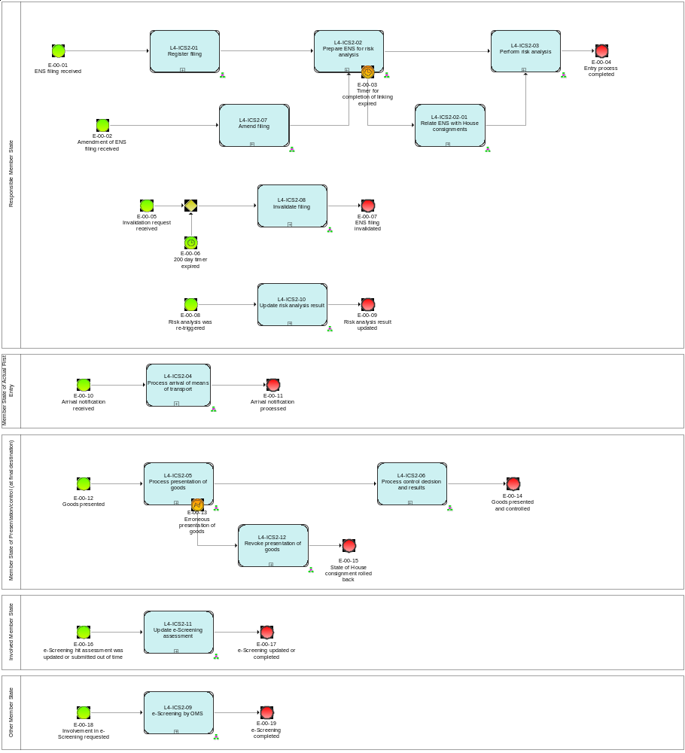
Figure 1: L4 ICS2 Master Process

Sub-processes

L4-ICS2-01 - Register filing
Register filing | L4-ICS2-01
Organisation: National Customs Administration of the Responsible Member State
Input: Received ENS filing
Description:
The ENS filing is validated in an automated process. The validation comprises semantical and syntactical checks in order to ensure workability and data consistency as well as the identification of the kind of filing.
If the ENS filing is not valid:
- it is rejected;
- the person filing is notified of the rejection and of the errors that caused the rejection.
If the ENS filing is valid:
- It is registered; an MRN is generated and allocated to the received filing.
- The Person filing is notified of the registration and the MRN which was allocated to the filing.
- When the Carrier is different from the Person filing and the Carrier can be identified from the data derived from the filing, and the Carrier has requested to be notified and is connected to the system he will also be notified.
Output (Final situation):
The filing is either registered or rejected.

Business Process Model
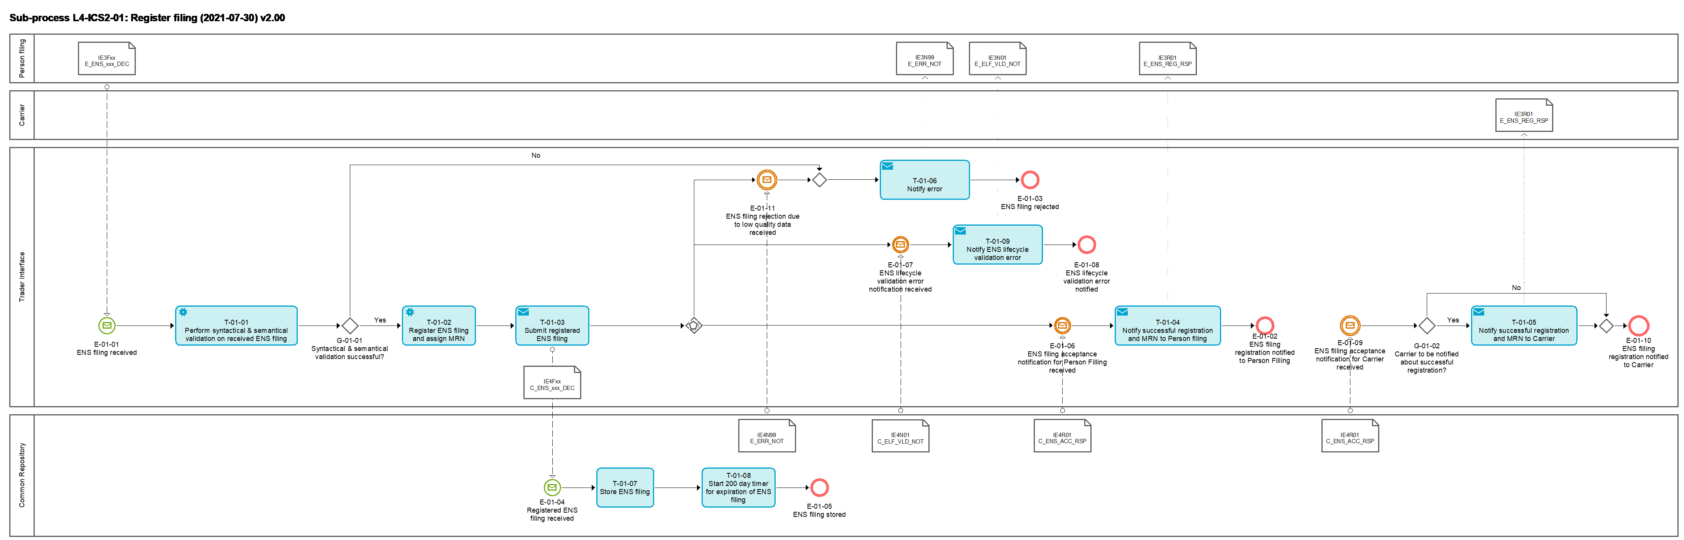
Figure 2: L4-ICS2-01 Register filing sub-process

Tasks

T-01-01 – Perform syntactical and semantical validation
Perform syntactical and semantical validation | T-01-01
System component: TI
Input: ENS filing
Description:
The received ENS filing is validated in an automated process. It comprises the validation against the message rules and conditions, as well as the relevant reference data which are valid at the date of the reception.
The messages rules and conditions and relevant reference data are defined in [R02] ICS2 Information Exchange Messages.
In case the ENS filing contains characters which are not Cyrillic, Latin or Greek, the ENS filing is rejected with “102” “Not allowed Unicode character” with pointer(s) to the elements resulting in the rejection.
Output (Final situation):
The validation will have the following possible outcomes:
- Successful;
- Unsuccessful, in which case
  - the error description will be generated
  - the ENS filing will obtain the state 'Rejected'

T-01-02 – Register ENS filing and assign MRN
Register ENS filing and assign MRN | T-01-02
System component: TI
Input: Valid ENS filing
Description:
Valid ENS filing obtains the state 'Registered'; an MRN is generated and assigned to the received ENS filing.
Output (Final situation):
The ENS filing was registered and MRN has been generated and assigned to it.

T-01-03 – Submit registered ENS filing
Submit registered ENS filing | T-01-03
System component: TI
Input: Registered ENS filing
Description:
The registered ENS filing is submitted from the TI to the CR for further processing via the message IE4FXX [Msg: C_ENS_xxx_DEC] (The xxx is placeholder for the number of the filing, i.e. F10).
Output (Final situation):
The ENS filing is available at the CR.

T-01-04 – Notify successful registration and MRN to Person filing
Notify successful registration and MRN to Person filing | T-01-04
System component: TI
Input: Registered ENS filing
Description:
The registration of the ENS filing and the MRN assigned to it are notified to the Person filing via the message IE3R01 [Msg: E_ENS_REG_RSP].
In case the registered ENS filing contains house consignments part of different ENSs – identified based on the master transport document reference and carrier – then a separate IE3R01 is generated to the Person filing per Master transport document reference and carrier.
Output (Final situation):
The Person filing is notified about the registration of the ENS filing and the MRN assigned to it.

T-01-05 – Notify successful registration and MRN to Carrier
Notify successful registration and MRN to Carrier | T-01-05
System component: TI
Input: Registered ENS filing
Description:
The registration of the ENS filing and the MRN assigned to it are notified to the Carrier via the message IE3R01 [Msg: E_ENS_REG_RSP].
Output (Final situation):
The Carrier is notified about the registration of the ENS filing and the MRN assigned to it.

T-01-06 - Notify error
Notify error | T-01-06
System component: TI
Input: ENS filing with unsuccessful validation results
Description:
The Person filing is notified about the fact that the ENS filing was rejected and about the errors that caused its rejection via the message IE3N99 [Msg: E_ERR_NOT].
Output (Final situation):
The notification of error is generated and sent to the Person filing.

T-01-07 – Store ENS filing
Store ENS filing | T-01-07
System component: CR
Input: Submitted ENS filing from TI
Description:
The submitted ENS filing from the TI is stored in the CR.
Output (Final situation):
The ENS filing and the MRN assigned to it are stored and available in the CR.

T-01-08 – Start 200 day timer
Start 200 day timer | T-01-08
System component: CR
Input: Stored ENS filing
Description:
The 200 day timer is started for the registered ENS filing. When the goods declared in the ENS filing do not arrive within 200 days the filing will be invalidated.
Output (Final situation):
200 days countdown is started.

T-01-09 – Notify ENS lifecycle validation error
Notify ENS lifecycle validation error | T-01-09
System component: TI
Input: Unsuccessful validation results
Description:
An error was sent by the CR and it is communicated to the Person filing through the TI. The error notification will be sent via the message IE3N01 [Msg: E_ELF_VLD_NOT] which includes the indication(s)/explanation(s) of the error(s) which caused the failure of the validity check of the ENS filing.
Output (Final situation):
The Person filing is notified of the errors of the ENS filing.

Events

E-01-01 – ENS filing received
ENS filing received | E-01-01
System component: TI
Description:
A person lodges an ENS filing.

E-01-02 – ENS filing registration notified to Person filing
ENS filing registered | E-01-02
System component: TI
Description:
ENS filing is registered, where applicable, MRN is generated and Person filing is notified

E-01-03 – ENS filing rejected
ENS filing rejected | E-01-03
System component: TI
Description:
ENS filing is rejected.

E-01-04 – Registered ENS filing received
Registered ENS filing received | E-01-04
System component: CR
Description:
Registered ENS filing is received by the CR.

E-01-05 – ENS filing stored
ENS filing stored | E-01-05
System component: CR
Description:
Registered ENS filing is stored in the CR.

E-01-06 – ENS filing acceptance notification for Person filing received
ENS filing acceptance notification for Person filing received | E-01-06
System component: TI
Description:
The ENS filing acceptance notification for Person filing is received by the TI.

E-01-07 – ENS lifecycle validation error notification received
ENS lifecycle validation error notification received | E-01-07
System component: TI
Description:
The ENS lifecycle validation error is sent to the TI.

E-01-08 – ENS lifecycle validation error notified
ENS lifecycle validation error notified | E-01-08
System component: TI
Description:
The ENS filing rejection is notified to the Person filing.

E-01-09 – ENS filing acceptance notification for Carrier received
ENS filing acceptance notification for Carrier received | E-01-09
System component: TI
Description:
The ENS filing acceptance notification for Carrier is received by the TI.

E-01-10 – ENS filing registration notified to Carrier
ENS filing registration notified to Carrier | E-01-10
System component: TI
Description:
ENS filing registration is notified to Carrier

E-01-11 – ENS filing rejection due to low quality data received
ENS filing rejection due to low quality data received | E-01-11
System component: TI
Description:
ENS filing rejection due to low quality data is received from the CR via the message IE4N99 [Msg: C_ERR_NOT].

Gateways

G-01-01 - Syntactical & semantical validation successful?
Syntactical & semantical validation successful? | G-01-01
System component: TI
Input: Outcome of Task: T-01-01 – Perform syntactical and semantical validation
Description:
In case the validation was successful, the answer is 'Yes', otherwise it is 'No'.

G-01-02 - Carrier to be notified about successful registration?
Carrier to be notified for successful registration? | G-01-02
System component: TI
Input: Validated ENS filing
Description:
The carrier is to be notified when
- Carrier is connected to the TI;
- Carrier has requested to receive 'ENS registration' notification messages IE3R01 [Msg: E_ENS_REG_RSP].

L4-ICS2-02 - Prepare ENS for risk analysis
Prepare ENS for risk analysis | L4-ICS2-02
Organisation: National Customs Administration of the Responsible Member State
Input: Registered ENS filing
Description:
This sub-process comprises the following actions on the registered ENS filing:
- ENS data cleansing and data validation
- Validation in terms of the relevant ENS lifecycle state
- Data quality check
- Management of the timers for the completion of risk analysis
- Extraction of the PLACI (i.e. 7+1 data elements)
- PLACI enrichment
- Triggering of the air pre-loading risk analysis
- Linking of the related filings in order to compose a complete ENS
- Data consistency check
- Relation of ENS filings after expiration of linking period
- ENS data enrichment
- Triggering of the full risk analysis
Output (Final situation):
The registered ENS filing is prepared for the air pre-loading risk analysis and/or the full risk analysis.

Business Process Model

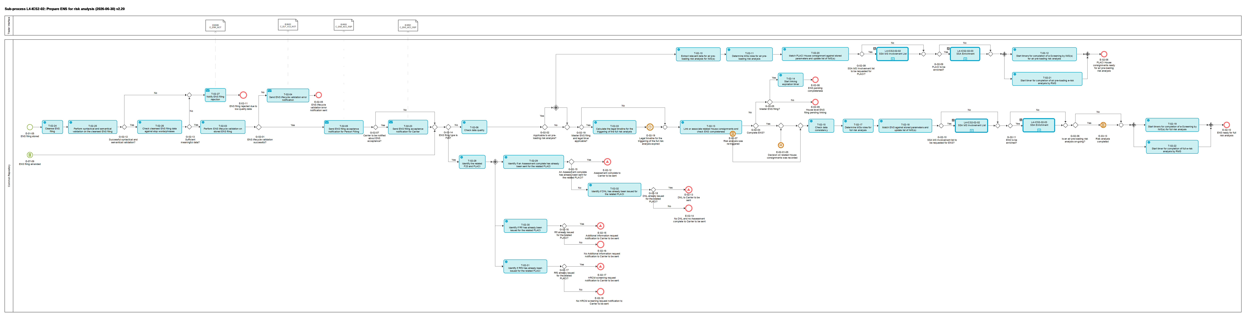
Figure 3: L4-ICS2-02 Prepare ENS for risk analysis sub-process

Tasks

T-02-03 - Perform ENS lifecycle validation on stored ENS filing
Perform ENS lifecycle validation on stored ENS filing | T-02-03
System component: CR
Input: Stored ENS filing
Description:
This validation task comprises the following operations:
- The check of the validity of the state of corresponding ENS, regarding the ENS lifecycle.
(E.g. whether an ENS filing refers to an ENS for which an arrival notification was filed already in the past or the goods covered by the ENS filing which were already presented to the customs and effectively this ENS filing cannot be filed for the same goods already presented.)
- The check of the uniqueness of specific key data elements among the relevant ENS filings throughout the database. These key data elements are data elements which are used in the linking process (e.g. the transport contract document numbers, consignment reference numbers, receptacles).
Each data element applicable to this check has its own uniqueness expiration period which "starts counting" as soon as the corresponding ENS filing is stored in the CR. After that period, that particular value of that data element is allowed to be re-used in a future ENS filing.
- An ENS is instantiated when the processed ENS filing falls into one of the following categories:
  - Full ENS filing (F10, F11, F20, F27, F28, F29, F30, F31, F34, F50, or F51), in this case the instantiated ENS will obtain the state “Complete”
  - Master level ENS filing (F12, F13, F21, F40, F41, F42, F45, F52 or F56), in this case the instantiated ENS will obtain the state “Pending completeness”

If the ENS lifecycle validation is successful, the ENS filing obtains the state 'Accepted'.
If the ENS lifecycle validation fails the ENS filing obtains the state 'Rejected'.
Output (Final situation):
The ENS filing was either accepted or rejected.

T-02-04 – Send ENS lifecycle validation error notification
Send ENS lifecycle validation error notification | T-02-04
System component: CR
Input: Unsuccessful validation results
Description:
The ENS filing is not valid and cannot be further processed. The CR sends the error notification to the TI in order to inform the Person filing via the message IE4N01 Msg: C_ELF_VLD_NOT].
Output (Final situation):
The notification of error is sent to the TI.

T-02-05 - Send ENS filing acceptance notification for Person filing
Send ENS filing acceptance notification for Person filing | T-02-05
System component: CR
Input: Successful validation results
Description:
The acceptance of the ENS filing is sent to TI in order to trigger the notification to the Person filing via the message IE4R01 [Msg: C_ENS_ACC_RSP].
Output (Final situation):
The ENS filing acceptance is sent to the TI.

T-02-06 - Check data quality
Check data quality | T-02-06
System component: CR
Input: Accepted ENS filing or Amended ENS filing
Description:
An automated data quality check will be performed. If the data quality issues are identified, the ENS filing is 'flagged'. This flag will be taken into account during the risk analysis process in Sub-process L4-ICS2-03 – Perform risk analysis, gateway: G-03-05 – e-risk analysis hit and/or other issues and/or flags raised? Data quality issues will be brought to the attention of the risk analyst in Task: T-03-08 - Assess e-risk analysis hit and/or other issues.
Output (Final situation):
Data quality check results, which will either be
- 'ok', or
- 'flagged', in the case of data quality issues, and pointer to the data element(s) with data quality issues.

T-02-10 – Extract relevant data for air pre-loading risk analysis for IMS(s)
Extract relevant data for air pre-loading risk analysis for IMS(s) | T-02-10
System component: CR
Input: Accepted ENS filing or Amended ENS filing applicable for air pre-loading risk analysis
Description:
Regardless of whether it is a full pre-loading ENS filing, or a full house level pre-loading ENS filing, or an ENS filing with minimum pre-loading dataset, only a specific subset of the data (the 7+1 data) which are required by air pre-loading risk analysis are extracted from the ENS filing for the purpose of making them available to the IMS(s).
Output (Final situation):
Relevant extracted datasets for air pre-loading risk analysis are composed.

T-02-11 – Determine MSs roles for air pre-loading risk analysis
Determine MSs roles for air pre-loading risk analysis | T-02-11
System component: CR
Input: Accepted ENS filing or Amended ENS filing applicable for air pre-loading risk analysis
Description:
For the air pre-loading risk analysis, the RMS is identified via the Customs office of first entry element [R02: IE3Fxx / Customs office of first entry] or the Addressed Member State element [R02: IE3Fxx / Addressed Member State] in the ENS filing.
The list of IMS(s) for air pre-loading risk analysis either comprises all remaining Member States or the IMS(s) are identified based on relevant data elements contained in the respective ENS filing(s).
Output (Final situation):
The roles of the Member States involved in an air pre-loading risk analysis are determined.

T-02-12 – Start timers for the completion of e-Screening by IMS(s) for air pre-loading risk analysis
Start timers for the completion of e-Screening by IMS(s) for air pre-loading risk analysis | T-02-12
System component: CR
Input: Accepted ENS filing or Amended ENS filing applicable for air pre-loading risk analysis
Description:
The value of the timers for the completion of e-Screening of an air pre-loading dataset is calculated and the timer is started based on the registration date and time of the ENS filing. Each IMS will have its own individual timer which indicates the time remaining to provide feedback to the RMS. The timer values are determined taking into account the overall timer for the RMS to complete the air pre-loading risk analysis and the time that is needed by the RMS to assess confirmed e-Screening hits from the IMSs.
The timer values will be communicated to the IMS(s) in the scope of the Sub-process: L4-ICS2-03 – Perform risk analysis via the message IE4Q01 [Msg: C_ESC_REQ].
Output (Final situation):
The timer values for all IMS are determined and timers are started.

T-02-13 – Link or associate related House consignments and check ENS completeness
Link or associate related House consignments and check ENS completeness | T-02-13
System component: CR
Input: Accepted ENS filing or Amended ENS filing
Description:
Depending on the state of the corresponding ENS, the process flow and the actions made through this task will differ.
- The normal flow, as depicted in the model, will be followed in the cases where a new ENS filing (of any type) is processed and its corresponding ENS is either not yet instantiated or is in state 'Pending completeness'. For those cases, the following actions will be done by this task:
- In case of a master level ENS filing (F12, F13, F21, F40, F41, F42, F45, F52 or F56),
- if there are house consignments in state ‘Pending linking’ (lodged through F14, F15, F16, F17, F22, F26, F33, F53, F54, F55, F57, F58, F59) that correspond to this ENS, they will be linked with it and obtain the state ‘Linked’;
- if all house consignments, that are needed for this ENS to be complete, have been lodged, the ENS will obtain the state ‘Complete’;
- if there are House consignments and Receptacles (lodged through F43 and F44, respectively) which correspond to this ENS, those consignments will be linked with the ENS and obtain the state ‘Linked’;
- if all Receptacles and PLACI house consignments, that are needed for this ENS to be complete, have been lodged, the ENS will obtain the state ‘Complete’;
- In case of a house level ENS filing (F14, F15, F16, F17, F22, F26, F33, F53, F54, F55, F57, F58 or F59),
  - if the corresponding ENS has already been instantiated,
    - the house consignments contained in this filing will be linked with the ENS and obtain the state ‘Linked’;
    - it will be checked whether after the linking of these house consignments, the ENS is complete, in which case the ENS will obtain the state ‘Complete’.
  - otherwise, if the corresponding ENS has not yet been instantiated, the house consignments will not be linked with an ENS and will remain in state ‘Pending linking’.
- In case of a postal house level ENS filing (F43 or F44),
  - The House consignments which correspond to an ENS that is already instantiated (by matching receptacle ids in F44 and F40, F41, F42 or F45 ENS filings), will be linked with it and obtain the state 'Linked';
  - the House consignments that do not yet correspond to an instantiated ENS, will not be linked and will remain in state 'Pending linking'.
- In case of an air pre-loading minimum dataset house level ENS filing (F23 + F25 or F24),
  - if the corresponding house consignment(s) have already been instantiated, the corresponding PLACI house consignments will obtain the state 'Associated',
  - otherwise, the corresponding PLACI House consignments will remain in state 'Pending association'.
- In case of an air pre-loading minimum dataset house level ENS filing (F32),
  - if the corresponding ENS has already been instantiated, the corresponding PLACI House consignments will obtain the state ‘Associated’,
  - otherwise, the corresponding PLACI House consignments will remain in state 'Pending association'.
- The alternative flow, triggered in the model via the interrupting Event: E-02-07 - Risk analysis was re-triggered (the full risk analysis is re-triggered with the same “Functional reference”, no timer and a new “Risk analysis request reference” (identical to the case of amendment)), will be followed in the following cases:
  - When a late house level ENS filing (F14, F15, F16, F17, F22, F26, F33, F43, F44, F53, F54, F55, F57, F58 or F59) is received containing house consignments for an already existing ENS in state different from “Pending completeness” (in case the ENS is in state "Pending completeness" the full risk analysis has not been triggered yet so no need of re-triggering), or
  - an amendment of the master ENS filing or of any of the related house ENS filing(s) for an ENS in state different from “Pending completeness”. If the amendment is received before the full risk analysis has been triggered, then there is no full risk analysis for re-triggering so the latest version of the ENS data is communicated when the full risk analysis is triggered.
The air pre-loading risk analysis is re-triggered (in case of an amendment of the corresponding air pre-loading ENS filing) or triggered for the first time (late pre-loading house level ENS filing) for the corresponding air pre-loading ENS filing types.
The re-triggered risk analysis initiates the check if the ENS is complete and if there are any supplementary declarants that have not submitted their part of the of the ENS via L4-ICS2-02-01 – Relate ENS with House consignments.
- For the cases of re-entry and split consignment, when a new master level ENS filing is lodged and is related to an existing ENS (through the same master transport document [R02: IE3Fxx / Consignment (Master level) / Transport document (Master level)] or through the previous MRN [R02: IE3Fxx / Split Consignment / Previous MRN]),
  - In case of a full ENS filing (F10, F11, F20, F27, F28, F29, F31, F34, F50, or F51),
    - the new ENS will be associated to the corresponding existing ENS.
  - In case of a master level ENS filing (F12, F13, F21, F40, F41, F42, F45, F52 or F56),
    - the ENS will be associated to the corresponding existing ENS, and
    - it will be checked whether all house consignments that are needed in order to form a complete ENS are lodged;
      - if yes, the ENS will obtain the state ‘Complete’;
      - if not, the ENS will remain in state ‘Pending completeness’.
Output (Final situation):
In case of a full filing, the ENS will obtain the state 'Complete'.
In case of a master level ENS filing,
- the instantiated ENS will either remain in state 'Pending completeness' or obtain the state 'Complete';
- 0 or more house consignments will be linked with an ENS and obtain the state 'Linked';
- 0 or more PLACI house consignments will be associated with an ENS and obtain the state 'Associated'.
In case of a house level ENS filing,
- the contained house consignments will either remain in state 'Pending linking' or obtain the state 'Linked',
- or the contained PLACI house consignments will either remain in state ‘Pending association’ or obtain the state ‘Associated’.
- if the corresponding ENS has been instantiated, it could obtain the state 'Complete' or remain in state 'Pending completeness'.

T-02-14 –Start linking expiration timer
Start linking expiration timer | T-02-14
System component: CR
Input: ENS in the state 'ENS pending completeness'
Description:
A partial master ENS filing triggers the start of the timer for linking it with the related house level ENS filings. The time allocated for the linking of all related ENS filings should allow sufficient time for the completion of the risk analysis according to the legally set deadlines. Those deadlines depend on the given ENS scenario.
Output (Final situation):
The timer for completing the ENS by linking house level ENS filings with a master level ENS filing is started.

T-02-15 - Check data consistency
Check data consistency | T-02-15
System component: CR
Input: Complete ENS
Description:
Data consistency of the ENS will be checked. This is done in order to ensure the appropriate ENS data consistency is provided for the risk analysis or to flag those ENSs with relevant inconsistencies. The consistency check will take into account relevant inconsistencies such as major weight and piece count discrepancies, changed actors, discrepancies in the referenced transport documents at the level of master and underlying house consignments as well as relevant differences in air pre-loading and pre-arrival ENS filings.
This flag will be taken into account in Sub-process L4-ICS2-03 – Perform risk analysis, Gateway: G-03-05 – e-risk analysis hit and/or other issues and/or flags raised?
Output (Final situation):
Data consistency check results, which will either be
- 'ok', or
- 'flagged', in the case the result is identified inconsistency, and pointer to the ENS filings and data element(s) with the identified inconsistency.

T-02-17 – Determine MSs roles for full risk analysis
Determine MSs roles for full risk analysis | T-02-17
System component: CR
Input: Complete ENS or ENS consisting of a master level ENS filing and 0 or more related house level ENS filings
Description:
For the full risk analysis, the RMS is identified via the Customs office of first entry element [R02: IE3Fxx / Customs office of first entry] or the Addressed Member State element [R02: IE3Fxx / Addressed Member State], and the list of IMS(s) is identified based on relevant data elements contained in the respective ENS filing(s).
Output (Final situation):
The Member States to be involved in full risk analysis are determined.

T-02-18 – Match ENS against stored parameters and update list of IMS(s)
Match ENS against stored parameters and update list of IMS(s) | T-02-18
System component: CR
Input: Complete ENS or ENS consisting of a Master ENS filing and 0 or more related house level ENS filings
Description:
The ENS that is being prepared for the risk analysis will be checked against the parameters that the MSs have stored which concern specific national knowledge on given actual cases (e.g. that a customs authority of a MS wishes to identify a specific container based on the knowledge of its unique container number which may be used for transport of illicit goods in the area of security and safety, or in the case where a MS needs to identify immediately consignments with similar/identical characteristics following the issuance of a DNL concerning a specific ENS filing).
The system will only take into account those parameters whose validity period matches the current date.
The system will only look for parameters that were submitted by a Member State that does not have a role of an Involved Member State or a Responsible Member State for this particular ENS.
In case there were matches with parameters submitted by currently not involved Member States, those Member States will be added to the list of Involved Member States for the risk analysis of this ENS.
Output (Final situation):
The list of Involved Member States was updated with Member State(s) whose stored parameters matched the data of the currently processed ENS.

T-02-19 – Start timers for the completion of e-Screening by IMS(s) for full risk analysis
Start timers for the completion of IMSs' e-Screening for full risk analysis | T-02-19
System component: CR
Input: Complete ENS or ENS consisting of a master level ENS filing and 0 or more related house level ENS filings
Description:
The value of the timers for the completion of e-Screening of an ENS is calculated and the timer is started based on the registration date and time of the master ENS filing with the condition of the air pre-loading risk analysis completion or the air pre-loading risk analysis timer expiration (in case of no risk hit), if applicable for the business case of the ENS (air mode of transport). Each IMS will have its own individual timer which indicates the time remaining to provide feedback to the RMS. The timer values are determined taking into account the overall timer for the RMS to complete the full risk analysis and the time that is needed by the RMS to assess confirmed e-Screening hits from the IMSs.
The timer values will be communicated to the IMS(s) in the scope of the Sub-process: L4-ICS2-03 – Perform risk analysis via the message IE4Q01 [Msg: C_ESC_REQ].
Output (Final situation):
The timer values for all IMS are determined and timers are started.

T-02-20 – Match ENS against stored parameters and update list of IMS(s)
Match PLACI house consignment against stored parameters and update list of IMS(s) | T-02-18
System component: CR
Input: PLACI house consignment data
Description:
The PLACI house consignment that is being prepared for the air pre-loading risk analysis will be checked against the parameters that the MSs have stored which concern specific national knowledge on given actual cases (e.g. that a customs authority of a MS wishes to identify a specific consignment based on the knowledge of its consignor and consignee which may contain illicit goods in the area of security and safety, or in the case where a MS needs to identify immediately consignments with similar/identical characteristics following the issuance of a DNL concerning a specific PLACI house consignment).
The system will only take into account those parameters whose validity period matches the current date.
The system will only look for parameters that were submitted by a Member State that does not have a role of an Involved Member State or a Responsible Member State for this particular PLACI house consignment.
In case there were matches with parameters submitted by currently not involved Member States, those Member States will be added to the list of Involved Member States for the air pre-loading risk analysis of this PLACI house consignment.
Output (Final situation):
The list of Involved Member States was updated with Member State(s) whose stored parameters matched the data of the currently processed PLACI house consignment.

T-02-21 – Start timer for completion of air pre-loading e-risk analysis by RMS
Start timer for completion of air pre-loading e-risk analysis by RMS | T-02-21
System component: CR
Input: Accepted ENS filing or Amended ENS filing applicable for air pre-loading risk analysis
Description:
The appropriate timer for the corresponding PLACI is calculated.
The timer's value will be communicated to the RMS in the scope of the Sub-process: L4-ICS2-03 – Perform risk analysis via the message IE4Q02 [Msg: C_ERA_REQ].
The timer for the completion of air pre-loading e-risk analysis is started based on the registration date and time of the ENS filing. In case of an amendment there is no timer and the already started timer is stopped.
Output (Final situation):
The timer for completion of air pre-loading e-risk analysis is started.
No timer is started in case of an amendment and the already started timer is stopped.

T-02-22 – Start timer for completion of full e-risk analysis by RMS
Start timer for completion of full e-risk analysis by RMS | T-02-22
System component: CR
Input: Complete ENS or ENS consisting of a master level ENS filing and 0 or more related house level ENS filings
Description:
The appropriate timer for the corresponding ENS is calculated.
The timer's value will be communicated to the RMS in the scope of the Sub-process: L4-ICS2-03 – Perform risk analysis via the message IE4Q02 [Msg: C_ERA_REQ].
The timer for the completion of full e-risk analysis is started based on the registration date and time of the master ENS filing with the condition of the air pre-loading risk analysis completion or the air pre-loading risk analysis timer expiration (in case of no risk hit), if applicable for the business case of the ENS (air mode of transport). In case of an amendment after the pre-arrival risk analysis has been triggered there is no timer and the already started timer is stopped.
Output (Final situation):
The timer for completion of full e-risk analysis is started.
No timer is started in case of an amendment and the already started timer is stopped.

T-02-23 - Send ENS filing acceptance notification for Carrier
Send ENS filing acceptance notification for Carrier | T-02-23
System component: CR
Input: Successful validation results
Description:
The acceptance of the ENS filing is sent to TI in order to trigger the notification to the Carrier via the message IE4R01 [Msg: C_ENS_ACC_RSP].
Output (Final situation):
The ENS filing acceptance is sent to the TI.

T-02-24 – Cleanse ENS filing
Cleanse ENS filing | T-02-24
System component: CR
Input: Stored ENS filing
Description:
The stored ENS filing is cleansed as per the configured cleansing rules per data element and the hard-coded cleansing rules, if activated. For the purpose of enrichment the non-cleansed ENS filing is stored and used for the enrichment later in the process.
Output (Final situation):
Stored cleansed ENS filing.

T-02-25 – Perform syntactical and semantical validation on the cleansed ENS filing
Perform syntactical and semantical validation on the cleansed ENS filing | T-02-25
System component: CR
Input: Stored cleansed ENS filing
Description:
The cleansed ENS filing is validated in an automated process. It comprises the validation against the message rules and conditions and the minimum meaningful length of each data element, where specified.
The messages rules and conditions are defined in [R02] ICS2 Information Exchange Messages.
Output (Final situation):
The validation will have the following possible outcomes:
- Successful;
- Unsuccessful, in which case
  - the error description will be generated
  - the ENS filing will obtain the state 'Rejected'

T-02-26 – Check cleansed ENS filing data against stop words/phrases
Check cleansed ENS filing data against stop words/phrases | T-02-26
System component: CR
Input: Cleansed ENS filing
Description:
The successfully validated cleansed ENS filing is checked against the configured stop words/phrases. After the removal of the stop words/phrases in case the data elements of the ENS filing are less than the pre-defined minimum meaningful length, then the particular data elements are considered empty and the data provided is considered of non-sufficient quality. The stop words/phrases are not removed from the data elements.
For the “Goods description” the configured whitelisted words/phrases are checked first. In case a whitelisted word/phrase is identified, then the particular “Goods description” is considered valid and no stop words/phrases are checked for this “Goods description”.
Output (Final situation):
The task will have the following possible outcomes:
- Sufficient meaningful data;
- Non-sufficient meaningful data.

T-02-27 – Notify ENS filing rejection
Notify ENS filing rejection | T-02-27
System component: CR
Input: Outcome of task: T-02-25 – Perform syntactical and semantical validation on the cleansed ENS filing or T-02-26 – Check cleansed ENS filing data against stop words/phrases
Description:
The unsuccessful validation of the cleansed ENS filing results in the rejection of the ENS filing. The non-sufficient meaningful data after the checking of the cleansed ENS filing against the stop words/phrases results in the rejection of the ENS filing.
Output (Final situation):
ENS filing rejection notified.

T-02-28 – Identify the related F23 and PLACI
Identify the related F23 and PLACI | T-02-28
System component: CR
Input: Outcome of task: T-02-03 - Perform ENS lifecycle validation on stored ENS filing
Description:
Based on the successfully validated F25 the related F23 and the particular PLACI from the related F23 are identified.
Output (Final situation):
F23 ENS filing and the particular PLACI for which F25 provides information are identified.

T-02-29 – Identify if an Assessment complete has already been sent for the related PLACI
Identify if an Assessment complete has already been sent for the related PLACI | T-02-29
System component: CR
Input: Outcome of task: T-02-28 – Identify the related F23 and
Description:
Based on the identified F23 and the PLACI for which F25 provides information the CR checks if an assessment complete notification has already been sent for the particular PLACI.
Output (Final situation):
In case an assessment complete notification has already been sent, the answer is “Yes”, otherwise the answer is “No”.

T-02-30 – Identify if RfI has already been issued for the related PLACI
Identify if RfI has already been issued for the related PLACI | T-02-30
System component: CR
Input: Outcome of task: T-02-28 – Identify the related F23 and
Description:
Based on the identified F23 and the house consignment for which F25 provides information the CR checks if an RfI was issued for the particular PLACI.
Output (Final situation):
In case an RfI has been issued, the answer is “Yes”, otherwise the answer is “No”.

T-02-31 – Identify if RfS has already been issued for the related PLACI
Identify if RfS has already been issued for the related PLACI | T-02-31
System component: CR
Input: Outcome of task: T-02-28 – Identify the related F23 and
Description:
Based on the identified F23 and the PLACI for which F25 provides information the CR checks if an RfS was issued for the particular PLACI.
Output (Final situation):
In case an RfS has been issued, the answer is “Yes”, otherwise the answer is “No”.

T-02-32 – Identify if DNL has already been issued for the related PLACI
Identify if DNL has already been issued for the related PLACI | T-02-32
System component: CR
Input: Outcome of task: T-02-29 – Identify if an Assessment complete has already been sent for the related PLACI
Description:
Based on the identified F23 and the PLACI for which F25 provides information the CR checks if a DNL was issued for the particular PLACI.
Output (Final situation):
In case a DNL has been issued, the answer is “Yes”, otherwise the answer is “No”.

T-02-33 – Calculate the legal timeline for the triggering of the full risk analysis
Calculate the legal timeline for the triggering of the full risk analysis | T-02-33
System component: CR
Input: ENS
Description:
Based on the relevant cases identified in gateway G-02-19 – Master ENS filing and legal timer applicable? the legal timeline for the triggering of the full risk analysis is calculated.
Output (Final situation):
The legal timeline for the triggering of the full risk analysis is calculated for the relevant ENSs.

Events

E-01-05 – ENS filing stored
ENS filing stored | E-01-05
System component: CR
Description:
Registered ENS filing is stored in the CR.

E-02-05 – ENS lifecycle validation error notification sent
ENS lifecycle validation error notification sent | E-02-05
System component: CR
Description:
The ENS filing is rejected.

E-07-08 – ENS filing amended
ENS filing amended | E-07-08
System component: CR
Description:
This event is triggered by the amendment of an ENS filing.
See Event: E-07-09 – ENS filing amended of Sub-process: L4-ICS2-07 – Amend filing.

E-02-06 – PLACI House consignments ready for air pre-loading risk analysis
PLACI House consignments ready for air pre-loading risk analysis | E-02-06
System component: CR
Description:
PLACI (7+1) data is ready for air pre-loading risk analysis.

E-02-07 - Risk analysis was re-triggered
Risk analysis was re-triggered | E-02-07
System component: CR
Description:
A re-run of a currently on-going or completed full risk analysis was triggered by the Task: T-02-13 – Link or associate related House consignments and check ENS completeness

E-02-08 – ENS pending completeness
ENS pending completeness | E-02-08
System component: CR
Description:
An ENS is not yet complete.

E-02-09 – House level ENS filing pending linking
House level ENS filing pending linking | E-02-09
System component: CR
Description:
A partial house level ENS filing is not yet linked to an ENS.

E-02-10 - ENS ready for full risk analysis
ENS ready for full risk analysis | E-02-10
System component: CR
Description:
The ENS is ready for full risk analysis.

E-02-01-05 - Decision on related House consignments was recorded
Decision on related House consignments was recorded | E-02-01-05
System component: CR
Description:
In case an ENS was processed by Task: T-02-01-04 – Relate ENS with House consignments or Task: T-02-01-10 - Send ENS pending notification to Person that has not yet filed, the outcome of it will trigger the continuation of the current sub-process via this event.

E-03-13 – Risk analysis completed
Risk analysis completed | E-03-13
System component: CR
Description:
The air pre-loading risk analysis is completed.

E-02-11 – ENS filing rejected due to low quality data
ENS filing rejected due to low quality data | E-02-11
System component: CR
Description:
The ENS filing is rejected.

E-02-12 – Assessment complete to Carrier to be sent
Assessment complete to Carrier to be sent | E-02-12
System component: CR
Description:
It was identified that an assessment complete has already been sent for the related PLACI and has to be sent to the Carrier.

E-02-13 – DNL to Carrier to be sent
DNL to Carrier to be sent | E-02-13
System component: CR
Description:
It was identified that DNL has already been sent for the related PLACI and has to be sent to the Carrier.

E-02-14 – No DNL and no Assessment complete to Carrier to be sent
No DNL and no Assessment complete to Carrier to be sent | E-02-14
System component: CR
Description:
No DNL or Assessment complete has been sent to the Carrier for the related PLACI.

E-02-15 – Additional information request notification to Carrier to be sent
Additional information request notification to Carrier to be sent | E-02-15
System component: CR
Description:
Request for information for the related PLACI is identified and an Additional information request notification has to be sent to the Carrier.

E-02-16 – No Additional information request notification to Carrier to be sent
No Additional information request notification to Carrier to be sent | E-02-16
System component: CR
Description:
No Additional information request notification to be sent to the Carrier for the related PLACI.

E-02-17 – HRCM screening request notification to Carrier to be sent
HRCM screening request notification to Carrier to be sent | E-02-17
System component: CR
Description:
Request for HRCM screening for the related PLACI is identified and HRCM screening request notification to Carrier has to be sent.

E-02-18 – No HRCM screening request notification to Carrier to be sent
No HRCM screening request notification to Carrier to be sent | E-02-18
System component: CR
Description:
No request for HRCM screening for the related PLACI is identified and no HRCM screening request notification to Carrier has to be sent.

E-02-19 – Legal timeline for the triggering of the full risk analysis expired
Legal timeline for the triggering of the full risk analysis expired | E-02-19
System component: CR
Description:
The initiated legal timeline for the triggering of the full risk analysis has expired.

Gateways

G-02-01 - ENS lifecycle validation successful?
ENS lifecycle validation successful? | G-02-01
System component: CR
Input: Accepted ENS filing or Amended ENS filing
Description:
In case the validation was successful, the answer is 'Yes', otherwise it is 'No'.

G-02-02 – Applicable to air pre-loading risk analysis?
Applicable to air pre-loading risk analysis? | G-02-02
System component: CR
Input: Accepted ENS filing or Amended ENS filing
Description:
It is determined whether the ENS filing is subject to air pre-loading risk analysis.
Only the following ENS filings are subject to air pre-loading risk analysis: F20, F23, F24, F26, F28, F32 and F43.

G-02-04 – Complete ENS?
Complete ENS? | G-02-04
System component: CR
Input: Outcome of Task: T-02-13 – Link or associate related House consignments and check ENS completeness
Description:
It will be checked whether the state of the current ENS is 'Complete' or not.

G-02-05 – Master ENS filing?
Master ENS filing? | G-02-05
System component: CR
Input: Accepted ENS filing or Amended ENS filing
Description:
The following ENS filings are (partial) master level ENS filings: F12, F13, F21, F40, F41, F42, F45,F52 and F56.

G-02-06 – Is an air pre-loading risk analysis on-going?
Is an air pre-loading risk analysis ongoing? | G-02-06
System component: CR
Input: Complete ENS or ENS consisting of a master level ENS filing and 0 or more related house level ENS filings
Description:
The CR determines whether an air pre-loading risk analysis is on-going for the ENS before it is submitted for full risk analysis.
If an air pre-loading risk analysis is on-going, the CR holds the ENS until results from air pre-loading risk analysis are available.
If not, the CR proceeds with initiating the full risk analysis on the ENS.

G-02-07 – Carrier to be notified about ENS acceptance?
Carrier to be notified about ENS acceptance? | G-02-07
System component: CR
Input:
Description:
The Carrier is to be notified when
- Carrier of this ENS is known;
- Carrier is different from the Person filing. The data elements Declarant [R02: IE4R01 / Declarant] and Carrier [R02: IE4R01 / Carrier] in the message IE4R01 [Msg: C_ENS_ACC_RSP] will be checked.

G-02-08 – SSA MS Involvement list to be requested for PLACI?
SSA MS Involvement list to be requested for PLACI? | G-02-08
System component: CR
Input: configuration of MS Involvement list for PLACI
Description:
In case the SSA MS Involvement list is activated for PLACI, the answer is 'Yes', otherwise it is 'No'.

G-02-09 – PLACI to be enriched?
PLACI to be enriched? | G-02-09
System component: CR
Input: configuration of PLACI enrichment
Description:
In case the PLACI Enrichment is activated, the answer is 'Yes', otherwise it is 'No'.

G-02-10 – SSA MS Involvement list to be requested for ENS?
SSA MS Involvement list to be requested for ENS? | G-02-10
System component: CR
Input: configuration of MS Involvement list for ENS
Description:
In case the SSA MS Involvement list is activated for ENS, the answer is 'Yes', otherwise it is 'No'.

G-02-11 – ENS to be enriched?
ENS to be enriched? | G-02-11
System component: CR
Input: configuration of ENS enrichment
Description:
In case the ENS Enrichment is activated, the answer is 'Yes', otherwise it is 'No'.

G-02-12 – Successful syntactical and semantical validation?
Successful syntactical and semantical validation? | G-02-12
System component: CR
Input: Outcome of Task: T-02-25 – Perform syntactical and semantical validation on the cleansed ENS filing
Description:
In case the validation was successful, the answer is 'Yes', otherwise it is 'No'.

G-02-13 – Sufficient meaningful data?
Sufficient meaningful data? | G-02-13
System component: CR
Input: Outcome of Task: T-02-26 – Check cleansed ENS filing data against stop words/phrases
Description:
In case there is sufficient meaningful data, the answer is 'Yes', otherwise it is 'No'.

G-02-14 – ENS filing type is F25?
ENS filing type is F25? | G-02-14
System component: CR
Input: Outcome of Task: T-02-03 - Perform ENS lifecycle validation on stored ENS filing
Description:
In case the ENS filing type is F25, the answer is 'Yes', otherwise it is 'No'.

G-02-15 – An Assessment complete has already been sent for the PLACI?
An Assessment complete has already been sent for the PLACI? | G-02-15
System component: CR
Input: Outcome of Task: T-02-29 – Identify if an Assessment complete has already been sent for the
Description:
In case an Assessment complete has already been sent for the PLACI, the answer is 'Yes', otherwise it is 'No'.

G-02-16 – RfI already issued for the related PLACI?
RfI already issued for the related PLACI? | G-02-16
System component: CR
Input: Outcome of Task: T-02-30 – Identify if RfI has already been issued for the related
Description:
In case an RfI has already been issued for the PLACI, the answer is 'Yes', otherwise it is 'No'.

G-02-17 – RfS already issued for the related PLACI?
RfS already issued for the related PLACI? | G-02-17
System component: CR
Input: Outcome of Task: T-02-31 – Identify if RfS has already been issued for the related
Description:
In case an RfS has already been issued for the PLACI, the answer is 'Yes', otherwise it is 'No'.

G-02-18 – DNL already issued for the related PLACI?
DNL already issued for the related PLACI? | G-02-18
System component: CR
Input: Outcome of Task: T-02-32 – Identify if DNL has already been issued for the related
Description:
In case a DNL has already been issued for the PLACI, the answer is 'Yes', otherwise it is 'No'.

G-02-19 – Master ENS filing and legal timer applicable?
Master ENS filing and legal timer applicable? | G-02-19
System component: CR
Input: ENS filing
Description:
In case the ENS filing is a master ENS filing of type F12 or F21, the identified business case is respectively either deep-sea cargo or air long-haul, or it is an F12/F21 amendment for these cases and the full risk analysis has not been triggered yet, the answer is 'Yes', otherwise it is 'No'.

L4-ICS2-02-01 – Relate ENS with House consignments
Relate ENS filings | L4-ICS2-02-01
Organisation: National Customs Administration of the Responsible Member State
Input: House consignments that could not be linked automatically
Description:
The CR attempts to identify not linked House consignments that could potentially constitute an ENS using other data elements than the ULK.
If such House consignments are found, they are linked to the ENS and the ENS becomes complete.
If House consignments are found but a complete ENS cannot be instantiated, the Master consignment with all so far linked House consignments are made available to the risk analysis.
Output (Final situation):
The ENS is complete by relating the relevant House consignments and is ready for risk analysis. If complete ENS cannot be created, Master consignments with all so far linked House consignments are ready for risk analysis.

Business Process Model

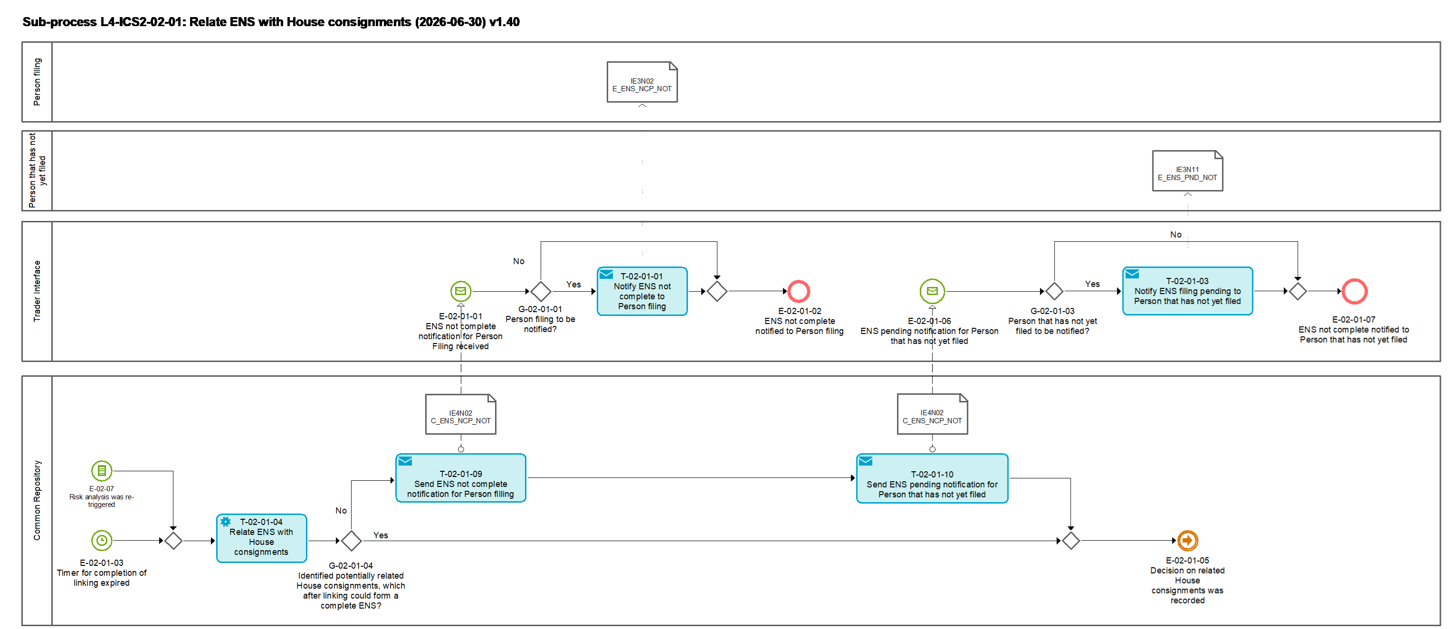
Figure 4: L4-ICS2-02-01 Relate ENS filings sub-process

Tasks

T-02-01-01 - Notify ENS not complete to Person filing
Notify ENS not complete to Person filing | T-02-01-01
System component: TI
Input: ENS not complete notification received from CR
Description:
The Person filing is informed that the ENS is still not complete, via the message IE3N02 [Msg: E_ENS_NCP_NOT].
The notification will also include a list of the filers [R02: IE3N02 / Supplementary declarant] that this person has indicated as obliged to file and who have not filed yet.
Output (Final situation):
The Person filing is notified about the ENS still not being complete.

T-02-01-03 - Notify ENS filing pending to Person that has not yet filed
Notify ENS filing pending to Person that has not yet filed | T-02-01-03
System component: TI
Input: ENS pending notification received from CR
Description:
The Person that has not yet filed is informed that he is obliged to file an ENS filing, via the message IE3N11 [Msg: E_ENS_PND_NOT].
Output (Final situation):
The Person that has not yet filed is notified about the ENS filing pending.

T-02-01-04 – Relate ENS with House consignments
Relate ENS filings | T-02-01-04
System component: CR (Service Layer)
Input: ENS for which the linking expiration timer has expired OR ENS for which the risk analysis has been re-triggered
Description:
The CR attempts to relate ENS filings by taking into account other data elements (i.e. container numbers, shipping marks etc.) than the ones composing a ULK (linking of ENS filings using the ULK is defined in Task: T-02-13 – Link or associate related House consignments and check ENS completeness).
The house consignments are attempted to be linked an ENS also in the cases when the pre-arrival risk analysis is re-triggered due to amendments or late house level ENS filings.
It will be checked whether with the linking of the potentially related ENS filings that were identified through this task the ENS can be considered complete. If that is the case, this ENS will obtain the state 'Considered complete', and the ENS will proceed with risk analysis.
In case the identified ENS master level filing and so far linked house level filings do not form a complete ENS, this partial ENS will obtain the state 'Considered complete', and the ENS will proceed with risk analysis only with the currently linked ENS filings.
Output (Final situation):
Master level ENS filing and so far linked house level filings that do not form a complete ENS, or
Related ENS.

T-02-01-09 - Send ENS not complete notification for Person filing
Send ENS not complete notification | T-02-01-09
System component: CR (Service Layer)
Input: ENS in the state 'Considered complete'
Description:
The ENS is still not complete after no related ENS filings that could form a complete ENS were found.
The CR sends the notification to the TI in order to inform the Person filing via the message IE4N02 [Msg: C_ENS_NCP_NOT].
Output (Final situation):
The ENS not complete notification is sent to the TI.

T-02-01-10 - Send ENS pending notification to Person that has not yet filed
Send ENS pending notification for Person that has not yet filed | T-02-01-10
System component: CR (Service Layer)
Input: T-02-01-09 – Send ENS not complete notification for Person filing
Description:
The CR sends the notification to the TI in order to inform the Person that has not yet filed via the message IE4N02 [Msg: C_ENS_NCP_NOT].
Output (Final situation):
The ENS pending notification is sent to the TI.

Events

E-02-01-01 – ENS not complete notification for Person filing received
ENS not complete notification for Person filing received | E-02-01-01
System component: TI
Description:
The notification for the Person filing from the CR that ENS is not complete is received by the TI.

E-02-01-02 – ENS not complete notified to Person filing
ENS not complete notified to Person filing | E-02-01-02
System component: TI
Description:
The notification from the CR that ENS is not complete is sent to the Person filing by the TI, if applicable.

E-02-01-03 – Timer for completion of linking expired
Timer for completion of linking expired | E-02-01-03
System component: CR (Service Layer)
Description:
The timer for all required partial house level ENS filings to be linked to the ENS has expired.

E-02-01-05 – Decision on related House consignments was recorded
Decision on related House consignments was recorded | E-02-01-05
System component: CR (Service Layer)
Description:
The decision on related ENS filings was taken and recorded in the CR. The process continues in Sub-process: L4-ICS2-02 - Prepare ENS for risk analysis, Event: E-02-01-05 - Decision on related House consignments was recorded.

E-02-01-06 – ENS pending notification for Person that has not yet filed received
ENS not complete notification received | E-02-01-06
System component: TI
Description:
The notification from the CR that ENS is pending is received by the TI.

E-02-01-07 – ENS pending notified to Person that has not yet filed
ENS not complete notified | E-02-01-07
System component: TI
Description:
The notification from the CR that ENS is pending was sent to the Person that has not yet filed by the TI.

E-02-07 - Risk analysis was re-triggered
Risk analysis was re-triggered | E-02-07
System component: CR
Description:
A re-run of a currently on-going or completed full risk analysis was triggered by the Task: T-02-13 – Link or associate related House consignments and check ENS completeness

Gateways

G-02-01-01 – Person filing to be notified?
Person filing to be notified? | G-02-01-01
System component: TI
Input: ENS not complete notification received from CR
Description:
The person filing is to be notified when
- One or more of the parties that this person has indicated [R02: IE3Fxx / Consignment (Master level) (or Consignment (Master level) / Consignment (House level)) / Supplementary declarant] as obliged to lodge ENS filings, have not yet filed;
- Person filing has requested to receive 'ENS not complete' notification messages IE3N02 [Msg: E_ENS_NCP_NOT].

G-02-01-03 – Person that has not yet filed to be notified?
Person that has not yet filed to be notified? | G-02-01-03
System component: TI
Input: ENS not complete notification received from CR
Description:
The Person that has not yet filed is to be notified when
- This person was indicated in an ENS filing (master or house level) as person that has an obligation to file a lower level ENS filing;
- Person is connected to the TI.

G-02-01-04 - Identified potentially related House consignments, which after linking could form a complete ENS?
Identified potentially related House consignments, which after linking could form a complete ENS? | G-02-01-04
System component: CR (Service Layer)
Input: Outcome of Task: T-02-01-04 – Relate ENS
Description:
If potentially related ENS House consignments are found, the answer is 'Yes', otherwise it is 'No'.

L4-ICS2-02-02 – SSA MS Involvement list
SSA Enrichment | L4-ICS2-02-02
Organisation: National Customs Administration of the Responsible Member State
Input: ENS/PLACI
Description:
The PLACI or the ENS is ready in the CR in order the enrichment to SSA to be triggered. A request is sent for the list of Member States that should be involved in the risk analysis according to SSA. Within a pre-defined time limit CR is expecting the list of the Member States which should be involved in the risk analysis. In case there is no response within the time limit, the enrichment is requested from SSA. When the MS involvement list is received by the CR the CR checks if there are MS(s) from the list which were not part of the created IMS list. If there are such MS(s) they are added to the IMS list.
Output (Final situation):
The list of MS part of the risk analysis is ready for the ENS/PLACI.

Business Process Model
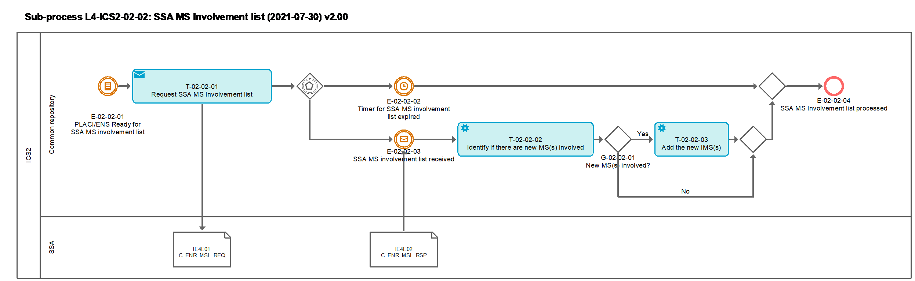
Figure 5 L4-ICS2-02-02 SSA MS Involvement list

Tasks

T-02-02-01 – Request SSA MS involvement list
Request SSA MS involvement list | T-02-02-01
System component: CR
Input: ENS/PLACI
Description:
A request to SSA is sent for the list of all MS(s) to be involved in the air pre-loading or the pre-arrival risk analysis via message IE4E01 [Msg: C_ENR_MSL_REQ] according to SSA. The PLACI/ENS sent for SSA MS involvement list contain the values of each data element as originally submitted by the EO, not cleansed.
Output (Final situation):
Request for SSA MS involvement list is sent to SSA.

T-02-02-02 – Identify if there are new MS(s) involved
Identify if there are new MS(s) involved | T-02-02-02
System component: CR
Input: An MS involvement list from SSA and the list of MS roles assigned by the CR
Description:
CR compares the MS involvement list received from the SSA to the list of the IMS(s) and the RMS identified by the CR.
Output (Final situation):
In case there are MS(s) in the MS involvement list different from the RMS and the IMS, the answer is 'Yes', otherwise it is 'No'.

T-02-02-03 – Add the new IMS(s)
Add the new IMS(s) | T-02-02-03
System component: CR
Input: The list of MS to become IMS(s)
Description:
The MS(s) identified as different from the RMS and the list of IMS(s) already identified by the CR are added to the IMS list and the necessary timers and e-screening requests are created.
Output (Final situation):
An updated list of IMS(s).

Events

E-02-02-01 – PLACI/ENS ready for SSA MS involvement list
PLACI/ENS ready for SSA MS involvement list | E-02-02-01
System component: CR
Description:
PLACI/ENS is ready to be sent to SSA for the list of MS involved according to SSA.

E-02-02-02 – Timer for SSA MS involvement list expired
Timer for SSA MS involvement list expired | E-02-02-02
System component: CR
Description:
There is a pre-configured timer within which the SSA MS involvement list IE4E02 [Msg: C_ENR_MSL_RSP] is expected from the SSA. If no IE4E02 is received within this timer the process continues with the PLACI/ENS enrichment.

E-02-02-03 – SSA MS Involvement list received
SSA MS Involvement list received | E-02-02-03
System component: CR
Description:
SSA MS Involvement list is received by CR and stored.

E-02-02-04 – SSA MS Involvement list processed
Enrichment completed | E-02-02-04
System component: CR
Description:
SSA MS Involvement list is updated when necessary and process continues with PLACI/ENS Enrichment.

Gateways

G-02-02-01 – New MS(s) involved?
New MS(s) involved? | G-02-02-01
System component: CR
Input: Outcome of Task: T-02-02-02 – Identify if there are new MS(s) involved
Description:
In case there are MS(s) in the MS involvement list different from the RMS and the IMS(s), the answer is 'Yes', otherwise it is 'No'.

L4-ICS2-02-03 – SSA Enrichment
SSA Enrichment | L4-ICS2-02-03
Organisation: National Customs Administration of the Responsible Member State
Input: ENS/PLACI
Description:
Enrichment of the PLACI/ENS from CR to SSA is requested. The enrichment is expected by the CR within a pre-defined time limit based on the specific business case. When the enrichment is provided it is added to the respective risk analysis request for the particular MS which has issued the enrichment. If no enrichment is received within the defined timer, the flow continues with the triggering of the risk analysis process without any enrichments attached.
Output (Final situation):
ENS or PLACI enrichment.

Business Process Model
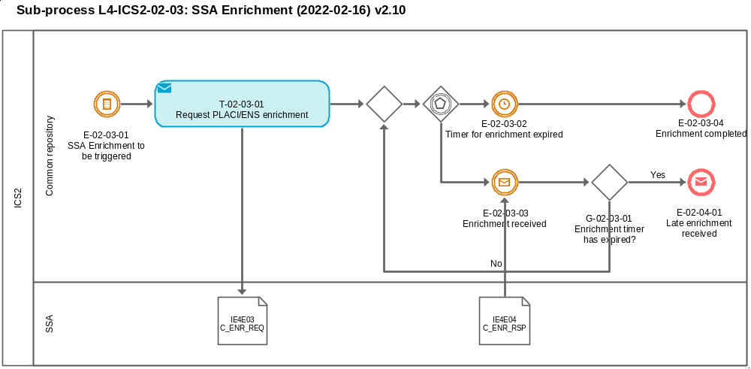
Figure 6 L4-ICS2-02-03 SSA Enrichment

Tasks

T-02-03-01 – Request PLACI/ENS enrichment
Request PLACI/ENS enrichment | T-02-03-01
System component: CR
Input: PLACI/ENS
Description:
CR creates the request for enrichment based on the PLACI/ENS with the additional information necessary to facilitate the enrichment. The PLACI/ENS sent for enrichment contain the values of each data element as originally submitted by the EO, not cleansed.
Output (Final situation):
PLACI/ENS enrichment is requested IE4E03 [Msg: C_ENR_REQ].

Events

E-02-03-01 – SSA Enrichment to be triggered
Timer for enrichment expired | E-02-03-01
System component: CR
Description:
SSA Enrichment is triggered.

E-02-03-02 – Timer for enrichment expired
Timer for enrichment expired | E-02-03-02
System component: CR
Description:
There is a pre-configured applicable timer within which the SSA enrichment IE4E04 [Msg: C_ENR_RSP] is expected from the SSA. If no IE4E0E is received within this timer the process continues with the pre-loading or pre-arrival risk analysis.

E-02-03-03 – Enrichment received
Enrichment received | E-02-03-03
System component: CR
Description:
SSA enrichment is received by CR and stored. The received enrichments are linked to the relevant risk analysis/e-Screening requests of the enrichment MS(s).

E-02-03-04 – Enrichment completed
Enrichment completed | E-02-03-04
System component: CR
Description:
PLACI/ENS enrichment process is completed at the CR and the air pre-loading/pre-arrival risk analysis will follow.

Gateways

G-02-03-01 – Enrichment timer has expired?
Enrichment timer has expired? | G-02-03-01
System component: CR
Input: Outcome of Event: E-02-03-03 – Enrichment received
Description:
In case the timer for receiving the enrichments for the particular ENS/PLACI has expired, the answer is 'Yes', otherwise it is 'No'.

L4-ICS2-02-04 – Late enrichment response
Late enrichment response | L4-ICS2-02-04
Organisation: National Customs Administration of the Responsible Member State
Input: Enrichment response
Description:
The process is triggered by a received enrichment response by CR from SSA after the expiration of the applicable timer for the particular enrichment.
In case the received enrichments contain high priority enrichments, they are forwarded to the relevant enrichment MS. If the risk analysis process is complete then just the enrichment is forwarded. In case the risk analysis process is still on-going a new risk analysis/e-Screening request is forwarded to the enrichment MS.
Output (Final situation):
Not high priority late enrichments are stored and the process is complete.
For high priority late enrichments and still on-going risk analysis, risk analysis request/e-Screening request is sent to the enrichment MS.
For high priority late enrichments and complete risk analysis the enrichment is forwarded to the enrichment MS.

Business Process Model
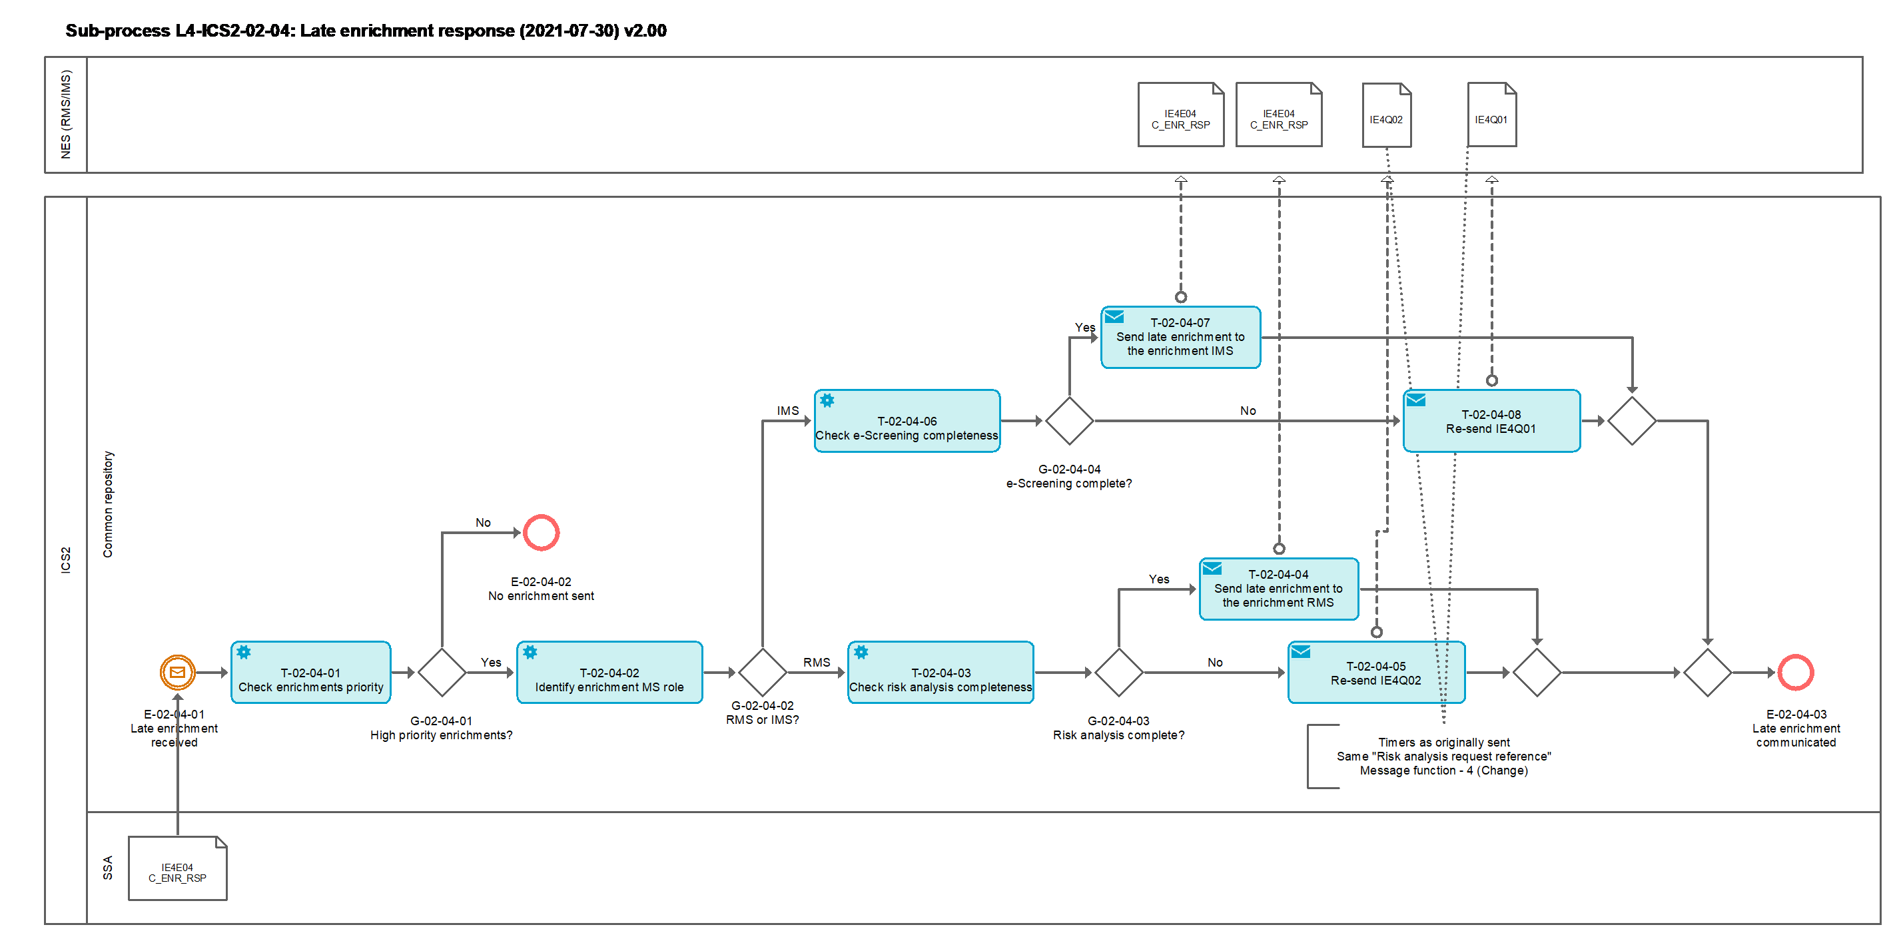
Figure 7 L4-ICS2-2-04 Late enrichment response

Tasks

T-02-04-01 – Check enrichments priority
Check enrichments priorities | T-02-04-01
System component: CR
Input: Late PLACI/ENS enrichment
Description:
Common repository checks whether any of received MS Enrichments is with high priority.
Output (Final situation):
In case there are high priority MS Enrichments, the answer is 'Yes', otherwise it is 'No'.

T-02-04-02 – Identify enrichment MS role
Identify enrichment MS role | T-02-04-02
System component: CR
Input: Late PLACI/ENS enrichment
Description:
Common repository identifies the role of the MS of the enrichment.
Output (Final situation):
In case the MS role is RMS, the answer is 'RMS', otherwise it is 'IMS'.

T-02-04-03 – Check risk analysis completeness
Check risk analysis completeness | T-02-04-03
System component: CR
Input: Late PLACI/ENS enrichment
Description:
Common repository checks the status of the air pre-loading or the full e-risk analysis completeness.
Output (Final situation):
In case the status is ‘Completed’, the answer is 'Yes', otherwise it is 'No'.

T-02-04-04 – Send late enrichment to the enrichment RMS
Send late enrichment to the enrichment RMS | T-02-04-04
System component: CR
Input: Late PLACI/ENS enrichment
Description:
Common repository sends the late enrichment to the RMS via IE4E04.
Output (Final situation):
Late enrichment sent to RMS.

T-02-04-05 – Re-send IE4Q02
Re-send IE4Q02 | T-02-04-05
System component: CR
Input: Late PLACI/ENS enrichment
Description:
Common repository re-sends IE4Q02 to the RMS.
Output (Final situation):
IE4Q02 re-sent to the RMS.

T-02-04-06 – Check e-Screening completeness
Check e-Screening completeness | T-02-04-06
System component: CR
Input: Late PLACI/ENS enrichment
Description:
Common repository checks the timer expiry and the status of the e-Screening request for air pre-loading or the full risk analysis completeness.
Output (Final situation):
In case the e-Screening timer has expired or the e-Screening request state is ‘Closed’, the answer is 'Yes', otherwise it is 'No'.

T-02-04-07 – Send late enrichment to the enrichment IMS
Send late enrichment to the enrichment IMS | T-02-04-07
System component: CR
Input: Late PLACI/ENS enrichment
Description:
Common repository sends the late enrichment to the IMS via IE4E04.
Output (Final situation):
Late enrichment sent to IMS.

T-02-04-08 – Re-send IE4Q01
Re-send IE4Q01 | T-02-04-08
System component: CR
Input: Late PLACI/ENS enrichment
Description:
Common repository re-sends IE4Q01 to the IMS.
Output (Final situation):
IE4Q01 re-sent to the IMS.

Events

E-02-04-01 – Late enrichment received
Late enrichment received | E-02-04-01
System component: CR
Description:
Common repository receives late enrichment for ENS/PLACI IE4E04 [Msg: E_ENS_ENR_RSP].

E-02-04-02 – No enrichment sent
No enrichment sent | E-02-04-02
System component: CR
Description:
Enrichment is not further processed due low priority.

E-02-04-03 – Late enrichment communicated
Late enrichment communicated | E-02-04-03
System component: CR
Description:
Late Enrichment has been communicated to the relevant Member State.

Gateways

G-02-04-01 – High priority enrichment?
High priority enrichment? | G-02-04-01
System component: CR
Input: Outcome of T-02-04-01 – Check enrichments priority
Description:
In case high priority indicator is true, then answer is ‘Yes’, otherwise ‘No’.

G-02-04-02 – RMS or IMS?
RMS or IMS? | G-02-04-02
System component: CR
Input: Outcome of T-02-04-02 – Identify enrichment MS role
Description:
In case the enrichment MS role is RMS, then answer is ‘RMS’, otherwise ‘IMS’.

G-02-04-03 – Risk analysis complete?
Risk analysis complete? | G-02-04-03
System component: CR
Input: Outcome of T-02-04-03 – Check risk analysis completeness
Description:
In case the state of the e-risk analysis for the related ENS/PLACI is ‘Complete’, then answer is ‘Yes’, otherwise ‘No’.

G-02-04-04 – e-Screening complete?
e-Screening complete? | G-02-04-04
System component: CR
Input: Outcome of

T-02-04-06 – Check e-Screening completeness
Description:
In case e-Screening request for the particular enrichment MS for the related ENS/PLACI is closed or the e-Screening timer has expired, then answer is ‘Yes’, otherwise ‘No’.

L4-ICS2-03 – Perform risk analysis
Perform risk analysis | L4-ICS-03
Organisation: National Customs Administration of the Responsible Member State
Input: ENS or ENS filing ready for risk analysis
Description:
The risk analysis sub-process is performed on an ENS filing or an ENS that has been prepared through the Sub-process L4-ICS2-02 - Prepare ENS for risk analysis and is now ready for risk analysis.
The risk analysis performed on an ENS comprises the full security and safety risk analysis tasks,
whereas the risk analysis performed on an ENS filing only comprises the air pre-loading security risk analysis.
The Member States to be involved are identified and the registered ENS filing or ENS is made available to all the relevant Member States for e-Screening. Additional Involved Member State(s) may be identified for the full risk analysis process in case they had submitted specific parameters which matched the currently processed ENS (Other Member State to become the IMS).
The Responsible Member State, as part of its overall electronic risk analysis process takes into account the final results of the e-Screening process performed by the IMSs. Results of the e-screening from involved Member States are collected, allocated and made available to the Responsible Member State before that Member State completes the risk analysis process.
Where necessary the RMS applies during the risk analysis process appropriate risk mitigation measures as per sub-process 0 L4-ICS2-03-01 – Send referral.
The RMS assigns a risk analysis result code which depends on the identified level of risk which will influence the decision on whether the goods will be subject to prohibition to be loaded on the means of transport (DNL) or subject to controls. If controls are deemed necessary, the nature of security and safety risk analysis also influences a decision on where the controls should take place (COFE or at a later stage like subsequent customs office of entry (first unloading location) or place where goods are presented subsequent to the place of first unloading, or customs office of destination).
Output (Final situation):
Risk analysis was performed and measures to be taken were decided.

Business Process Model
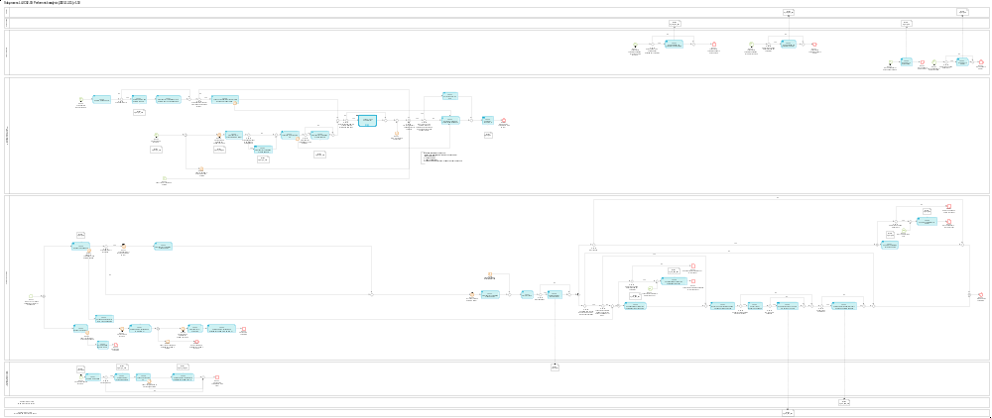
Figure 8: L4-ICS2-03 Perform risk analysis sub-process

Tasks

T-03-01 - Notify assessment complete to Person filing
Notify assessment complete to Person filing | T-03-01
System component: TI
Input: Assessment complete notification received from CR
Description:
The notification of the completed assessment is sent from the TI to the Person filing via the message IE3N03 [Msg: E_ASM_CMP_NOT].
Output (Final situation):
The assessment complete notification is sent to the Person filing.

T-03-02 - Notify assessment complete to Carrier
Notify assessment complete Carrier | T-03-02
System component: TI
Input: Assessment complete notification received from CR
Description:
The notification of the completed assessment is sent from the TI to the Carrier via the message IE3N03 [Msg: E_ASM_CMP_NOT].
Output (Final situation):
The assessment complete notification is sent to the carrier.

T-03-03 - Notify DNL to Person filing
Notify DNL to Person filing | T-03-03
System component: TI
Input: Received DNL C_DNL_REQ
Description:
The DNL notification is sent from the TI to the Person filing via the message IE3Q01 [Msg: E_DNL_REQ].
Output (Final situation):
The DNL is sent to the Person filing.

T-03-04 - Notify DNL to Carrier
Notify DNL to Carrier | T-03-04
System component: TI
Input: Received DNL C_DNL_REQ
Description:
The DNL notification is sent from the TI to the Carrier via the message IE3Q01 [Msg: E_DNL_REQ].
Output (Final situation):
The DNL is sent to the Carrier.

T-03-05 - Perform e-risk analysis
Perform e-risk analysis | T-03-05
System component: NES (RMS)
Input: ENS or ENS filing
Description:
Received ENS or PLACI House consignment is electronically analysed against CRC category 1, CRC category 2 and any potential additional national security and safety related risk profiles not falling in the scope of the CRCs.
Electronic risk analysis (e-risk analysis) either results in an automated ‘match / hit’ of a given CRC / national risk profile or not.
Output (Final situation):
e-risk analysis hit or no hit.

T-03-06 – Communicate e-risk analysis hit to CR
Communicate e-risk analysis hit to CR | T-03-06
System component: NES (RMS)
Input: Outcome of Task: T-03-05 - Perform e-risk analysis
Description:
The hit from e-risk analysis is communicated by the NES (RMS) to the CR via the message IE4N03 [Msg: C_ERA_HIT_NOT].
Output (Final situation):
The e-risk analysis hit information from RMS is available in the CR.

T-03-07 - Stop timer for completion of risk analysis due to e-risk analysis hit
Stop timer for completion of risk analysis due to e-risk analysis hit | T-03-07
System component: NES (RMS)
Input: Outcome of Task: T-03-05 - Perform e-risk analysis
Description:
The time limit for completion of the risk analysis for the ENS concerned are suspended at the RMS, since a risk was identified and additional risk analysis needs to be carried out (i.e. review of the e-risk analysis hit, and additionally a possible data quality or data inconsistency issued by the risk analysis official – human review and risk mitigation).
Output (Final situation):
The timer for completion of risk analysis is stopped.

T-03-08 - Assess e-risk analysis hit and/or other issues
Assess e-risk analysis hit and/or other issues and/or flags raised | T-03-08
System component: NES (RMS)
Input: e-risk analysis hit and/or data quality and/or consistency issue
Description:
Result of the e-risk analysis (i.e. match/hit of CRCs / potential national profiles) and/or data quality and/or data inconsistency issue is presented to the risk analyst.
Risk analyst performs additional analysis on the presented information and decides on risk mitigation measures.
The outcome of the risk assessment performed by the risk analyst can be a decision either to:
- Request for additional information (RfI) from the Person filing concerned, and/or
- Request for HRCM screening (RfS) (air pre-loading only), and/or
- Request for further information from the Involved Member State(s) that may hold necessary additional risk mitigation information, or
- Finalize the risk analysis and proceed directly to Task: T-03-12 - Record RA result and control recommendation
Output (Final situation):
The assessment of the e-risk analysis result and/or data quality and/or data consistency issue was completed and any necessary risk mitigation actions were decided.

T-03-09 - Stop timer for e-Screening in NES (RMS)
Stop timer for e-Screening in NES (RMS) | T-03-09
System component: CR and NES (RMS)
Input: E-screening hit from IMS
Description:
The timer for e-Screening on the PLACI House consignment or ENS concerned is suspended for the IMS that communicated an e-Screening hit.
Output (Final situation):
The timer for e-Screening is stopped for the given IMS.

T-03-10 - Assess IMS e-Screening hit
Assess IMS e-Screening hit | T-03-10
System component: NES (RMS)
Input: Confirmed e-Screening hit communicated by an Involved Member State
Description:
A confirmed e-Screening hit was communicated by the IMS and is now assessed by the risk analyst of the RMS.
The outcome of this assessment performed by the risk analyst can be a decision either to:
- Request for additional information (RfI) from the Person filing concerned, and/or
- Request for HRCM-screening (RfS) (air pre-loading only), and/or
- Request for further information from the Involved Member State(s) that may hold necessary additional risk mitigation information, or
- Finalize the risk analysis and proceed directly to Task: T-03-12 - Record RA result and control recommendation
Output (Final situation):
The assessment of a confirmed e-Screening hit that was communicated by an Involved Member State was completed and any necessary risk mitigation actions were decided.

T-03-11 - Set RA result to 'No risk'
Set RA result to 'No risk' | T-03-11
System component: NES (RMS)
Input: No e-risk analysis hit, no e-Screening hit, no data quality flag, no data consistency flag.
Description:
The risk analysis result is automatically set to 'No risk' when there was no e-risk analysis hit, no e-Screening hit, no data quality flag and no data consistency flag in the scope of an air pre-loading risk analysis or full risk analysis on an PLACI House consignment or ENS, respectively.
Output (Final situation):
The risk analysis result is set to 'No risk'.

T-03-12 - Record RA result and control recommendation
Record RA result and control recommendation | T-03-12
System component: NES (RMS)
Input: Outcomes of Tasks: T-03-08 - Assess e-risk analysis hit and/or other issues, T-03-10 - Assess IMS e-Screening hit
Description:
Result of the e-risk analysis process (through manual risk assessment, and supported where necessary by additional information provided by the EO and/or Involved Member State(s)) and/or of the e-Screening process(es) completed and communicated by the Involved Member State is transformed into the final risk analysis result by the risk analyst.
The risk analyst will record the risk analysis result and control recommendation based on the level and the nature of the risk identified. Choice of recommended place of control should be limited to the MS(s) identified in an ENS concerned.
- Recommendation on place of control is set to (applicable to full risk analysis cases only):
  - Customs Office of First Entry, or
  - First unloading place (it can be either COFE or a subsequent customs office), or
  - where identifiable and most appropriate, at the place where goods are presented subsequent to the place of first unloading in maritime and air.
The exact structure of the risk analysis result and control recommendation is defined in the message IE4S02 [Msg: C_RSK_RES], which will be generated later based on the input of the risk analyst acquired through this task and sent to the CR.
Output (Final situation):
The risk analysis result and control recommendation is recorded.

T-03-13 – Submit RA result to CR
Submit RA result to CR | T-03-13
System component: NES (RMS)
Input:
The set risk analysis result and control recommendation (if applicable) recorded at Task: T-03-11 - Set RA result to 'No risk' or T-03-12 - Record RA result and control recommendation.
Description:
The set risk analysis result and control recommendation is submitted to the CR via the message IE4S02 [Msg: C_RSK_RES].
Output (Final situation):
The set risk analysis result is available in the CR.

T-03-14 - Stop timer for completion of risk analysis
Stop timer for completion of risk analysis | T-03-14
System component: CR
Input: Outcome of Task: T-03-05 - Perform e-risk analysis
Description:
The time-limits for completion of the risk analysis for the ENS concerned are suspended at the RMS, since a risk was identified and additional risk analysis needs to be carried out (i.e. review of the e-risk analysis hit, and additionally a possible data quality or data inconsistency issue by the risk analysis official – human review and risk mitigation). CR also stops the timer.
The state of the air pre-loading or the state of the full risk analysis will change to 'Timer stopped'.
Output (Final situation):
The timer for completion of risk analysis is stopped.

T-03-15 - Request e-risk analysis
Request e-risk analysis | T-03-15
System component: CR
Input: ENS or PLACI House consignment
Description:
Before sending the request to a Member State, certain alphabetical letters, which could be found in the ENS data, will be transliterated into the desired alphabet, according to the preferences of each Member State.
A request for e-risk analysis is communicated to the Responsible Member State via the message IE4Q02 [Msg: C_ERA_REQ].
The state of the air pre-loading risk analysis or the state of the full risk analysis will change to 'Initiated'.
This request will contain among others:
- the ENS or PLACI House consignment (or references of them) that is subject to risk analysis
- any raised (negative) flags from the data check, data consistency (performed in Sub-process: L4-ICS2-02 - Prepare ENS for risk analysis)
- list of Involved Member States and their time limits for the completion of their e-Screening tasks
- timer for the overall completion of the risk analysis
Output (Final situation):
Request for e-risk analysis is communicated to the Responsible Member State.

T-03-16 - Set risk analysis result to 'No RA result available'
Set risk analysis result to 'No RA result available' | T-03-16
System component: CR
Input: The timer for the completion of the risk analysis has expired and there is no risk analysis result submitted by the NES (RMS).
Description:
After expiration of the timer the CR sets the risk analysis result for the pre-loading risk analysis or full risk analysis to 'No RA result available'.
The state of the air pre-loading risk analysis or the state of the full risk analysis remains 'Initiated'.
Output (Final situation):
The CR stores information that no risk analysis results are available.

T-03-17 – Store RA result
Store RA result | T-03-17
System component: CR
Input: Received risk analysis results
Description:
The results from the received message are stored in the CR.
The state of the air pre-loading or full risk analysis will change to ‘Completed’.
Output (Final situation):
The risk analysis results were stored in the CR and the states of the corresponding entities were changed accordingly.

T-03-18 – Communicate risk analysis result to IMS(s)
Communicate risk analysis result to IMS(s) | T-03-18
System component: CR
Input: Available risk analysis results
Description:
In case there was an e-Screening hit at the IMS(s) on the ENS or ENS filing, the risk analysis result is communicated to concerned IMS(s) via the message IE4S02 [Msg: C_RSK_RES].
In case risk analysis result contains DNL information, the risk analysis result is communicated to all MS(s), even when they were not involved in the risk analysis before, via the message IE4S02 [Msg: C_RSK_RES].
Output (Final situation):
The risk results are communicated to concerned IMS(s) or all MS(s).

T-03-19 - Send assessment complete notification for Person filing
Send assessment complete notification for Person filing | T-03-19
System component: CR
Input: Available risk analysis results
Description:
The purpose of this notification is solely to inform the Person(s) filing that the customs did not identify the risk of a nature for which an immediate intervention would be required prior to loading of goods on a means of transport (i.e. DNL).
Hence, this notification will be sent when a risk analysis process is complete and its result does not contain DNL information.
Where the DNL information in the risk analysis result does not cover all goods or house consignments of a given ENS filing, a 'Do not load request' (as described in T-03-21) containing the details of the parts that are not to be loaded and an 'Assessment complete notification' for the remaining parts are sent.
The notification of the completed assessment is triggered by sending the message IE4N04 [Msg: C_ASM_CMP_NOT] from the CR to TI as per Annex 4 – IE4N04 Assessment complete notification content.
Output (Final situation):
The assessment complete notification is sent to the TI.

T-03-20 – Communicate risk analysis result and control recommendation
Communicate risk analysis result and control recommendation | T-03-20
System component: CR
Input: Available risk analysis results and control recommendations
Description:
The risk analysis results together with control recommendation are sent to the intended Member State of Control (which can also be the RMS) via the message IE4N05 [Msg: C_CON_RCM_NOT].
Output (Final situation):
The risk analysis results and control recommendations are available at the intended Member State of Control.

T-03-21 - Send DNL notification for Person filing
Send DNL notification for Person filing | T-03-21
System component: CR
Input: Available risk analysis results
Description:
The notification of the 'Do Not Load' is triggered by sending the message IE4Q03 [Msg: C_DNL_REQ] from the CR to the TI. Where the DNL information in the risk analysis result does not cover all goods or house consignments of a given ENS filing, a 'Do not load request' containing the details of the parts that are not to be loaded and an 'Assessment complete notification' (as described in T-03-19) are sent.
Output (Final situation):
The DNL is sent to the TI.

T-03-22 - Request e-Screening
Request e-Screening | T-03-22
System component: CR
Input: ENS or PLACI House consignment
Description:
Before sending the request to a Member State, certain alphabetical letters, which could be found in the ENS data, will be transliterated into the desired alphabet, according to the preferences of each Member State.
A request for e-Screening is communicated to the Involved Member State(s) via the message IE4Q01 [Msg: C_ESC_REQ].
Output (Final situation):
Request for e-Screening is communicated to the Involved Member States.

T-03-23 - Set e-Screening result to 'No hit'
Set e-Screening result | T-03-23
System component: CR
Input: The timer for the completion of e-Screening for an IMS has expired.
Description:
After expiration of the timer the CR sets the e-Screening result for the air pre-loading risk analysis or the result for the full risk analysis of the given IMS to 'No hit'. This will happen in the case the CR did not receive a notification about an e-Screening hit from the IMS.
Output (Final situation):
The CR stores information that no e-Screening results are available from the given IMS.

T-03-24 - Stop timer for e-Screening
Stop timer for e-Screening | T-03-24
System component: CR and NES (RMS)
Input: E-screening hit from IMS
Description:
The timer for e-Screening on the PLACI House consignment or ENS concerned is suspended for the IMS that communicated an e-Screening hit.
Output (Final situation):
The timer for e-Screening is stopped for the given IMS.

T-03-26 – Communicate e-Screening hit assessment outcome to NES (RMS)
Communicate e-Screening hit assessment outcome to NES (RMS) | T-03-26
System component: CR
Input: E-Screening hit assessment of the IMS (Task: T-03-28 - Assess e-Screening hit)
Description:
The assessment outcome from the e-Screening hit (true positive) of an IMS is communicated by CR to the NES (RMS) via the message IE4S01 [Msg: C_ESC_ASM_RES].
Output (Final situation):
The e-Screening hit assessment outcome of the IMS is made available to the RMS.

T-03-27 - Perform e-Screening
Perform e-Screening | T-03-27
System component: NES (IMS)
Input: e-Screening request
Description:
Received PLACI House consignment or ENS is electronically screened against CRC category 2 and any potential additional national security and safety related risk profiles not falling in the scope of the CRC category 2.
Output (Final situation):
e-Screening can result in a hit or no hit.

T-03-28 - Assess e-Screening hit
Assess e-Screening hit | T-03-28
System component: NES (IMS)
Input: e-Screening hit
Description:
Result of the e-Screening (i.e. match/hit of CRC category 2 / potential relevant national profiles and information applicable either for air cargo specific risks, or those applicable for customs security and safety risks) is presented to the risk analyst.
Customs risk analyst completes the e-Screening process through manual review and risk mitigation of the presented electronic result.
The e-Screening assessment result is either 'true positive' or 'false positive'.
Output (Final situation):
e-Screening result can be 'true positive' or 'false positive'.

T-03-30 – Communicate e-Screening hit assessment outcome to CR
Communicate e-Screening hit assessment outcome to CR | T-03-30
System component: NES (IMS)
Input: Outcome of Task: T-03-28 - Assess e-Screening hit
Description:
The outcome of the e-Screening hit assessment is communicated by NES (IMS) to the CR via the message IE4S01 [Msg: C_ESC_ASM_RES].
Output (Final situation):
The e-Screening hit assessment outcome of the IMS is made available to the CR.

T-03-31 – Identify if control recommendation has been previously issued
Identify if control recommendation has been previously issued | T-03-31
System component: CR
Input: Outcome of Task: Store RA results
Description:
The CR identifies whether the previous risk analysis results contained control recommendations.
Output (Final situation):
It is known whether the previous risk analysis results contained control recommendations.

T-03-32 – Check if MS of control has changed
Check if MS of control has changed | T-03-32
System component: CR
Input: Outcome of Task: Identify if control recommendation has been previously issued
Description:
The CR identifies whether the MS of control has changed compared with control recommendation of previous risk analysis results.
Output (Final situation):
It is known whether the MS of control has changed.

T-03-33 – Notify MS of control is not MS of control
Notify MS of control is not MS of control | T-03-33
System component: CR
Input: Outcome of Task: Check if MS of control has changed
Description:
The CR notifies the previous MS of control via IE4N15 [Msg: C_CON_CHA_NOT] when it is no longer the MS of control after update of the risk analysis results and the control recommendations.
Output (Final situation):
The former MS of control is notified about the role change.

T-03-34 – Stop timer for completion of e-risk analysis
Stop timer for completion of e-risk analysis | T-03-34
System component: NES (RMS)
Input: Outcome of Task: T-03-09 - Stop timer for e-Screening in NES (RMS)
Description:
The time limit for completion of the risk analysis for the ENS concerned is suspended automatically at the RMS after e-screening assessment result is received. The stop of the e-risk analysis timer is notified to the CR via IE4N03 [Msg: C_ERA_HIT_NOT].
Output (Final situation):
The timer for completion of risk analysis is stopped.

T-03-35 – Stop timer for completion of e-risk analysis
Stop timer for completion of e-risk analysis | T-03-35
System component: NES (RMS)
Input: Outcome of Task: T-03-10 - Assess IMS e-Screening hit
Description:
The time limit for completion of the risk analysis for the ENS concerned is suspended after an assessment on NES (RMS) side after e-screening assessment result is received. The stop of the e-risk analysis timer is notified to the CR via IE4N03 [Msg: C_ERA_HIT_NOT].
Output (Final situation):
The timer for completion of risk analysis is stopped.

T-03-36 – Communicate e-Screening hit to CR
Communicate e-Screening hit to CR | T-03-36
System component: NES (IMS)
Input: Outcome of Task: T-03-27 - Perform e-Screening
Description:
The e-Screening hit is communicated by the NES (IMS) to the CR via the message IE4N03 [Msg: C_ERA_HIT_NOT].
Output (Final situation):
The e-Screening hit information from IMS is available in the CR.

T-03-37 – Communicate e-Screening hit to NES (RMS)
Communicate e-Screening hit to NES (RMS) | T-03-37
System component: CR
Input: Outcome of Event: E-03-23 – e-Screening hit received
Description:
The e-Screening hit is communicated by CR to the NES (RMS) via the message IE4N03 [Msg: C_ERA_HIT_NOT].
Output (Final situation):
The e-Screening hit from CR is available in the NES (RMS).

T-03-38 - Send assessment complete notification for Carrier
Send assessment complete notification for Carrier | T-03-38
System component: CR
Input: Available risk analysis results
Description:
The purpose of this notification is solely to inform the Carrier that the customs did not identify the risk of a nature for which an immediate intervention would be required prior to loading of goods on a means of transport (i.e. DNL).
Hence, this notification will be sent when a risk analysis process is complete and its result does not contain DNL information.
Where the DNL information in the risk analysis result does not cover all goods or house consignments of a given ENS filing, a 'Do not load request' (as described in T-03-21) containing the details of the parts that are not to be loaded and an 'Assessment complete notification' for the remaining parts are sent.
The notification of the completed assessment is triggered by sending the message IE4N04 [Msg: C_ASM_CMP_NOT] from the CR to TI as per Annex 4 – IE4N04 Assessment complete notification content.
Output (Final situation):
The assessment complete notification is sent to the TI.

T-03-39 - Send DNL notification for Carrier
Send DNL | T-03-39
System component: CR
Input: Available risk analysis results
Description:
The notification of the 'Do Not Load' is triggered by sending the message IE4Q03 [Msg: C_DNL_REQ] from the CR to the TI. Where the DNL information in the risk analysis result does not cover all goods or house consignments of a given ENS filing, a 'Do not load request' containing the details of the parts that are not to be loaded and an 'Assessment complete notification' (as described in T-03-19) are sent.
Output (Final situation):
The DNL is sent to the TI.

Events

E-03-01 – Assessment complete notification received
Assessment complete notification for Person filing received | E-03-01
System component: TI
Description:
An assessment complete notification from the CR is received by the TI in form of the message IE4N04 [Msg: C_ASM_CMP_NOT].

E-03-02 – Assessment complete notified to Person filing
Assessment complete notified | E-03-02
System component: TI
Description:
The assessment complete was notified to the Person filing if applicable.

E-03-03 – DNL notification for Person filing received
DNL notification for Person filing received | E-03-03
System component: TI
Description:
A DNL from the CR is received by the TI in form of the message IE4Q03 [Msg: C_DNL_REQ].

E-03-04 – DNL notified to Person filing
DNL notified to Person filing | E-03-04
System component: TI
Description:
The DNL was notified to the Person filing.

E-03-05 – e-risk analysis request received
e-risk analysis request received | E-03-05
System component: NES (RMS)
Description:
A PLACI House consignment is received for air pre-loading risk analysis or an ENS is received for full risk analysis.

E-03-08 - e-Screening hit assessment outcome received
e-Screening hit assessment outcome received | E-03-08
System component: NES (RMS)
Description:
An e-Screening hit assessment outcome (true positive) IE4S01 [Msg: C_ESC_ASM_RES] was received from the CR.

E-09-02 - OMS e-Screening hit assessed
OMS e-Screening hit assessed | E-09-02
System component: NES (RMS)
Description:
This event is triggered by the Sub-process: L4-ICS2-09 – e-Screening by OMS.

E-03-09 – Timer to perform e-Screening by IMS expired
Timer to perform e-Screening by IMS expired | E-03-09
System component: NES (RMS)
Description:
The timer to perform e-Screening by IMS expired. This means that IMS had no hit within the time limit.

E-03-10 – Risk analysis completed in NES (RMS)
Risk analysis completed in NES (RMS) | E-03-10
System component: NES (RMS)
Description:
The air pre-loading or full risk analysis is complete.

E-10-04 – Updated risk analysis results submitted to CR
Risk analysis was triggered | E-10-04
System component: NES (RMS)
Description:
The updated risk analysis results are submitted to CR by the NES (RMS).

E-03-11 - ENS or ENS filing ready for risk analysis
ENS or PLACI House consignment ready for risk analysis | E-03-11
System component: CR
Description:
This event is triggered when a PLACI House consignment or an ENS has been prepared for risk analysis.

E-03-12 – Timer for completion of risk analysis expired
Timer for completion of risk analysis expired | E-03-12
System component: CR
Description:
The timer for completion of risk analysis expired without having a set risk analysis result by RMS.

E-03-13 – Risk analysis completed
Risk analysis completed | E-03-13
System component: CR
Description:
The air pre-loading or full risk analysis is complete.

E-03-14 – e-risk analysis hit received from NES (RMS)
e-risk analysis hit received from NES (RMS) | E-03-14
System component: CR
Description:
An e-risk analysis hit from RMS was received by the CR in form of the message [R02: Msg: C_ERA_HIT_NOT].

E-03-15 – RA result received from NES (RMS)
RA result received from NES (RMS) | E-03-15
System component: CR
Description:
The set risk analysis results from NES (RMS) are received by the CR via the message IE4S02 [Msg: C_RSK_RES].

E-03-16 – Timer for receiving e-Screening hit expired
Timer for receiving e-Screening hit expired | E-03-16
System component: CR
Description:
The timer for receiving e-Screening hit from NES (IMS) expired.

E-03-18 - e-Screening hit assessment outcome received
e-Screening hit assessment outcome received | E-03-18
System component: CR
Description:
An e-Screening hit assessment outcome (true positive) IE4S01 [Msg: C_ESC_ASM_RES] was received from the NES (IMS).

E-03-19 – e-Screening completed
e-Screening completed | E-03-19
System component: CR
Description:
The e-Screening is complete.

E-03-20 – e-Screening request received
E-Screening request received | E-03-20
System component: NES (IMS)
Description:
A PLACI House consignment is received for air pre-loading e-Screening or an ENS is received for e-Screening.

E-03-21 – Timer for completion of e-Screening expired
Timer for completion of e-Screening expired | E-03-21
System component: NES (IMS)
Description:
The timer for completion of e-Screening expired. The e-Screening needs to be completed and e-Screening hit assessment needs to be communicated to the RMS.

E-03-22 – e-Screening completed in NES (IMS)
e-Screening completed in NES (IMS) | E-03-22
System component: NES (IMS)
Description:
The e-Screening is complete.

E-03-23 – e-Screening hit received
e-Screening hit received | E-03-23
System component: CR
Description:
The e-Screening hit from NES (IMS) is received by CR.

E-03-24 – e-Screening hit received
e-Screening hit received | E-03-24
System component: NES (RMS)
Description:
The e-Screening hit is received by NES (RMS) from CR via IE4N03 [Msg: C_ERA_HIT_NOT].

E-03-25 – Timer for e-Screening hit expired
Timer for e-Screening hit expired | E-03-25
System component: NES (RMS)
Description:
The timer for e-Screening hit expired without having received an e-Screening hit from NES (IMS).

E-03-26 – Timer for e-Screening hit assessment outcome expired
Timer for e-Screening hit assessment outcome expired | E-03-26
System component: CR
Description:
The timer for e-Screening hit assessment outcome expired without having received an e-Screening hit assessment outcome from NES (IMS).

E-03-27 – No e-Screening hit assessment outcome received
No e-Screening hit assessment outcome received | E-03-27
System component: CR
Description:
The e-Screening for the particular NES (IMS) is complete with no e-Screening hit assessment outcome received.

E-03-29 – Assessment complete notification for Carrier received
Assessment complete notification for Carrier received | E-03-29
System component: TI
Description:
An assessment complete notification from the CR for the Carrier is received by the TI in form of the message IE4N04 [Msg: C_ASM_CMP_NOT].

E-03-30 – Assessment complete notified to Carrier
Assessment complete notified | E-03-30
System component: TI
Description:
The assessment complete was notified to the Carrier.

E-03-31 – DNL notification for Carrier received
DNL notification for Carrier received | E-03-31
System component: TI
Description:
A DNL from the CR is received by the TI in form of the message IE4Q03 [Msg: C_DNL_REQ].

E-03-32 – DNL notified to Carrier
DNL notified to Carrier | E-03-32
System component: TI
Description:
The DNL was notified to the Carrier.

E-02-12 – Assessment complete to Carrier to be sent
Assessment complete to Carrier to be sent | E-02-12
System component: CR
Description:
It was identified that an assessment complete has already been sent for the related PLACI and has to be sent to the Carrier.

E-03-33 – No assessment complete sent to the carrier
No assessment complete sent to the carrier | E-03-33
System component: CR
Description:
No assessment complete was notified to the Carrier.

E-03-34 – Assessment complete notification to the carrier sent
Assessment complete notification to the carrier sent | E-03-34
System component: CR
Description:
Assessment complete for the Carrier was sent to the TI by the CR.

E-02-13 – DNL to Carrier to be sent
DNL to Carrier to be sent | E-02-13
System component: CR
Description:
It was identified that DNL has already been sent for the related PLACI and has to be sent to the Carrier.

E-03-35 – No DNL notification sent to the carrier
No DNL notification sent to the carrier | E-03-35
System component: CR
Description:
No DNL notification was notified to the Carrier.

E-03-36 – DNL notification to the carrier sent
DNL notification to the carrier sent | E-03-36
System component: CR
Description:
DNL notification for the Carrier was sent to the TI by the CR.

Gateways

G-03-01 – Person filing to be notified about assessment complete?
Person filing to be notified about assessment complete? | G-03-01
System component: TI
Input: Assessment complete notification
Description:
The answer is 'Yes' when the Person filing requested to receive the assessment complete notification. This request is based on a permanent subscription which is stored in the EO user management.
Else the answer is 'No'.

G-03-02 – Carrier to be notified about assessment complete?
Carrier to be notified about assessment complete? | G-03-02
System component: TI
Input: Assessment complete notification
Description:
The answer is 'Yes' when the Carrier has requested to receive the assessment complete notification. This request is based on a permanent subscription which is stored in the EO user management.
Else the answer is 'No'.

G-03-03 – Carrier to be notified about DNL?
Carrier to be notified about DNL? | G-03-03
System component: CR
Input: DNL received
Description:
The answer is 'Yes' when the Carrier is connected to the TI.
Else the answer is 'No'.

G-03-04 – e-risk analysis hit?
e-risk analysis hit? | G-03-04
System component: NES (RMS)
Input: e-risk analysis hit
Description:
The answer is 'Yes', if e-risk analysis generated a hit.
Else the answer is 'No'.

G-03-05 – e-risk analysis hit and/or other issues and/or flags raised?
e-risk analysis hit and/or other issues and/or flags raised? | G-03-05
System component: NES (RMS)
Input: e-risk analysis hit and/or data quality and/or consistency issue
Description:
The answer is 'Yes', if one or more of the following conditions are met:
- E-risk analysis generated a hit;
- There was a data quality issue flagged;
- There was a data consistency issue flagged.
Else the answer is 'No'.

G-03-07 – Referral needed from EO or risk mitigating information from IMS?
Referral needed from EO or risk mitigating information from IMS? | G-03-07
System component: NES (RMS)
Input: outcome from Task: T-03-08 - Assess e-risk analysis hit and/or other issues and/or Task: T-03-10 - Assess IMS e-Screening hit
Description:
The decision on referrals is taken by the risk analyst of the RMS who can decide on the following:
- Requesting additional information from Person filing;
- Requesting HRCM screening (air pre-loading risk analysis only);
- Requesting additional information from an IMS.
- Any combination of the above-mentioned options.
If one of the above-mentioned decisions was taken the answer is 'Yes', otherwise it is 'No'.

G-03-08 – Are the necessary conditions met to continue?
Are the necessary conditions met to continue? | G-03-08
System component: NES (RMS)
Input: Multiple
Description:
The following conditions are to be met cumulatively before the process can continue:
- E-risk analysis was performed and generated either a hit or not;
- All IMS determined for the given case have either notified a confirmed hit or their timers for e-Screening have expired.

G-03-09 – Was there no e-risk analysis hit and no confirmed e-Screening hit and no other issues and no flags raised?
Was there no e-risk analysis hit and no confirmed e-Screening hit and no other issues and no flags raised? | G-03-09
System component: NES (RMS)
Input: G-03-08 – Are the necessary conditions met to continue?
Description:
The answer is 'No' when:
- E-risk analysis was performed and generated a hit and/or;
- An IMS has notified a confirmed hit and/or;
- Other issues or flags were raised.
Else the answer is 'Yes'.

G-03-11 - e-risk analysis hit received?
e-risk analysis hit received? | G-03-11
System component: CR
Input: e-risk analysis hit or risk analysis result received by the CR
Description:
If an e-risk analysis hit was received by the CR, the answer is 'Yes'.
Else the answer is 'No'.

G-03-12 - Risk identified?
Risk identified? | G-03-12
System component: CR
Input: Risk analysis result
Description:
If the risk analysis result indicates that risk was identified, the answer is 'Yes'.
Else the answer is 'No'.

G-03-13 – DNL issued?
DNL issued? | G-03-13
System component: CR
Input: Risk analysis result
Description:
In case all the following criteria for either of the two combinations are true, the answer is ‘Yes’, else the answer is ‘No’.
Either:
- The risk analysis result contains DNL information.
- The ENS is lodged for maritime deep sea containerized cargo.
- Full risk analysis is performed.
Or:
- The risk analysis result contains DNL information.
- Air pre-loading risk analysis is performed.
The risk analysis result is sent within 24 hours of registration of the ENS.

G-03-14 - Controls to be performed?
Controls to be performed? | G-03-14
System component: CR
Input: Risk analysis result
Description:
If the risk analysis result indicates that control needs to be performed, the answer is 'Yes'.
Else the answer is 'No'.

G-03-16 - e-Screening hit?
e-Screening hit? | G-03-16
System component: NES (IMS)
Input: Outcome of e-Screening
Description:
If the e-Screening produced a hit, the answer is 'Yes'.
Else the answer is 'No'.

G-03-18 – Consignments (House level) for which no DNL was issued identified?
Consignments (House level) for which no DNL was issued identified? | G-03-18
System component: CR
Input: Risk analysis result
Description:
If the risk analysis result does not contain DNL information, the answer is 'Yes'.
Else the answer is 'No'.

G-03-19 – Assessment complete already sent for this house consignment or ENS?
Assessment complete already sent for this house consignment or ENS? | G-03-19
System component: CR
Input: Risk analysis result
Description:
If an assessment complete notification was already sent for this house consignment or ENS, the answer is 'Yes' [MSG. IE4N04 C_ASM_CMP_NOT].
Else the answer is 'No'.

G-03-20 – Control recommendation previously issued?
Control recommendation previously issued? | G-03-20
System component: CR
Input: T-03-31 Identify if control recommendation has been previously issued
Description:
If a control recommendation was previously issued, the answer is 'Yes'.
Else the answer is 'No'.

G-03-21 – MS of control changed?
MS of control changed? | G-03-21
System component: CR
Input: T-03-32 Check if MS of control has changed
Description:
If the MS of control is different from the one of the previous control recommendation, the answer is 'Yes'.
Else the answer is 'No'.

G-03-22 – e-risk analysis timer to be stopped automatically?
e-risk analysis timer to be stopped automatically? | G-03-22
System component: NES (RMS)
Input: Outcome of T-03-09 - Stop timer for e-Screening in NES (RMS)
Description:
If the e-risk analysis timer is stopped automatically, the answer is 'Yes'.
Else the answer is 'No'.

G-03-23 – Stop timer for completion of e-risk analysis?
Stop timer for completion of e-risk analysis? | G-03-23
System component: NES (RMS)
Input: Outcome of T-03-10 - Assess IMS e-Screening hit
Description:
If the assessment of the e-Screening hit results in the decision for the e-risk analysis timer to be stopped, the answer is 'Yes'.
Else the answer is 'No'.

G-03-26 – Carrier to be notified about assessment complete?
Carrier to be notified about assessment complete? | G-03-26
System component: CR
Input: Assessment complete notification
Description:
The answer is 'Yes' when Carrier is different from the Person filing.
Else the answer is 'No'.

G-03-27 – Carrier to be notified about DNL?
Carrier to be notified about DNL? | G-03-27
System component: CR
Input: DNL received
Description:
The answer is 'Yes' when the Carrier is different from the Person filing.
Else the answer is 'No'.

L4-ICS2-03-01 – Send referral
Send referral | L4-ICS2-03-01
Organisation: National Customs Administration of the Responsible Member State
Input: Decision of the risk analyst to request risk mitigating information
Description:
During the risk analysis process the RMS applies, when necessary, appropriate risk mitigation measures in order to ensure a proper risk analysis outcome. These measures can be a request for information from the economic operator or from the IMS and a request for HRCM screening in the air cargo pre-loading phase. It is possible that the NES (IMS) recommends either RfI or RfS to be issued. Based on the recommendation the NES (RMS) takes a decision whether the RfI or the RfS is to be issued.
Output (Final situation):
Risk mitigating information is received by the RMS.

Business Process Model

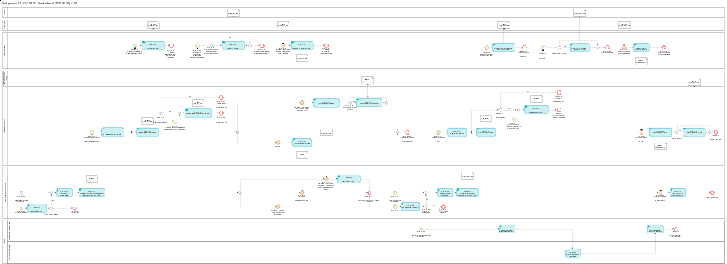
Figure 9: L4-ICS-03-01 Send referral sub-process

Tasks

T-03-01-01 – Request additional information from Person filing
Request additional information from Person filing | T-03-01-01
System component: TI
Input: Request for additional information from Person filing received
Description:
The request for additional information is sent to the Person filing via the message IE3Q02 [Msg: E_REF_RFI_REQ].
Output (Final situation):
The request for additional information is sent to the Person filing.

T-03-01-02 – Notify additional information request to Carrier
Notify additional information request to Carrier | T-03-01-02
System component: TI
Input: Request for additional information from Person filing received
Description:
The Carrier is notified via the message IE3N04 [Msg: E_REF_RFI_NOT] that the Person filing was requested to provide additional information.
Output (Final situation):
The Carrier is notified about the additional information request that was sent to the Person filing.

T-03-01-03 – Submit additional information response from Person filing
Submit additional information response received from Person filing | T-03-01-03
System component: TI
Input: Additional information from Person filing received
Description:
The response to the additional information request received from Person filing is sent to the CR via the message IE4R02 [Msg: C_REF_RFI_RSP].
In case no corresponding RfI request can be found, then an error notification is sent by the CR to the STI and then forwarded to the person filing.
Output (Final situation):
The additional information from Person filing is available in the CR.

T-03-01-04 – Request HRCM screening from Person filing
Request HRCM screening from Person filing | T-03-01-04
System component: TI
Input: Request for HRCM screening received
Description:
The request for HRCM screening is sent to the Person filing via the message IE3Q03 [Msg: E_REF_RFS_REQ].
Output (Final situation):
The request for HRCM screening is sent to the Person filing.

T-03-01-05 – Notify HRCM screening request to Carrier
Notify HRCM screening request to Carrier | T-03-01-05
System component: TI
Input: Request for HRCM screening received
Description:
The Carrier is notified via the message IE3N05 [Msg: E_REF_RFS_NOT] that the Person filing was requested to provide HRCM screening outcome.
Output (Final situation):
The Carrier is notified about the HRCM screening request that was sent to the Person filing.

T-03-01-06 – Submit HRCM screening outcome
Submit HRCM screening outcome | T-03-01-06
System component: TI
Input: HRCM screening outcome received
Description:
The outcome of the HRCM screening is sent to the CR via the message IE4R03 [Msg: C_REF_RFS_RSP].
In case no corresponding RfS request can be found, then an error notification is sent by the CR to the STI and then forwarded to the person filing.
Output (Final situation):
The HRCM screening outcome is available in the CR.

T-03-01-07 – Send additional information request to Person filing
Send additional information request to Person filing | T-03-01-07
System component: CR
Input: Successfully validated request for additional information
Description:
The successfully validated and transformed request for additional information is sent to the TI for the person filing via the message IE4Q04 [Msg: C_REF_RFI_REQ].
Output (Final situation):
The request for additional information is available at the TI.

T-03-01-08 – Communicate additional information response from Person filing
Communicate additional information response from Person filing | T-03-01-08
System component: CR
Input: Additional information from Person filing received
Description:
The response to the additional information request is sent to the NES (RMS) via the message IE4R02 [Msg: C_REF_RFI_RSP].
Output (Final situation):
The additional information from Person filing is available in the NES (RMS).

T-03-01-09 – Communicate ENS filing amendment notification
Communicate ENS filing amendment notification | T-03-01-09
System component: CR
Input: ENS filing amended
Description:
The notification that ENS filing was amended as requested by the RMS is sent to the NES (RMS) via the message IE4N06 [Msg: C_REF_AMD_NOT].
Output (Final situation):
The notification that the ENS filing was amended is available in the NES (RMS).

T-03-01-10 – Send HRCM screening request to Person filing
Send HRCM screening request to Person filing | T-03-01-10
System component: CR
Input: Successfully validated request for HRCM screening
Description:
The successfully validated and transformed request for HRCM screening is sent to the TI for the person filing via the message IE4Q05 [Msg: C_REF_RFS_REQ].
Output (Final situation):
The request for HRCM screening is available at the TI.

T-03-01-11 – Communicate HRCM screening outcome from Person filing
Communicate HRCM screening outcome from Person filing | T-03-01-11
System component: CR
Input: HRCM screening outcome received from TI
Description:
The outcome of the HRCM screening is sent to the NES (RMS) via the message IE4R03 [Msg: C_REF_RFS_RSP].
Output (Final situation):
The HRCM screening outcome is available in the NES (RMS).

T-03-01-12 - Record RfI for Person filing
Record RfI for Person filing | T-03-01-12
System component: NES (RMS)
Input: Request for Information decision was made
Description:
The risk analyst of the RMS defines the type of information that is to be requested from the Person filing.
The RfI may comprise any of the following requests:
- the request for additional information / documents to be sent by the Person filing, or
- the request to improve the data quality of specific data element(s) through amendment of an ENS filing.
The exact structure of an RfI is defined in the message IE4Q04 [Msg: C_REF_RFI_REQ], which will be generated later based on the input from the risk analyst acquired through this task and sent to the CR.
Output (Final situation):
An RfI has been recorded by the risk analyst of the RMS.

T-03-01-13 – Communicate request for additional information to Person filing
Communicate request for additional information to Person filing | T-03-01-13
System component: NES (RMS)
Input: Outcome of Task: T-03-01-12 - Record RfI for Person filing
Description:
The request for additional information is sent to the CR via the message IE4Q04 [Msg: C_REF_RFI_REQ].
Output (Final situation):
The request for additional information is available in the CR.

T-03-01-14 - Assess additional information from Person filing
Assess additional information from Person filing | T-03-01-14
System component: NES (RMS)
Input: Additional information received from the Person filing
Description:
The risk analyst performs additional assessment based on the information received from the Person filing.
In the case of air pre-loading risk analysis, the outcome of the assessment can be the necessity for a HRCM screening to be performed.
Output (Final situation):
Additional information is assessed and decision on further risk mitigation measures is taken.

T-03-01-15 - Request HRCM screening
Request HRCM screening | T-03-01-15
System component: NES (RMS)
Input: Decision to request HRCM screening (RfS) was made
Description:
In the case the risk analyst decided that HRCM screening is necessary, the request is recorded in the NES (RMS).
HRCM screening can be requested either
- after assessing an identified potential risk, or
- after additional information was requested from a Person filing or an IMS and the subsequent assessment lead to the need for an HRCM screening as an escalation measure, or
- while the RfI request is still in pending status the risk analyst decides to escalate the risk mitigation measure by requesting HRCM screening (this is in particular valid in the case when the Person filing does not provide necessary additional information or improve data quality via the amendment of the ENS filing, in a 'reasonable time-frame').
The HRCM screening request may include also information about the recommended method(s) of the HRCM screening to be performed on the basis of influencing factors, such as the nature of the goods, weight, number of packages, or any relevant combination of different PLACI data elements.
The exact structure of an HRCM screening request is defined in the message IE4Q05 [Msg: C_REF_RFS_REQ], which will be generated later based on the input from the risk analyst acquired through this task and sent to the CR.
Output (final situation):
The request for HRMC screening is recorded in the NES (RMS).

T-03-01-16 – Communicate HRCM screening request to Person filing
Communicate HRCM screening request to Person filing | T-03-01-16
System component: NES (RMS)
Input: Outcome of Task: T-03-01-15 - Request HRCM screening
Description:
The request is sent to the CR via the message IE4Q05 [Msg: C_REF_RFS_REQ].
Output (Final situation):
The request for HRCM screening is available in the CR.

T-03-01-17 - Assess HRCM screening outcome
Assess HRCM screening outcome | T-03-01-17
System component: NES (RMS)
Input: HRCM screening outcome
Description:
The risk analyst assesses the available outcome of the HRCM screening in order to decide on air pre-loading risk assessment.
Output (Final situation):
HRCM screening results have been assessed.

T-03-01-18 - Request additional information from IMS
Request additional information from IMS | T-03-01-18
System component: CRMS2
Input: Decision to request for further information from the Involved Member State(s)
Description:
In the case the risk analyst of the Responsible Member State decided that additional risk mitigation information is necessary to be obtained from a specific Involved Member State, the request is communicated to that Member State via CRMS2.
Output (Final situation):
Additional risk mitigation information request is communicated via CRMS2 to the specific Involved Member State.

T-03-01-19 - Provide additional information
Provide additional information | T-03-01-19
System component: CRMS2
Input: Received request for additional information
Description:
The risk analyst of the Involved Member State communicates the additional risk mitigation information to the Responsible Member State via CRMS2.
Output (Final situation):
Additional risk mitigation information as requested by the RMS is provided via CRMS2.

T-03-01-20 - Assess additional information from IMS
Assess additional information from IMS | T-03-01-20
System component: CRMS2
Input: Additional information received from the IMS
Description:
The risk analyst of the Responsible Member State assesses the additional information received from the IMS via CRMS2.
Output (Final situation):
Customs risk analyst assessed the received additional information.

T-03-01-27 – Validate and forward IE4Q04
Validate and forward IE4Q04 | T-03-01-27
System component: CR
Input: Request for additional information from Person filing received
Description:
The submission of IE4Q04 [Msg: C_REF_RFI_REQ] message to the CR will trigger the following actions:
- Based on the provided MRN and the “Risk analysis request reference” the CR identifies the ENS / ENS filing the submitted message relates to. Then the content of IE4Q04 is validated against the identified ENS / ENS filing.
- If IE4Q04 is valid then it is forwarded to the STI for the corresponding party / parties. The Carrier is notified in case it is different from the Person filing.
Output (Final situation):
Request for additional information validated and forwarded.

T-03-01-28 – Validate and forward IE4Q05
Validate and forward IE4Q05 | T-03-01-28
System component: CR
Input: Request for HRCM screening received
Description:
The submission of IE4Q05 [Msg: C_REF_RFS_REQ] message to the CR will trigger the following actions:
- Based on the provided MRN and the “Risk analysis request reference” the CR identifies the ENS / ENS filing the submitted message relates to. Then the content of IE4Q05 is validated against the identified ENS / ENS filing.
- If IE4Q05 is valid then it is forwarded to the STI for the corresponding party / parties. The Carrier is notified in case it is different from the Person filing.
Output (Final situation):
The request for HRCM screening validated and forwarded.

T-03-01-21 – Take a decision to request additional information
Take a decision to request additional information | T-03-01-21
System component: NES (RMS)
Input: RfI in e-Screening results
Description:
The provided by the NES (IMS) e-Screening results IE4S01 [Msg: C_ESC_ASM_RES] message contains “Referral request details/Request type = RFI”. NES (RMS) takes a decision if RfI is to be requested.
Output (Final situation):
Decision to request additional information

T-03-01-22 – Communicate the additional information response to the IMS(s)
Communicate the additional information response to the IMS(s) | T-03-01-22
System component: CR
Input: RfI Response
Description:
The provided by the EO RfI Response IE4R02 [Msg: C_REF_RFI_RSP] message is communicated to the IMS(s).
Output (Final situation):
RfI Response is communicated to IMS(s)

T-03-01-23 – Take a decision to request HRCM
Take a decision to request HRCM | T-03-01-23
System component: NES (RMS)
Input: RfS in e-Screening results
Description:
The provided by the NES (IMS) e-Screening results IE4S01 [Msg: C_ESC_ASM_RES] message contains “Referral request details/Request type = RFS”. NES (RMS) takes a decision if RfS is to be requested.
Output (Final situation):
Decision to request HRCM Screening

T-03-01-24 – Communicate the HRCM result to the IMS(s)
Communicate the HRCM result to the IMS(s) | T-03-01-24
System component: CR
Input: RfS Response
Description:
The provided by the EO RfS Response IE4R03 [Msg: C_REF_RFS_RSP] message is communicated to the IMS(s).
Output (Final situation):
RfI Response is communicated to IMS(s)

T-03-01-29 – Send additional information request notification to Carrier
Send additional information request notification to Carrier | T-03-01-29
System component: CR
Input: Successfully validated request for additional information
Description:
The successfully validated and transformed request for additional information is sent to the TI for the carrier notification via the message IE4N17 [Msg: C_REF_RFI_NOT].
Output (Final situation):
The request for additional information is available at the TI.

T-03-01-30 – Send HRCM screening request to Carrier
Send HRCM screening request notification to Carrier | T-03-01-30
System component: CR
Input: Successfully validated request for HRCM screening
Description:
The successfully validated and transformed request for HRCM screening is sent to the TI for the carrier notification via the message IE4N18 [Msg: C_REF_RFS_NOT].
Output (Final situation):
The request for HRCM screening for purposes of notification is available at the TI.

Events

E-03-01-01 – Request for additional information from Person filing received
Request for additional information from Person filing received | E-03-01-01
System component: TI
Description:
The TI received the request for additional information from Person filing via the message IE4Q04 [Msg: C_REF_RFI_REQ] from the CR.

E-03-01-02 – Additional information response from Person filing received
Additional information from Person filing received | E-03-01-02
System component: TI
Description:
The TI received the additional information from Person filing via the message IE4R02 [Msg: E_REF_RFI_RSP].

E-03-01-03 - Additional information response provided
Additional information response provided | E-03-01-03
System component: TI
Description:
Person filing has provided the requested additional information.

E-03-01-04 – Request for HRCM screening received
Request for HRCM screening received | E-03-01-04
System component: TI
Description:
The TI received the request for HRCM screening from the CR via the message IE4Q05 [Msg: C_REF_RFS_REQ].

E-03-01-05 – HRCM screening outcome received from Person filing
HRCM screening outcome received from Person filing | E-03-01-05
System component: TI
Description:
The TI received the outcome of the HRCM screening from Person filing via the message IE4R03 [Msg: E_REF_RFS_RSP].

E-03-01-06 - HRCM screening outcome provided
HRCM screening outcome provided | E-03-01-06
System component: TI
Person filing has provided the HRCM screening outcome.

E-03-01-07 – Request for additional information from Person filing received by CR
Request for additional information from Person filing received by CR | E-03-01-07
System component: CR
Description:
The CR received the request for additional information from Person filing via the message IE4Q04 [Msg: C_REF_RFI_REQ] from the NES (RMS).

E-03-01-08 – Additional information from Person filing received by CR
Additional information from Person filing received by CR | E-03-01-08
System component: CR
Description:
The CR received the additional information from Person filing via the message IE4R02 [Msg: C_REF_RFI_RSP] from TI.

E-07-08 – ENS filing amended
ENS filing amended | E-07-08
System component: CR
Description:
This event is triggered by the amendment of an ENS filing.
See Event: E-07-09 – ENS filing amended of Sub-process: L4-ICS2-07 – Amend filing.

E-03-01-09 - Additional information response or amendment received by CR
Additional information response or amendment received by CR | E-03-01-09
System component: CR
Description:
The CR has either received additional information or an amendment of the ENS filing.

E-03-01-10 – Request for HRCM screening received by CR
Request for HRCM screening received by CR | E-03-01-10
System component: CR
Description:
The CR received the request for HRCM screening from the NES (RMS) via the message IE4QQ05 [Msg: C_REF_RFS_REQ].

E-03-01-11 – HRCM screening outcome received by CR
HRCM screening outcome received by CR | E-03-01-11
System component: CR
Description:
The CR received the outcome of the HRCM screening from the TI via the message IE4R03 [Msg: C_REF_RFS_RSP].

E-03-01-12 - HRCM screening outcome received
HRCM screening outcome received | E-03-01-12
System component: CR
Description:
The CR received the requested HRCM screening outcome.

E-03-01-13 – Request for information decision was made
Request for information decision was made | E-03-01-13
System component: NES (RMS)
Description:
Risk analyst of the RMS has decided to request additional information from the Person filing.

E-03-01-14 – Additional information response from Person filing received by NES (RMS)
Additional information response from Person filing received by NES (RMS) | E-03-01-14
System component: NES (RMS)
Description:
The CR communicated the response to the request for additional information to the NES (RMS).

E-03-01-15 – ENS filing amendment notification received
ENS filing amendment notification received | E-03-01-15
System component: NES (RMS)
Description:
The CR communicated that the ENS filing which is subject to the request for additional information from Person filing (subtype 'request for amendment') was amended.

E-03-01-16 – Decision to request HRCM screening was made
Decision to request HRCM screening was made | E-03-01-16
System component: NES (RMS)
Description:
Risk analyst of the RMS has decided to request HRCM screening.

E-03-01-17 - Additional information or amendment received or escalated to HRCM screening
Additional information or amendment received or escalated to HRCM screening | E-03-01-17
System component: NES (RMS)
Description:
Additional information or amendment of the ENS filing was received from the Person filing. If no response was provided by the Person filing, the RfI was escalated to the HRCM screening.

E-03-01-18 – HRCM screening outcome received by NES (RMS)
HRCM screening outcome received by NES (RMS) | E-03-01-18
System component: NES (RMS)
Description:
The CR communicated the outcome of the HRCM screening to the NES (RMS).

E-03-01-19 - HRCM screening outcome assessed
HRCM screening outcome assessed | E-03-01-19
System component: NES (RMS)
Description:
HRCM screening outcome is received by the NES (RMS) and assessed by the risk analyst.

E-03-01-20 – Request for additional information from IMS decision was made
Request for additional information from IMS decision was made | E-03-01-20
System component: CRMS2
Description:
Risk analyst of the RMS has decided to request additional information from IMS.

E-03-01-21 - Additional information from IMS received
Additional information from IMS received | E-03-01-21
System component: CRMS2
Description:
Additional information from IMS is received.

E-03-01-22 – RfI recommended by IMS
RfI recommended by IMS | E-03-01-22
System component: NES (RMS)
Description:
RfI recommended by the NES (IMS) in the e-Screening results IE4S01 [Msg: C_ESC_ASM_RES] message

E-03-01-23 – No RfI to be requested
No RfI to be requested | E-03-01-23
System component: NES (RMS)
Description:
Decision is taken that no RfI is to be requested based on the recommended RfI in the e-Screening results IE4S01 [Msg: C_ESC_ASM_RES] message

E-03-01-24 – RfS Issued by IMS
RfS Issued by IMS | E-03-01-24
System component: NES (RMS)
Description:
RfS is issued by the NES (IMS) in the e-Screening results IE4S01 [Msg: C_ESC_ASM_RES] message

E-03-01-25 – No RfS to be requested
No RfS to be requested | E-03-01-25
System component: NES (RMS)
Description:
Decision is taken that no RfS is to be requested based on the issued RfS in the e-Screening results IE4S01 [Msg: C_ESC_ASM_RES] message

E-03-01-31 – Additional information from Person filing requested
Additional information from Person filing requested | E-03-01-31
System component: TI
Description:
Additional information from Person filing was requested.

E-03-01-32 – Request for additional information notification received
Request for additional information notification received | E-03-01-32
System component: TI
Description:
The TI received the request for additional information from Person filing that needs to be notified to Carrier via the message IE4Q04 [Msg: C_REF_RFI_REQ] from the CR.

E-03-01-33 – Request for additional information notified to Carrier
Request for additional information notified to Carrier | E-03-01-33
System component: TI
Description:
Additional information from Person filing request have been notified to Carrier if applicable.

E-03-01-34 - HRCM screening from Person filing requested
HRCM screening from Person filing requested | E-03-01-34
System component: TI
Request for HRCM screening has been send to Person filing

E-03-01-35 – HRCM screening request notification received
HRCM screening request notification received | E-03-01-35
System component: TI
Description:
The TI received the request for HRCM screening from the CR for the purpose of Carrier notification via the message IE4Q05 [Msg: C_REF_RFS_REQ].

E-03-01-36 – HRCM screening request notified
HRCM screening request notified | E-03-01-36
System component: TI
Request for HRCM screening has been notified to Carrier.

E-02-15 – Additional information request notification to Carrier to be sent
Additional information request notification to Carrier to be sent | E-02-15
System component: CR
Description:
Request for information for the related PLACI is identified and an Additional information request notification has to be sent to the Carrier.

E-03-01-37 – No additional information request notification sent
No additional information request notification sent | E-03-01-37
System component: CR
No additional information request notification has been sent.

E-03-01-38 – Additional information request notification sent
Additional information request notification sent | E-03-01-38
System component: CR
Additional information request notification has been sent.

E-02-17 – HRCM screening request notification to Carrier to be sent
HRCM screening request notification to Carrier to be sent | E-02-17
System component: CR
Description:
Request for screening for the related PLACI is identified and HRCM screening request notification to Carrier has to be sent.

E-03-01-39 – No HRCM screening request notification sent
No HRCM screening request notification sent | E-03-01-39
System component: CR
No HRCM screening request notification has been sent.

E-03-01-40 – HRCM screening request notification sent
HRCM screening request notification sent | E-03-01-40
System component: CR
HRCM screening request notification has been sent.

Gateways

G-03-01-01 – Carrier to be notified about additional information request?
Carrier to be notified about additional information request? | G-03-01-01
System component: TI
Input: Request for additional information from Person filing
Description:
The Carrier is to be notified when
- Carrier is connected to the TI;
- Carrier has requested to receive 'RfI request' notification messages IE3N04 [Msg: E_REF_RFI_NOT].

G-03-01-02 – Carrier to be notified about HRCM screening request?
Carrier to be notified about HRCM screening request? | G-03-01-02
System component: TI
Input: Request for HRCM screening from Person filing
Description:
The carrier is to be notified when
- Carrier is connected to the TI;
- Carrier has requested to receive 'RfS request' notification messages IE3N05 [Msg: E_REF_RFS_NOT].

G-03-01-04 – RfI to be requested?
RfI to be requested? | G-03-01-04
System component: NES (RMS)
Input: Decision to request RfI
Description:
In case a positive decision to request additional information is taken, the answer is 'Yes', otherwise it is 'No'.

G-03-01-05 – RfI Result to be sent to IMS(s)?
RfI Result to be sent to IMS(s)? | G-03-01-05
System component: CR
Input: RfI Response
Description:
In case the RfI is recommended by NES (IMS), the answer is 'Yes', otherwise it is 'No'. Based on the configurable “RfI Response to be sent to all IMS’s” the RfI Response is forwarded either only to the NES (IMS) that has recommended the RfI or to all IMS’s.

G-03-01-06 – RfS to be requested?
RfS to be requested? | G-03-01-06
System component: NES (RMS)
Input: Decision to request HRCM Screening
Description:
In case a positive decision to request HRCM Screening is taken, the answer is 'Yes', otherwise it is 'No'.

G-03-01-07 – RfS Result to be sent to IMS(s)?
RfS Result to be sent to IMS(s)? | G-03-01-07
System component: CR
Input: RfS Response
Description:
In case the RfS is recommended by NES (IMS), the answer is 'Yes', otherwise it is 'No'. Based on the configurable “RfS Response to be sent to all IMS’s” the RfS Response is forwarded either only to the NES (IMS) that has recommended the RfS or to all IMS’s.

G-03-01-09 – Carrier to be notified about additional information request?
Carrier to be notified about additional information request? | G-03-01-09
System component: CR
Input: Request for additional information from Person filing
Description:
The Carrier is to be notified when
- Carrier of this ENS is known;
- Carrier is different from the Person filing. The data elements Declarant [R02: IE4Q04 / Declarant] and Carrier [R02: IE4Q04 / Carrier] in the message IE4Q04 [Msg: C_REF_RFI_REQ] will be checked.

G-03-01-10 – Carrier to be notified about HRCM screening request?
Carrier to be notified about HRCM screening request? | G-03-01-10
System component: CR
Input: Request for HRCM screening from Person filing
Description:
The carrier is to be notified when
- Carrier of this ENS is known;
- Carrier is different from the Person filing. The data elements Declarant [R02: IE4Q05 / Declarant] and Carrier [R02: IE4Q05 / Carrier] in the message IE4Q05 [Msg: C_REF_RFS_REQ] will be checked.

L4-ICS2-04 – Process arrival of the means of transport
Process arrival of the means of transport | L4-ICS2-04
Organisation: National Customs Administration of the Member State of Actual First Entry
Input: Arrival notification
Description:
In case of air and maritime transport an arrival notification for the means of transport is to be lodged by the economic operator. The arrival notification identifies the Member State of Actual First Entry and triggers controls on goods which were identified being a risk requiring a control at the first point of entry in the EU (i.e. security and safety threat of such nature that immediate action is required upon arrival).
The arrival notification can be lodged either via TI or national arrival system.
Output (Final situation):
The arrival of the means of transport is recorded and the relevant ENSs which are subject to immediate control measures at the Customs Office of First Entry are identified.

Business Process Model
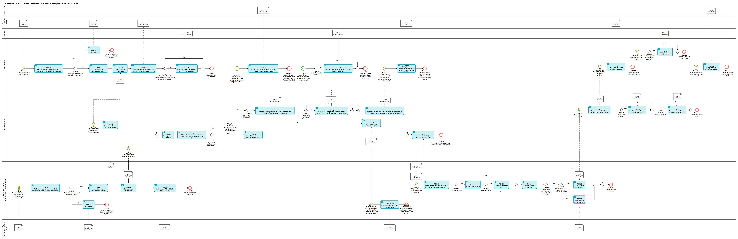
Figure 10: L4-ICS2-04 Process arrival of the means of transport sub-process

Tasks

T-04-01 - Perform syntactical and semantical validation on received arrival notification
Perform syntactical and semantical validation on received arrival notification | T-04-01
System component: TI
Input: Arrival notification
Description:
The arrival notification is validated in an automated process. It comprises the validation against the message rules and conditions, as well as the relevant reference data which are valid at the date of the reception.
The messages rules and conditions and relevant reference data are defined in [R02] ICS2 Information Exchange Messages.
Output (Final situation):
The validation will have the following possible outcomes:
- Successful;
- Unsuccessful, in which case
  - the error description will be generated
  - the input arrival notification will obtain the state 'Rejected'

T-04-02 – Notify error
Notify error | T-04-02
System component: TI
Input: Unsuccessful validation results
Description:
The file is not valid and is rejected. The person notifying the arrival is notified of the rejection and of the errors that caused the rejection via the message IE3N99 [Msg: E_ERR_NOT].
Output (Final situation):
The notification of error is generated and sent to the person notifying the arrival.

T-04-03 – Register arrival notification and assign MRN
Register arrival notification and assign MRN | T-04-03
System component: TI
Input: Valid arrival notification
Description:
The valid arrival notification is registered; an MRN is generated and allocated to the arrival notification.
The arrival notification obtains the state 'Registered'.
Output (Final situation):
The arrival notification was registered and MRN has been generated.

T-04-04 – Submit arrival notification
Submit arrival notification | T-04-04
System component: TI
Input: Registered arrival notification from Task: T-04-03 – Register arrival notification and assign MRN
Description:
The registered arrival notification is submitted to the CR via the message IE4N07 [Msg: C_ARV_NOT].
Output (Final situation):
The arrival notification is available in the CR.

T-04-05 – Notify successful registration and MRN to Person notifying the arrival
Notify successful registration and MRN to Person notifying the arrival | T-04-05
System component: TI
Input: Registered arrival notification from Task: T-04-03 – Register arrival notification and assign MRN
Description:
The registration and assigned MRN of the arrival notification is notified to the Person notifying the arrival via the message IE3R04 [Msg: E_ARV_REG_RSP].
Output (Final situation):
The Person notifying the arrival is notified of the successful registration of the arrival notification and the MRN assigned to it.

T-04-06 – Notify House consignments in incorrect state to Person notifying the arrival
Notify House consignments in incorrect state to Person notifying the arrival | T-04-06
System component: TI
Input: Incorrect state notification received from CR
Description:
The message IE3N07 [Msg: E_HCS_INC_NOT] is sent to the person notifying the arrival informing him that ENS is in incorrect state and its House consignments cannot obtain the state 'Arrived'.
Output (Final situation):
Person notifying the arrival is notified that ENS in incorrect state and its House consignments did not obtain the state 'Arrived'.

T-04-07 – Notify control to Person notifying the arrival
Notify control to Person notifying the arrival | T-04-07
System component: TI
Input: Control notification received from CR
Description:
Control notification for the identified items is sent to the Person notifying the arrival via the message IE3N08 [Msg: E_CON_NOT].
The Person notifying the arrival will be forced to unload the selected goods in order to make them available to customs for controls, regardless of whether the presentation of those goods was originally foreseen at this place or not.
Output (Final situation):
The control decision for items which require a control upon entry is notified to Person notifying the arrival.

T-04-08 – Identify relevant ENS(s)
Identify relevant ENS(s) | T-04-08
System component: CR
Input: Received arrival notification
Description:
ENS data related to the given journey of the means of transport for which the arrival has been notified is to be retrieved in an automated process.
Matching of the ENS with the arrival notification per mode of transport will be done as follows:
- Maritime:
  - the IMO-number or ENI-number [R02: IE3N06 / Active means of transport / Identity] in the arrival notification will need to be matched against the IMO-number or the ENI-number of a master level ENS filing linked to a stored ENS and at the same time
  - the Frozen estimated date and time of arrival [R02: IE3N06 / Active means of transport / Frozen estimated date and time of arrival] in the arrival notification will need to be matched against the frozen estimated date and time of arrival of a master level ENS filing linked to a stored ENS.
- Air:
  - the flight number [R02: IE3N06 / Active means of transport / Conveyance reference number] and the estimated date and time of arrival [R02: IE3N06 / Active means of transport / Estimated date and time of arrival] in the arrival notification will need to be matched against the flight number and the estimated date and time of arrival of a master level ENS filing linked to a stored ENS, respectively, or alternatively
  - each MAWB [R02: IE3N06 / Related transport document] and the estimated date and time of arrival [R02: IE3N06 / Active means of transport / Estimated date and time of arrival] contained in an arrival notification will need to be matched against the MAWB and the estimated date and time of arrival of a master level ENS filing linked to a stored ENS.
- Alternatively, (applicable to both modes of transport):
  - each MRN [R02: IE3N06 / Related MRN] contained in an arrival notification will need to be matched against the MRN of an ENS filing linked to a stored ENS.

Output (Final situation):
The ENS(s) for which the arrival is notified are identified by the CR.

T-04-09 – Check House consignments state correctness and update their state
Check House consignments state correctness and update their state | T-04-09
System component: CR
Input: Identified relevant ENS(s)
Description:
It is checked whether the related ENS is in a correct state.
The house consignments of the related ENS will obtain the state 'Arrived' after this task is executed. If the ENS is not in a correct state, the state of its house consignments will not be updated.
Output (Final situation):
In case of a correct state the relevant house consignments obtain the state 'Arrived'. Else the current state of the house consignments remains.

T-04-10 – Stop 200 day timer for relevant ENS filing(s)
Stop 200 day timer for relevant ENS filing(s) | T-04-10
System component: CR
Input: Arrival notification
Description:
The 200 day timer of the underlying ENS filing(s) of the identified ENS(s) will be stopped.
Output (Final situation):
The 200 day timer was stopped for the relevant ENS filing(s).

T-04-11 – Communicate ENS(s) and control recommendations
Communicate ENS(s) and control recommendations | T-04-11
System component: CR
Input: Outcome of Task: T-04-08 – Identify relevant ENS(s)
Description:
Each retrieved ENS as well as related risk analysis results and control recommendations are communicated to the NES (MS of Actual First Entry) via the message IE4N05 [Msg: C_CON_RCM_NOT] regardless of whether the ENS was in correct state or not.
In case the Arrival notification was lodged via the Trader interface, a list of all ENSs that were covered by this Arrival notification will be communicated to the NES (MS of Actual First Entry) via message IE4N14 [Msg: C_HCS_ NOT].
Output (Final situation):
The retrieved ENS(s), risk analysis results and control recommendations are available in the NES (MS of Actual First Entry) for follow-up action.

T-04-13 – Send incorrect state notification to NES
Send incorrect state notification to NES | T-04-13
System component: CR
Input: Outcome of Task: T-04-09 – Check House consignments state correctness and update their state
Description:
The message IE4N08 [Msg: C_HCS_INC_NOT] is sent to the NES (MS of Actual First Entry) in order to trigger the notification to the Person notifying the arrival via the NAS.
Output (Final situation):
NES (MS of Actual First Entry) receives notification about the ENS(s) which are in incorrect state.

T-04-14 – Send house consignment in incorrect state notification to Trader Interface for Person notifying the arrival
Send house consignment in incorrect state notification to Trader Interface for Person notifying the arrival | T-04-14
System component: CR
Input: Outcome of Task: T-04-09 – Check House consignments state correctness and update their state
Description:
The message IE4N08 [Msg: C_HCS_INC_NOT] is sent to the TI in order to trigger the notification to the Person notifying the arrival.
Output (Final situation):
TI receives notification about the ENS(s) with the related house consignments which are in incorrect state.

T-04-15 – Send control notification to Person notifying the arrival
Send control notification | T-04-15
System component: CR
Input: Control decision IE4N09 [Msg: C_CON_NOT] received from NES (MS of Actual First Entry)
Description:
The message IE4N09 [Msg: C_CON_NOT] is sent to the TI in order to notify control to the Person notifying the arrival.
Output (Final situation):
The control notification is available at the TI.

T-04-16 – Notify successful registration and MRN to NAS
Notify successful registration and MRN to NAS | T-04-16
System component: NES (MS of Actual First Entry)
Input: Registered arrival notification
Description:
The registration and assigned MRN of the arrival notification is notified to the NAS via the message IE3R04 [Msg: E_ARV_REG_RSP].
Output (Final situation):
The NAS is notified of the successful registration of the arrival notification and the MRN assigned to it.

T-04-17 – Notify House consignments in incorrect state to NAS
Notify House consignments in incorrect state to NAS | T-04-17
System component: NES (MS of Actual First Entry)
Input: Incorrect state notification received from CR
Description:
The message IE3N07 [Msg: E_HCS_INC_NOT] is sent to the NAS informing it that HC is in incorrect state.
Output (Final situation):
The NAS is notified that ENS is in incorrect state.

T-04-18 – Check for previous involvement in the full risk analysis process per ENS
Check for previous involvement in the full risk analysis process per ENS | T-04-18
System component: NES (MS of Actual First Entry)
Input: ENS(s) and control recommendations received from CR
Description:
It is checked whether the MS of Actual First Entry was already involved in the risk analysis process either as RMS or IMS.
Output (Final situation):
It is known whether the MS of Actual First Entry was already involved in the risk analysis process.

T-04-19 – Perform e-Screening
Perform e-Screening | T-04-19
System component: NES (MS of Actual First Entry)
Input: ENS which was not risk analysed or screened by this Member State
Description:
Received ENS is electronically screened against CRC category 2 and any potential additional national security and safety related risk profiles not falling in the scope of the CRC category 2.
Output (Final situation):
e-Screening can result in a hit or no hit.

T-04-20 - Assess e-Screening hit
Assess e-Screening hit | T-04-20
System component: NES (MS of Actual First Entry)
Input: e-Screening hit
Description:
Result of the e-Screening (i.e. match/hit of CRC category 2 / potential relevant national profiles and information applicable either for air cargo specific risks, or those applicable for customs security and safety risks) is presented to the risk analyst.
Customs risk analyst completes the e-Screening process through manual review and risk mitigation of the presented electronic result.
The e-Screening assessment result is either 'true positive' or 'false positive'.
Output (Final situation):
e-Screening result can be 'true positive' or 'false positive'.

T-04-21 – Record control decision
Record control decision | T-04-21
System component: NES (MS of Actual First Entry)
Input: Received control recommendation from RMS and, where applicable, the assessed outcome of own e-Screening hit
Description:
The Member State of Actual First Entry records the decision on whether to control the goods taking into account the recommendation received from RMS and, where applicable, the assessed outcome of own e-Screening hit.
Possible outcomes:
- Decide to control goods upon arrival even if the previously identified risk was considered lower than the one requiring an immediate action at COFE in the case its own e-Screening assessment resulted (outcome of Task: T-04-20 - Assess e-Screening hit) in an identified security and safety threat of such nature that an immediate intervention is required at arrival
- Decide to control the goods as per recommendations for control received from RMS
- Decide not to control the goods disregarding the control recommendations received from RMS.
Output (Final situation):
Control decision is recorded.

T-04-22 – Submit control decision to CR
Submit control decision to CR | T-04-22
System component: NES (MS of Actual First Entry)
Input: Outcome of Task: T-04-21 – Record control decision
Description:
The control decision is submitted to the CR via the message IE4N09 [Msg: C_CON_NOT].
Output (Final situation):
Control decision is submitted to the CR.

T-04-23 – Notify control decision to NAS
Notify control decision to NAS | T-04-23
System component: NES (MS of Actual First Entry)
Input: Outcome of Task: T-04-21 – Record control decision
Description:
The issued control decision is submitted to the NAS via the message IE3N08 [Msg: E_CON_NOT].
Output (Final situation):
Control decision is submitted to the NAS.

T-04-26 – Notify successful registration and MRN to notify party
Notify successful registration and MRN to notify party | T-04-26
System component: TI
Input: Outcome of Task: T-04-05 – Notify successful registration and MRN to Person notifying the arrival
Description:
The registration and assigned MRN of the arrival notification is notified to each of the indicated notify parties via the message IE3R04. IE3R04 contains only the Notify party to which it is sent. [Msg: E_ARV_REG_RSP].
Output (Final situation):
The notify party is notified of the successful registration of the arrival notification and the MRN assigned to it.

T-04-27 – Notify control to notify party
Notify control to notify party | T-04-27
System component: TI
Input: Control notification received from CR
Description:
Control notification for the identified items is sent to each of the indicated notify parties via the message IE3N08. IE3N08 contains only the Notify party to which it is sent. [Msg: E_CON_NOT].
The notify party will be forced to organise to unload and present the selected goods in order to make them available to customs for controls, regardless of whether the presentation of those goods was originally foreseen at this place or not.
Output (Final situation):
The control decision for items which require a control upon entry is notified to notify party.

T-04-28 – Forward the arrival notification to NES
Forward the arrival notification to NES | T-04-28
System component: CR
Input: E-04-08
Description:
The CR generates and sends the arrival notification data received from TI to the NES of the MS of actual first entry [Msg: C_ARV_NOT].
Output (Final situation):
The arrival notification is forwarded to the NES of the MS of actual first entry.

T-04-29 – Notify House consignments in incorrect state to Person filing the ENS
Notify House consignments in incorrect state to Person filing the ENS | T-04-29
System component: TI
Input: Incorrect state notification received from CR
Description:
The message IE3N07 [Msg: E_HCS_INC_NOT] is sent to the Person filing the ENS notifying that ENS contains House consignments in incorrect state.
Output (Final situation):
Person filing the ENS is notified that the ENS contains House consignments in incorrect state.

T-04-31 – Send house consignment in incorrect state notification to Trader Interface for Person filing ENS
Send incorrect state notification to TI | T-04-31
System component: CR
Input: Outcome of Task: T-04-09 – Check House consignments state correctness and update their state
Description:
The message IE4N08 [Msg: C_HCS_INC_NOT] is sent to the TI in order to trigger the notification to the Person filing the ENS.
Output (Final situation):
TI receives notification about the ENS(s) which are in incorrect state.

T-04-32 – Send house consignment in incorrect state notification to Trader Interface for Notify party
Send incorrect state notification to TI | T-04-32
System component: CR
Input: Outcome of Task: T-04-09 – Check House consignments state correctness and update their state
Description:
The message IE4N08 [Msg: C_HCS_INC_NOT] is sent to the TI in order to trigger the notification to the Notify party.
Output (Final situation):
TI receives notification about the ENS(s) which are in incorrect state.

T-04-33 – Notify House consignments in incorrect state to Notify Party
Notify House consignments in incorrect state to Notify Party | T-04-33
System component: TI
Input: Incorrect state notification received from CR
Description:
The message IE3N07 [Msg: E_HCS_INC_NOT] is sent to the Notify Party notifying that ENS contains House consignments in incorrect state.
Output (Final situation):
Notify Party is notified that the ENS contains House consignments in incorrect state.

T-04-34 – Send control notification to Notify party
Send control notification to Notify party | T-04-34
System component: CR
Input: Control decision IE4N09 [Msg: C_CON_NOT] received from NES (MS of Actual First Entry)
Description:
The message IE4N09 [Msg: C_CON_NOT] is sent to the TI in order to notify control to the Notify Party
Output (Final situation):
The control notification for Notify party is available at the TI.

T-04-35 – Send control notification to Person filling the ENS
Send control notification to Person filling the ENS | T-04-35
System component: CR
Input: Control decision IE4N09 [Msg: C_CON_NOT] received from NES (MS of Actual First Entry)
Description:
The message IE4N09 [Msg: C_CON_NOT] is sent to the TI in order to notify control to the Person filing the ENS.
Output (Final situation):
The control notification for Person filing the ENS is available at the TI.

T-04-36 – Notify control to Person filing the ENS
Notify control to Person notifying the arrival | T-04-36
System component: TI
Input: Control notification received from CR
Description:
Control notification for the identified items is sent to the Person filing the ENS via the message IE3N08 [Msg: E_CON_NOT].
Output (Final situation):
The control decision for items which require control upon entry is notified to Person filing the ENS.

Events

E-04-01 – Arrival notification of the means of transport received
Arrival notification of the means of transport received | E-04-01
System component: TI
Description:
Arrival notification of the means of transport is received by the TI.

E-04-02 – Arrival notification of the means of transport rejected
Arrival notification of the means of transport rejected | E-04-02
System component: TI
Description:
Arrival notification is rejected.

E-04-03 - Arrival notification submitted
Arrival notification submitted | E-04-03
System component: TI
Description:
Arrival notification was submitted to the TI.

E-04-04 – Incorrect House consignments state notification for Person notifying the arrival received
Incorrect House consignments state notification for Person notifying the arrival received | E-04-04
System component: TI
Description:
Notification for Person notifying the arrival is received that House consignment(s) part of an ENS (related to the arrival notification) is in incorrect state.

E-04-05 – Incorrect house consignment state notification sent to Person notifying the arrival
Incorrect house consignment state notification sent to Person notifying the arrival | E-04-05
System component: TI
Description:
The Person notifying the arrival was informed that an ENS part of the Arrival notification contains House consignment(s) in incorrect state.

E-04-06 – Control notification for Person notifying the arrival received
Control notification for Person notifying the arrival received | E-04-06
System component: TI
Description:
The TI has received a control notification for Person notifying the arrival from the CR.

E-04-07 – Control notified to Person notifying arrival
Control notified to Person notifying arrival | E-04-07
System component: TI
Description:
The control was notified to the person notifying the arrival.

E-04-08 – Arrival notification received from TI
Arrival notification received from TI | E-04-08
System component: CR
Description:
Arrival notification is received by the CR.

E-04-09 – Arrival notification received from NES (MS of Actual First Entry)
Arrival notification received from NES (MS of Actual First Entry) | E-04-09
System component: CR
Description:
Arrival notification is received by the CR.

E-04-11 - ENS(s) communicated and control recommendations sent
Control results stored | E-04-11
System component: CR
Description:
The CR has stored the control results

E-04-12 – Control decision received
Control decision received | E-04-12
System component: CR
Description:
The CR has received a control decision from the NES (MS of Actual First Entry).

E-04-13 – Control notification sent
Control notification sent | E-04-13
System component: CR
Description:
The CR has sent a control notification to the TI.

E-04-14 – Arrival notification of the means of transport received from NAS
Arrival notification of the means of transport received from NAS | E-04-14
System component: NES (MS of Actual First Entry)
Description:
Arrival notification of the means of transport is received by the NES (MS of Actual First Entry).

E-04-15 – ENSs and control recommendations received
ENSs and control recommendations received | E-04-15
System component: NES (MS of Actual First Entry)
Description:
The ENSs including control recommendations were received from the CR.

E-04-16 – Control decision recorded
Control decision recorded | E-04-16
System component: NES (MS of Actual First Entry)
Description:
The control decision and results are recorded.

E-04-17 – Incorrect House consignments state notification for Person filing ENS received
Incorrect House consignments state notification for Person filing ENS received | E-04-17
System component: TI
Description:
Notification for Person filing ENS was received that House consignment(s) part of an ENS (related to the arrival notification) is in incorrect state.

E-04-18 – Incorrect House consignments state notification sent to Person filing ENS
Incorrect House consignments state notification sent to Person Filing ENS | E-04-18
System component: TI
Description:
Notification for Person filing ENS that House consignment(s) part of an ENS (related to the arrival notification) is in incorrect state sent.

E-04-19 – Incorrect House consignments state notification for Notify Party received
Incorrect House consignments state notification for Notify Party received | E-04-19
System component: TI
Description:
Notification for Notify Party was received that House consignment(s) part of an ENS (related to the arrival notification) is in incorrect state.

E-04-20 – Incorrect House consignments state notification sent to Notify party
Incorrect House consignments state notification sent to Notify Party | E-04-20
System component: TI
Description:
Notification for Notify Party that House consignment(s) part of an ENS (related to the arrival notification) is in incorrect state sent.

E-04-21 – Control notification received for Notify Party
Control notification received for Notify Party | E-04-21
System component: TI
Description:
The TI has received a control notification for Notify Party from the CR.

E-04-22 – Control notified to Notify Party
Control notified to Notify Party | E-04-22
System component: TI
Description:
The control was notified to the Notify Party.

E-04-23 – Control notification for Person filling the ENS received
Control notification for Person filling the ENS received | E-04-23
System component: TI
Description:
The TI has received a control notification for Person filling the ENS from the CR.

E-04-24 – Control notified to Person filling the ENS
Control notified to Person filling the ENS | E-04-24
System component: TI
Description:
The control was notified to Person filling the ENS.

Gateways

G-04-01 - Syntactical & semantical validation successful?
Syntactical & semantical validation successful? | G-04-01
System component: TI or NES
Input: Outcome of Task: T-04-01 - Perform syntactical and semantical validation on received arrival notification
Description:
In case the validation was successful, the answer is 'Yes', otherwise it is 'No'.

G-04-02 – Are House consignments in correct state?
Are House consignments in correct state? | G-04-02
System component: CR
Input: Outcome of Task: T-04-09 – Check House consignments state correctness and update their state
Description:
In case the House consignments are in correct state, the answer is 'Yes', otherwise it is 'No'.

G-04-03 - Arrival notification received from TI?
Arrival notification received from TI? | G-04-03
System component: CR
Input: Origin of the arrival notification
Description:
In case the sub-process was initiated through the Event: E-04-01 – Arrival notification of the means of transport received, the answer is 'Yes', otherwise it is 'No'.

G-04-04 - Was MS involved?
Was MS involved? | G-04-04
System component: NES
Input: Outcome of Task: T-04-18 – Check for previous involvement in the full risk analysis process per ENS
Description:
This gateway will distinguish between the ENS which was risk analysed or screened by this Member State and the ENS that this Member State has not previously risk analysed or screened.

G-04-05 - e-Screening hit?
e-Screening hit? | G-04-05
System component: NES
Input: Outcome of Task: T-04-19 – Perform e-Screening
Description:
In case there was an e-Screening hit, the answer is 'Yes', otherwise it is 'No'.

G-04-06 - Goods to be controlled at first port or airport of arrival?
Goods to be controlled at first port or airport of arrival? | G-04-06
System component: NES
Input: Outcome of Task: T-04-21 – Record control decision
Description:
In case it was decided that goods will be controlled at first port or airport of arrival, the answer is 'Yes', otherwise it is 'No'.

G-04-07 – Notify party to be notified about the registration of the arrival notification and MRN?
Notify party to be notified about the registration of the arrival notification and MRN? | G-04-07
System component: TI
Input: Outcome of Task: T-04-21 – Record control decision successful registration and MRN to person filing
Description:
Where a notify party is declared, different from the person filing and connected to the TI, the answer is ‘YES’, else ‘NO’.

G-04-08 – Notify party to be notified about controls?
Notify party to be notified about controls? | G-04-08
System component: TI
Input: Outcome of Task: T-04-21 – Record control decision control to person filing
Description:
Where a notify party is declared, different from the person filing and connected to the TI, the answer is ‘YES’, else ‘NO’.

G-04-13 – Mode of transport is Maritime?
Mode of transport is Maritime? | G-04-13
System component: CR
Input: Outcome of Task: T-04-09 – Check House consignments state correctness and update their state
Description:
If the mode of transport is maritime the answer is ‘YES’, else ‘NO’.

G-04-14 – Notify party available?
Notify party available? | G-04-14
System component: CR
Input: Outcome of Task: T-04-09 – Check House consignments state correctness and update their state
Description:
If the Arrival notification contains one or more Notify party and it is different from the Person filing the ENS the answer is ‘YES’, else ‘NO’.

G-04-15 – Notify party available?
Notify party available? | G-04-15
System component: CR
Input: Outcome of Task: T-04-22 – Submit control decision to CR
Description:
If the Arrival notification contains one or more Notify party and it is different from the Person filing the ENS the answer is ‘YES’, else ‘NO’.

G-04-16 – Mode of transport is Maritime?
Mode of transport is Maritime? | G-04-16
System component: CR
Input: Outcome of Task: T-04-22 – Submit control decision to CR
Description:
If the mode of transport is maritime the answer is ‘YES’, else ‘NO’.

G-04-17 – Notify party to be notified?
Notify party to be notified? | G-04-17
System component: TI
Input: Incorrect House consignment state notification from CR
Description:
The Notify Party is to be notified when
- Notify party is connected to the TI.

L4-ICS2-05 – Process presentation of goods
Process presentation of goods | L4-ICS2-05
Organisation: National Customs Administration of Member State of Presentation/Control (at final destination)
Input: Presentation information was received or entered by the user
Description:
The submission of presentation information in the NES and the CR will trigger
- the update of state for all relevant house consignments, and
- the submission by the CR of ENS(s) and control recommendations that were not previously sent to this Member State (diversion).
Output (Final situation):
Goods were presented.

Business Process Model
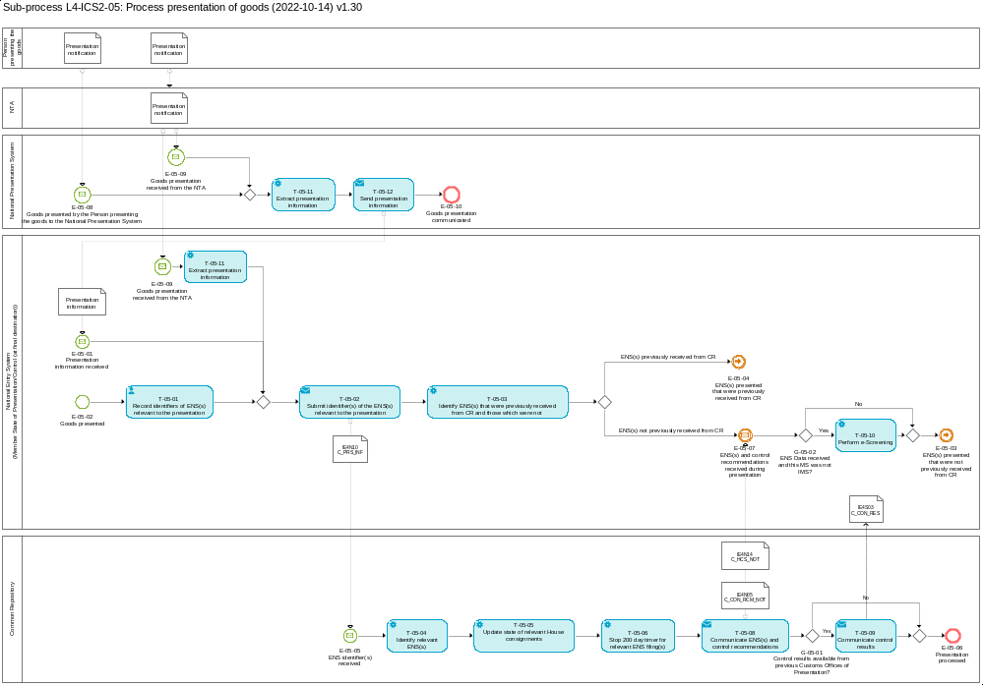
Figure 11: L4-ICS2-05 Process presentation of goods sub-process

Tasks

T-05-01 – Record identifiers of ENS(s) relevant to the presentation
Record identifiers of ENS(s) relevant to the presentation | T-05-01
System component: NES (MS of Presentation/Control (at final destination))
Input: ENS(s) relevant to the presentation
Description:
The identifiers (MRN or transport contract number) of the ENS(s) relevant to the presentation of goods are recorded in the NES.
The possible identifiers are specified in the message IE4N10 [Msg: C_PRS_INF].
Output (Final situation):
The identifier(s) of the ENS(s) related to the presentation of goods are recorded in the national entry system.

T-05-02 – Submit identifier(s) of the ENS(s) relevant to the presentation
Submit identifier(s) of the ENS(s) relevant to the presentation | T-05-02
System component: NES (MS of Presentation/Control (at final destination))
Input: Identifier(s) of the ENS(s) relevant to the presentation
Description:
The identifier(s) of the ENS(s) relevant to the presentation are sent to the CR via the message IE4N10 [Msg: C_PRS_INF].
Output (Final situation):
The identifier(s) of the ENS(s) related to the presentation of goods are available in the CR.

T-05-03 – Identify ENS(s) that were previously received from CR and those which were not
Identify ENS(s) that were previously received from CR and those which were not | T-05-03
System component: NES (MS of Presentation/Control (at final destination))
Input: Identifier(s) of the ENS(s) and ENS(s) previously received from CR
Description:
The identifiers of ENS(s) received/recorded at the presentation are used to identify the ENS(s) previously received from the CR and ENS(s) which were not received yet. ENS(s) that are received can be immediately processed as per sub-process L4-ICS2-06 – Process control decision and results. The ENS(s) which are not yet available will be sent by the CR.
Output (Final situation):
The ENS(s) that were previously received from CR and ENS(s) which were not received yet are identified.

T-05-04 – Identify relevant ENS(s)
Identify relevant ENS(s) | T-05-04
System component: CR
Input: Identifier(s) of the ENS(s) relevant to the presentation
Description:
The CR identifies the ENS(s) based on the received identifier(s).
In order for an ENS to be identified, the MRN or the Transport Contract Document number that was previously used in the Task: T-05-02 – Submit identifier(s) of the ENS(s) relevant to the presentation will need to be matched against the corresponding data element(s) of a stored ENS.
Output (Final situation):
The related ENSs to the presentation of goods are identified.

T-05-05 – Update state of relevant House consignments
Update state of ENS(s) and underlying Consignments (House level) | T-05-05
System component: CR
Input: ENS identifier(s) received
Description:
The CR updates the state of the relevant presented House consignments to 'Presented'.
Output (Final situation):
The state of the House consignments in the CR is updated to 'Presented'.

T-05-06 – Stop 200 day timer for relevant ENS filing(s)
Stop 200 day timer for relevant ENS filing(s) | T-05-06
System component: CR
Input: Outcome of Task: T-05-03 – Identify ENS(s) that were previously received from CR and those which were not
Description:
The 200 day timer of the underlying ENS filing(s) of the identified ENS(s) will be stopped.
Output (Final situation):
The 200 day timer was stopped for the relevant ENS filing(s).

T-05-08 – Communicate ENS(s) and control recommendations
Communicate ENS(s) and control recommendations | T-05-08
System component: CR

Input: Outcome of Tasks: T-05-04 – Identify relevant ENS(s) and T-05-05 – Update state of relevant house consignments.
Description:
Each retrieved ENS as well as related risk analysis results and control recommendations are communicated to the NES (MS of Presentation/Control) via the message IE4N05 [Msg: C_CON_RCM_NOT]. Furthermore, the state change of the house consignments to ‘presented’ is notified via the message IE4N14 [Msg: C_HCS_NOT].
Output (Final situation):
The retrieved ENS(s) and control recommendations are available in the NES (MS of Presentation/Control (at final destination)) for follow-up action.

T-05-09 – Communicate control results
Communicate control results | T-05-09
System component: CR
Input: Outcome of Tasks: T-05-04 – Identify relevant ENS(s) and T-05-05 – Update state of relevant house consignments and Gateway G-05-01 – Control results available from previous customs offices of presentation?
Description:
Available control results are communicated to the NES (MS of presentation) via message IE4S03 [Msg: C_CON_RES].
Output (Final situation):
The available control results are communicated to the MS of presentation.

T-05-10 – Perform e-Screening
Perform e-Screening | T-05-10
System component: NES (MS of Presentation/Control (at final destination))
Input: Outcome of Tasks: T-05-08 – Communicate ENS(s) and control recommendations and T-05-03 – Identify ENS(s) that were previously received from CR and those which were not – for cases when ENS(s) not received previously from the CR.
Description:
In case MS of presentation receives ENS(s) for the first time when the goods are presented it is recommended an e-Screening to be performed.
Output (Final situation):
e-Screening can result in a hit or no hit. The result is not to be sent to the CR.

T-05-11 – Extract presentation information
Extract presentation information | T-05-11
System component: NES (MS of Presentation/Control (at final destination))/National presentation system
Input: Outcome of Events: E-05-08 – Goods presented by the Person presenting the goods to the National Presentation System or E-05-09 – Goods presentation received from the NTA.
Description:
In case a Presentation notification is received either directly from the Person presenting the goods or from the National Transit Application, then the content for the corresponding Presentation information is extracted and prepared for sending to the ICS2 Common repository.
Output (Final situation):
The presentation information is extracted.

T-05-12 – Send presentation information
Send presentation information | T-05-12
System component: NES (MS of Presentation/Control (at final destination))
Input: Outcome of Task: T-05-11 – Extract presentation information
Description:
The National Presentation system sends a Presentation information to the National Entry system.
Output (Final situation):
The Presentation information is sent from the National Presentation system to the National Entry system.

Events

E-05-01 – Presentation information received
Presentation information received | E-05-01
System component: NES (MS of Presentation/Control (at final destination))
Description:
Electronically submitted structured presentation information with ENS identifier(s) was received.

E-05-02 – Goods presented
Goods presented | E-05-02
System component: NES (MS of Presentation/Control (at final destination))
Description:
Goods are presented at the place where controls were recommended to be carried out and temporary storage declaration was lodged and accepted (i.e. either goods presented or unloaded at the COFE, goods unloaded at the subsequent office of entry, or goods unloaded at the place subsequent to the first place of unloading).
Goods are presented by providing documents to customs, orally or by any other act.

E-05-03 - ENS(s) presented that were not previously received from CR
ENS(s) presented that were not previously received from CR | E-05-03
System component: NES (MS of Presentation/Control (at final destination))
Description:
ENS(s) were presented that were not previously received from CR. This event happens when the goods that were diverted to a new MS of Presentation/Control (at final destination) are presented.

E-05-04 - ENS(s) presented that were previously received from CR
ENS(s) presented that were previously received from CR | E-05-04
System component: NES (MS of Presentation/Control (at final destination))
Description:
ENS(s) presented that were previously received from CR.

E-05-05 – ENS identifier(s) received
ENS identifier(s) received | E-05-05
System component: CR
Description:
The identifier(s) of the relevant ENS(s), and if applicable the identifiers of specific Consignments (House level), are received by the CR.

E-05-06 – Presentation processed
Presentation processed | E-05-06
System component: NES (MS of Presentation/Control (at final destination))
Description:
Presentation was processed.

E-05-07 – ENS(s) and control recommendations received during presentation
ENS(s) and control recommendations received during presentation | E-05-07
System component: NES (MS of Presentation/Control (at final destination))
Description:
The ENSs including control recommendations were received from the CR.

E-05-08 – Goods presented by the Person presenting the goods to the National Presentation System
Goods presented by the Person presenting the goods to the National Presentation System | E-05-08
System component: National Presentation System
Description:
A Presentation notification received in the National Presentation System from the Person presenting the goods.

E-05-09 – Goods presentation received from the NTA
Goods presentation received from the NTA | E-05-09
System component: National Presentation System / NES (MS of Presentation/Control (at final destination))
Description:
A Presentation notification received from the National Transit Application.

E-05-10 – Goods presentation communicated
Goods presentation communicated | E-05-10
System component: National Presentation System
Description:
A Presentation information is sent from the National Presentation System to the National Entry System.

Gateways

G-05-01 – Control results available from previous customs offices of presentation?
Control results available from previous customs offices of presentation? | G-05-01
System component: CR
Input: Outcome of Task: Identify relevant ENS(s).
Description:
In case control results for the relevant ENSs already exist, the answer is 'Yes', otherwise it is 'No'.

G-05-02 – ENS Data received and this MS was not IMS?
ENS Data received and this MS was not IMS? | G-05-02
System component: NES (MS of Presentation/Control (at final destination))
Input: Outcome of Task: T-05-08 – Communicate ENS(s) and control recommendations
Description:
In case ENS data is received for the first time and MS of presentation was not IMS, the answer is 'Yes', otherwise it is 'No'.

L4-ICS2-06 – Process control decision and results
Process control decision and results | L4-ICS2-06
Organisation: National Customs Administration of Member State of Presentation/Control (at final destination)
Input: Received Control recommendations and presentation of goods
Description:
This sub-process covers two cases when the Member State of Presentation/Control (at final destination) will receive an ENS and any control recommendations relevant to it.
- Risk analysis is complete and control recommendations were set for a specific ENS by the RMS. The ENS and the control recommendations are then sent to the Member State of Presentation/Control (at final destination).
- Goods are presented after diversion at this Member State. In this case the CR will send the ENS(s) and any relevant control recommendations to the Member State of Presentation/Control (at final destination).
After having received a control recommendation for an ENS, the Member State of Presentation/Control (at final destination) will decide whether to control the goods. If goods are controlled, control results are submitted to the CR.
This sub-process contains a lower level sub-process L4-ICS2-06-01 – Handle AEO notification for the cases where the Person filing and the Carrier (where applicable) that hold an AEOS authorisation can be informed about the control in advance if that does not jeopardise the outcome of the control.
Output (Final situation):
Decision on control was made by the MS of Presentation/Control (at final destination), relevant controls were performed and their results were submitted to the CR.

Business Process Model
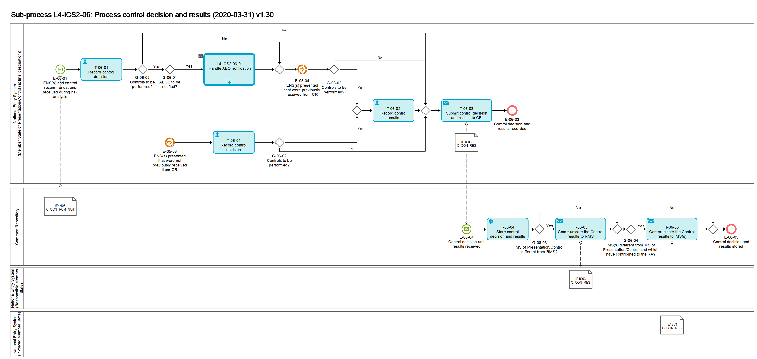
Figure 12: L4-ICS2-06 Process control decision and results sub-process

Tasks

T-06-01 – Record control decision
Record control decision | T-06-01
System component: NES (MS of Presentation/Control (at final destination))
Input: Presented ENS(s) and control recommendations
Description:
The Member State of Presentation and/or Control records the decision on whether
- to control the goods taking into account the recommendation received from RMS via CR
- To notify the Person filing that holds an AEOS authorisation about control in advance
The AEOS authorisation of the Person filing is verified via the Economic Operator System (EOS).
Possible outcomes:
- Decision to control goods, including the type of control
  - Decision to notify the Person filing that holds AEOS authorisation
  - Decision not to notify the Person filing that holds AEOS authorisation
- Decision not to control goods, including the reason
The outcome of this task will be contained in the message IE4S03 [Msg: C_CON_RES] that will be submitted to the CR later in the process.
Output (Final situation):
Control decision is recorded.

T-06-02 – Record control results
Record control results | T-06-02
System component: NES (MS of Presentation/Control (at final destination))
Input: Results of control
Description:
The customs officer records the results of the performed control in the NES.
If the decision in Task: T-06-01 – Record control decision was not to control the goods, the control result can be set automatically.
Output (Final situation):
Control results are recorded.

T-06-03 – Submit control decision and results to CR
Submit control decision and results to CR | T-06-03
System component: NES (MS of Presentation/Control (at final destination))
Input: Outcome of Tasks:T-06-01 – Record control decision and T-06-02 – Record control results
Description:
The recorded control decision and results are submitted to the CR via the message IE4S03 [Msg: C_CON_RES].
Output (Final situation):
Control results are submitted to the CR.

T-06-04 – Store control decision and results
Store control decision and results | T-06-04
System component: CR
Input: Submitted control decision and results by NES (MS of Presentation/Control (at final destination))
Description:
The received control decision and results are stored in the CR.
Output (Final situation):
Control results are stored and available in the CR.

T-06-05 – Communicate the Control results to RMS
Communicate the Control results to RMS | T-06-05
System component: CR
Input: T-06-03 – Submit control decision and results to CR
Description:
If MS of Presentation/Control is different from RMS, control results are communicated to NES (RMS) via the message IE4S03 [Msg: C_CON_RES].
Output (Final situation):
Control results are submitted to the NES (RMS).

T-06-06 – Communicate the Control results to IMS(s)
Communicate the Control results to IMS(s) | T-06-06
System component: CR
Input: T-06-03 – Submit control decision and results to CR
Description:
If IMS(s) have contributed to the RA and is different from MS of Presentation/Control, control results are communicated to NES (IMS) via the message IE4S03 [Msg: C_CON_RES].
Output (Final situation):
Control results are submitted to the NES (IMS).

Events

E-06-01 – ENS(s) and control recommendations received during risk analysis
ENS(s) and control recommendations received during risk analysis | E-06-01
System component: NES (MS of Presentation/Control (at final destination))
Description:
The ENS(s) including control recommendations were received from the CR. This event happens right after the sub-process L4-ICS2-03 – Perform risk analysis is completed.

E-05-04 - ENS(s) presented that were previously received from CR
ENS(s) presented that were previously received from CR | E-05-04
System component: NES (MS of Presentation/Control (at final destination))
Description:
ENS(s) presented that were previously received from CR. This event links the sub-process L4-ICS2-05 – Process presentation of goods with the current one.

E-05-03 - ENS(s) presented that were not previously received from CR
ENS(s) presented that were not previously received from CR | E-05-03
System component: NES (MS of Presentation/Control (at final destination))
Description:
ENS(s) were presented that were not previously received from CR. This event happens when the goods that were diverted to a new MS of Presentation/Control (at final destination) are presented. This event links the sub-process L4-ICS2-05 – Process presentation of goods with the current one.

E-06-03 – Control decision and results recorded
Control decision and results recorded | E-06-03
System component: NES (MS of Presentation/Control (at final destination))
Description:
The control decision and results were recorded.

E-06-04 – Control results received
Control decision and results received | E-06-04
System component: CR
Description:
The control decision and results from NES (MS of Presentation/Control (at final destination)) were received by the CR.

E-06-05 – Control decision and results stored
Control decision and results stored | E-06-05
System component: CR
Description:
The received control decision and results were stored in the CR.

Gateways

G-06-01 – AEOS to be notified?
AEOS to be notified? | G-06-01
System component: NES (MS of Presentation/Control (at final destination))
Input: Outcome of Task: T-06-01 – Record control decision
Description:
In case it was decided that the AEOS is to be notified, the answer is 'Yes', otherwise it is 'No'.

G-06-02 – Controls to be performed?
Controls to be performed? | G-06-02
System component: NES (MS of Presentation/Control (at final destination))
Input: Outcome of Task: T-06-01 – Record control decision
Description:
In case it was decided on performing a control, the answer is 'Yes', otherwise it is 'No'.

G-06-03 – MS of Presentation/Control different from RMS?
MS of Presentation/Control different from RMS? | G-06-03
System component: CR
Input: Outcome of Task: T-06-04 – Store control decision and results
Description:
In case MS of Presentation/Control different from RMS, the answer is 'Yes', otherwise it is 'No'.

G-06-04 – IMS(s) different from MS of Presentation/Control and which have contributed to the RA?
IMS(s) different from MS of Presentation/Control and which have contributed to the RA? | G-06-04
System component: CR
Input: Outcome of Task: T-06-05 – Communicate the Control results to RMS
Description:
In case IMS(s) different from MS of Presentation/Control and which have contributed to the RA, the answer is 'Yes', otherwise it is 'No'.

L4-ICS2-06-01 – Handle AEO notification
Handle AEO notification | L4-ICS2-06-01
Organisation: National Customs Administration of Member State of Presentation/Control (at final destination)
Input: Decision to inform the holders of an AEOS authorisation about control in advance
Description:
The MS of Presentation/Control (at final destination) makes a decision whether the Person filing and the Carrier (where applicable) that hold an AEOS authorisation will receive an advance control notification.
Output (Final situation):
Person filing and Carrier (where applicable) that hold an AEOS authorisation will receive an advance control notification.

Business Process Model
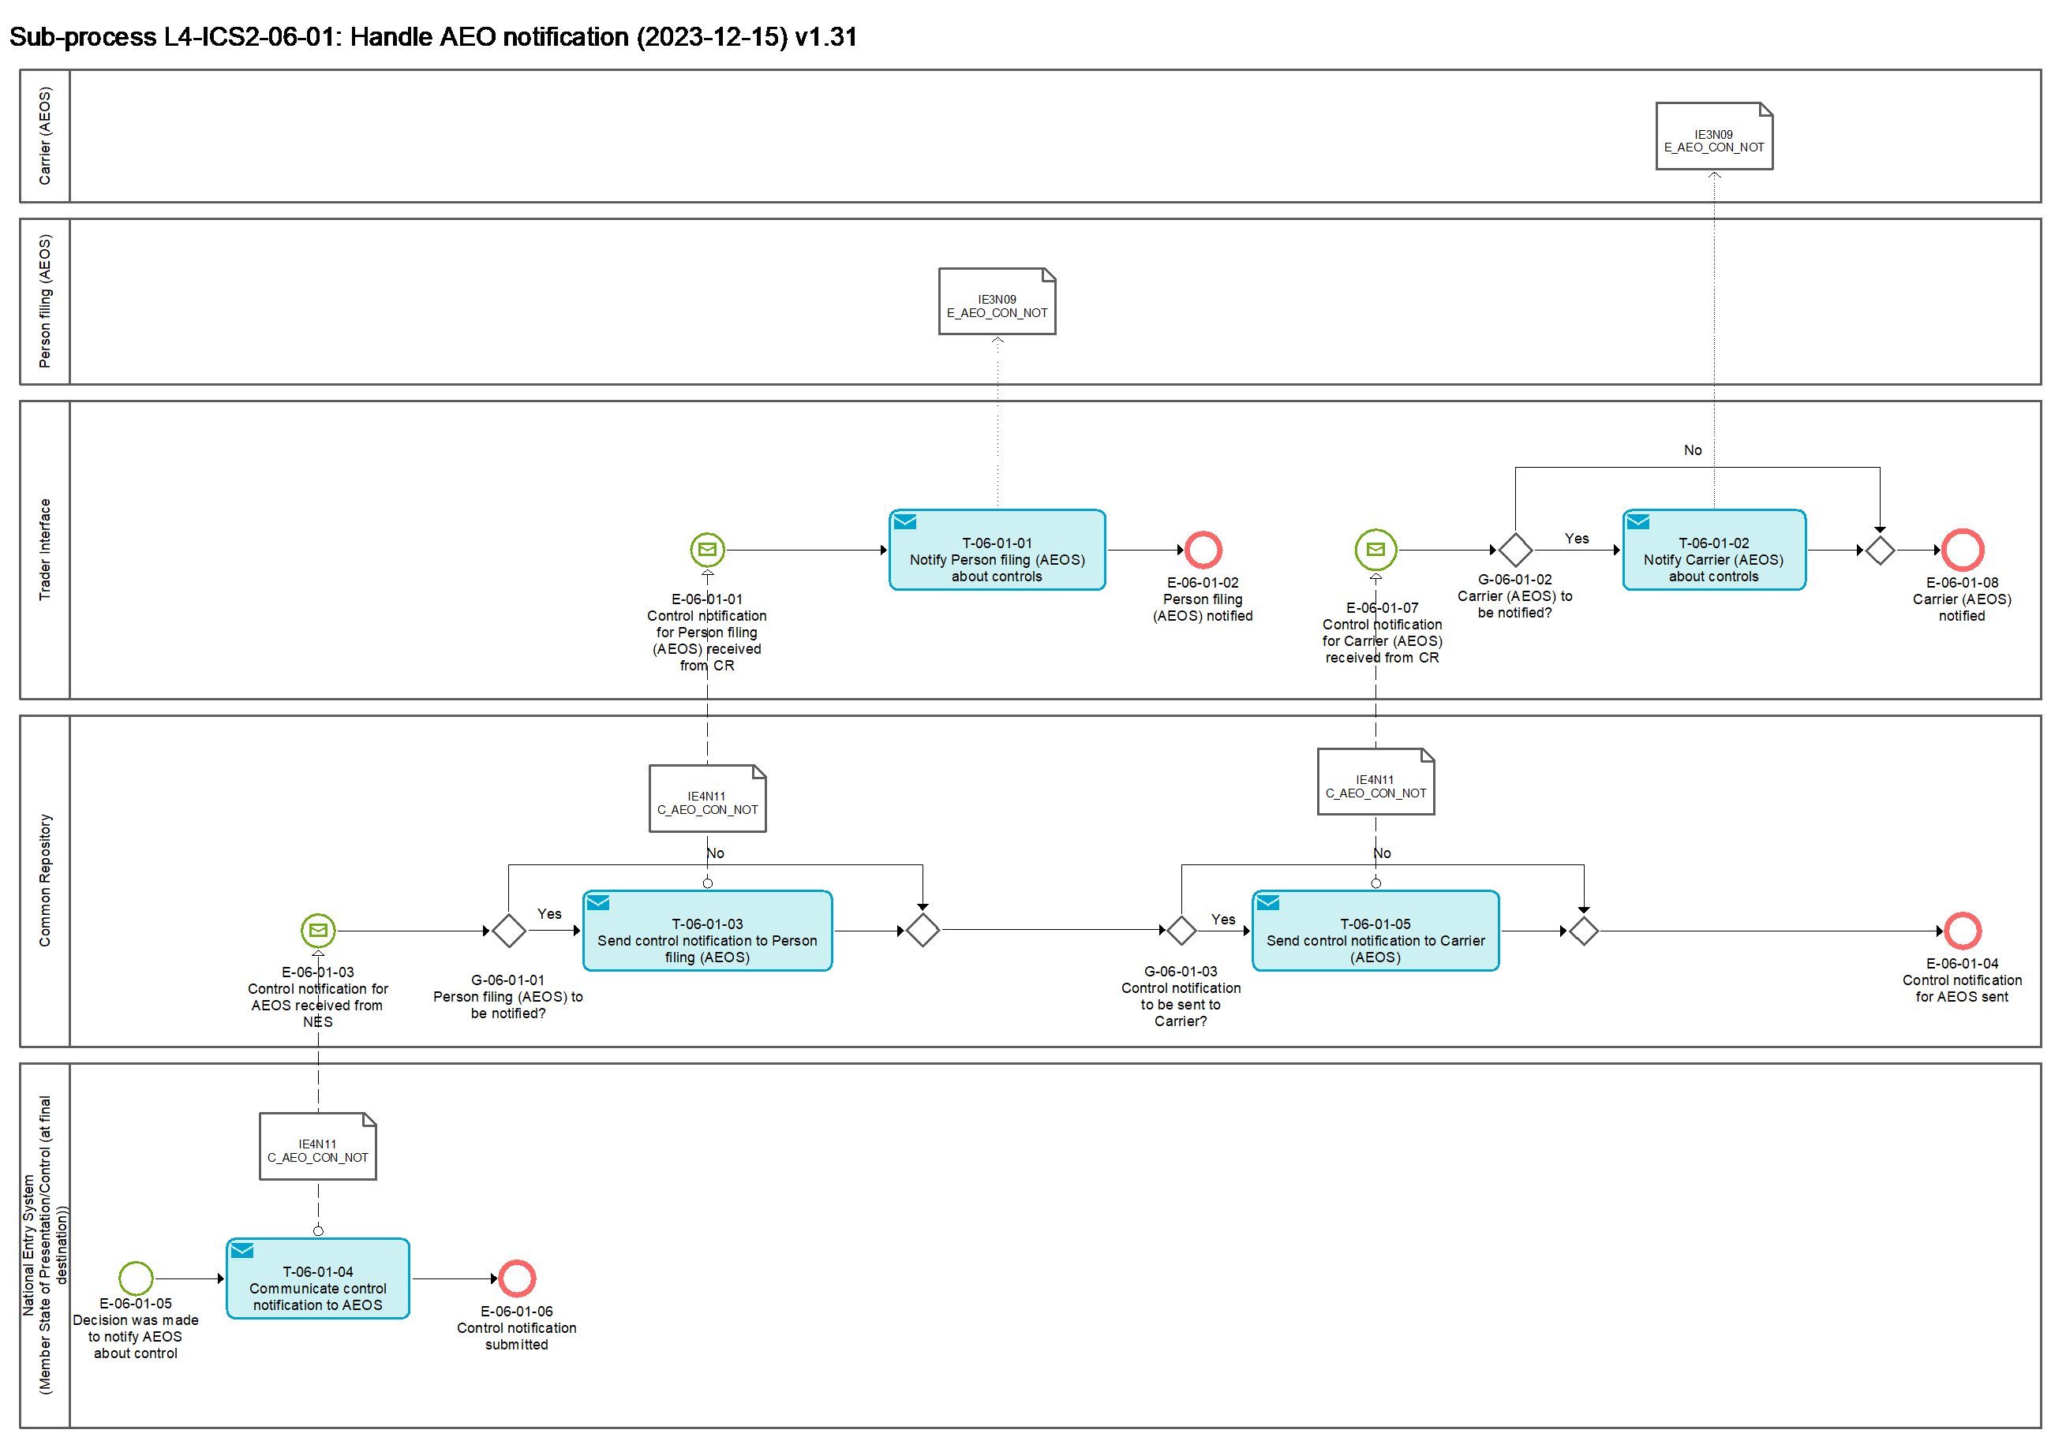
Figure 13: L4-ICS2-06-01 Handle AEO notification sub-process

Tasks

T-06-01-01 – Notify Person filing (AEOS) about controls
Notify Person filing (AEOS) about controls | T-06-01-01
System component: TI
Input: Control notification for AEOS received from CR
Description:
The Person filing (AEOS) is informed about the intended control in advance via the message IE3N09 [Msg: E_AEO_CON_NOT].
Output (Final situation):
The control was notified to the Person filing (AEOS).

T-06-01-02 – Notify Carrier (AEOS) about controls
Notify Carrier (AEOS) about controls | T-06-01-02
System component: TI
Input: Control notification for AEOS received from CR
Description:
The carrier (AEOS) is informed about the intended control in advance via the message IE3N09 [Msg: E_AEO_CON_NOT].
Output (Final situation):
The control was notified to the carrier (AEOS).

T-06-01-03 – Send control notification to Person filing (AEOS)
Send control notification to Person filing (AEOS) | T-06-01-03
System component: CR
Input: Control notification received from NES (MS of Presentation and/or Control (at final destination))
Description:
The notification to the Person filing (AEOS) about the intended control is sent to the TI via the message IE4N11 [Msg: C_AEO_CON_NOT].
Output (Final situation):
The notification to the Person filing (AEOS) is available at the TI.

T-06-01-04 – Communicate control notification to AEOS
Communicate control notification to AEOS | T-06-01-04
System component: NES (MS of Presentation and/or Control (at final destination))
Input: Decision was made to notify the AEOS about control
Description:
The notification to the Person filing (AEOS) about the intended control is communicated to the CR via the message IE4N11 [Msg: C_AEO_CON_NOT].
Output (Final situation):
The notification to the Person filing (AEOS) is available in the CR.

T-06-01-05 – Send control notification to Carrier (AEOS)
Send control notification to Carrier (AEOS) | T-06-01-05
System component: CR
Input: Control notification received from NES (MS of Presentation and/or Control (at final destination))
Description:
The notification to the Carrier (AEOS) about the intended control is sent to the TI via the message IE4N11 [Msg: C_AEO_CON_NOT].
Output (Final situation):
The notification to the Carrier (AEOS) is available at the TI.

Events

E-06-01-01 – Control notification for Person filing AEOS received from CR
Control notification for Person filing (AEOS) received from CR | E-06-01-01
System component: TI
Description:
TI has received the control notification for Person filing (AEOS) in form of the message IE4N11 [Msg: C_AEO_CON_NOT] from the CR.

E-06-01-02 – Person filing (AEOS) notified
Person filing (AEOS) notified | E-06-01-02
System component: NES (Member State of Presentation/Control (at final destination))
Description:
Person filing (AEOS) was notified about controls in advance.

E-06-01-03 – Control notification for AEOS received from NES
Control notification for AEOS received from NES | E-06-01-03
System component: CR
Description:
CR has received the control notification for AEOS in form of the message IE4N11 [Msg: C_AEO_CON_NOT].

E-06-01-04 – Control notification for AEOS sent
Control notification for AEOS sent | E-06-01-04
System component: CR
Description:
CR has sent the control notification for AEOS in form of the message IE4N11 [Msg: C_AEO_CON_NOT] to the TI.

E-06-01-05 - Decision was made to notify AEOS about control
Decision was made to notify AEOS about control | E-06-01-05
System component: NES (Member State of Presentation/Control (at final destination))
Description:
Decision was made to notify AEOS about control in advance.

E-06-01-06 - Control notification submitted
Control notification submitted | E-06-01-06
System component: NES (Member State of Presentation/Control (at final destination))
Description:
The control notification was submitted to the CR.

E-06-01-07 – Control notification for Carrier (AEOS) received from CR
Control notification for Carrier (AEOS) received from CR | E-06-01-07
System component: TI
Description:
TI has received the control notification for Carrier (AEOS) in form of the message IE4N11 [Msg: C_AEO_CON_NOT] from the CR.

E-06-01-08 – Carrier (AEOS) notified
Carrier (AEOS) notified | E-06-01-08
System component: TI
Description:
Carrier (AEOS) was notified about controls in advance.

Gateways

G-06-01-01 – Person filing (AEOS) to be notified?
Person filing (AEOS) to be notified? | G-06-01-01
System component: CR
Input: Control notification for AEOS received from NES
Description:
The Person filing is to be notified about the control when
- The Person filing holds the AEOS authorisation.

G-06-01-02 – Carrier (AEOS) to be notified?
Carrier (AEOS) to be notified? | G-06-01-02
System component: TI
Input: Control notification for AEOS received from CR
Description:
The Carrier is to be notified when
- Carrier is connected to the TI.

G-06-01-03 – Control notification to be sent to Carrier?
Control notification to be sent to Carrier? | G-06-01-03
System component: CR
Input: Control notification for AEOS received from CR
Description:
The Carrier is to be notified when
- Carrier holds the AEOS authorisation;
- Carrier is different from the Person filing.

L4-ICS2-07 – Amend filing
Amend filing | L4-ICS2-07
Organisation: National Customs Administration of Responsible Member State
Input: Amendment of ENS filing
Description:
An original ENS filing can be amended by an amendment filing which refers to the original filing by its MRN. The amendment of an ENS has to be filed by the declarant or the representative that filed the original ENS filing.
Output (Final situation):
The ENS filing is amended and processed again with the amended data depending on the lifecycle of the original ENS.

Business Process Model
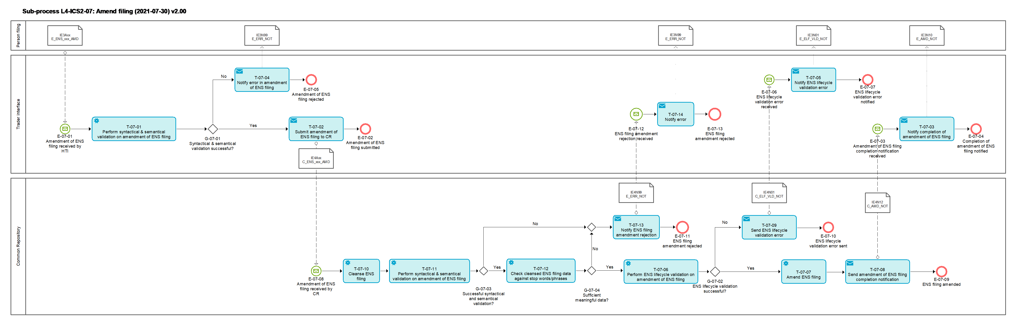
Figure 14: L4-ICS2-07 Amend filing sub-process

Tasks

T-07-01 – Perform syntactical & semantical validation on amendment of ENS filing
Perform syntactical & semantical validation on amendment of ENS filing | T-07-01
System component: TI
Input: Amendment of ENS filing received
Description:
The received amendment is validated in an automated process. It comprises the validation against the message rules and conditions, as well as the relevant reference data which is valid at the date of the reception.
The messages rules and conditions and relevant reference data are defined in [R02] ICS2 Information Exchange Messages.
In case the ENS filing contains characters which are not Cyrillic, Latin or Greek, the ENS filing is rejected with “102” “Not allowed Unicode character” with pointer(s) to the elements resulting in the rejection.
Output (Final situation):
The validation will have the following possible outcomes:
- Successful;
- Unsuccessful, in which case
  - the error description will be generated

T-07-02 – Submit amendment of ENS filing to CR
Submit amendment of ENS filing to the CR | T-07-02
System component: TI
Input: Positively validated amendment of ENS filing
Description:
The amendment of ENS filing is submitted to the CR via the message IE4AXX [Msg: C_ENS_xxx_AMD].
Output (Final situation):
The amendment of ENS filing was submitted to the CR.

T-07-03 - Notify completion of amendment of ENS filing
Notify completion of amendment of ENS filing | T-07-03
System component: TI
Input: Amendment of ENS filing completion notification received
Description:
The message IE3N10 [Msg: E_AMD_NOT] is generated and sent to the Person filing the amendment. It informs about successful amendment of the ENS filing.
Output (Final situation):
The Person filing is notified that the amendment of ENS filing was processed successfully.

T-07-04 – Notify error in amendment of ENS filing
Notify error in amendment of ENS filing | T-07-04
System component: TI
Input: Notification of error in amendment of ENS filing received
Description:
The information about a validation error is sent to the Person filing the amendment via the message IE3N99 [Msg: E_ERR_NOT].
Output (Final situation):
The Person filing the amendment is informed about unsuccessful ENS lifecycle validation of the amendment of ENS filing.

T-07-05 – Notify ENS lifecycle validation error
Notify ENS lifecycle validation error | T-07-05
System component: TI
Input: ENS lifecycle validation error received
Description:
The information about unsuccessful ENS lifecycle validation is sent to the Person filing the amendment via the message IE3N01 [Msg: E_ELF_VLD_NOT].
Output (Final situation):
The Person filing the amendment is informed about unsuccessful ENS lifecycle validation of the amendment of ENS filing.

T-07-06 – Perform ENS-lifecycle validation on amendment of ENS filing
Perform ENS lifecycle validation on amendment of ENS filing | T-07-06
System component: CR
Input: Amendment of ENS filing received
Description
The ENS lifecycle validation for the amendment of an ENS filing comprises the following checks:
- The ENS filing with the same MRN as the MRN [R02: IE4Axx / MRN] contained in the received message IE4Axx [Msg: C_ENS_xxx_AMD] exists.
- The original ENS filing and the corresponding ENS are in an appropriate state.
- That no data elements were amended which are not allowed to be amended.
- The person filing the amendment needs to be the declarant [R02: IE4Fxx / Declarant] or the representative [R02: IE4Fxx / Representative] that filed the original ENS filing IE4Fxx [Msg: C_ENS_xxx_DEC].
- If the ENS lifecycle validation is successful, the original ENS filing is amended.
If the ENS lifecycle validation fails, the original ENS filing remains as is.
Output (Final situation): The original ENS filing will either be amended or it will not be affected at all.

T-07-07 – Amend ENS filing
Amend ENS filing | T-07-07
System component: CR
Input: Accepted amendment
Description:
The original ENS filing is amended.
Output (Final situation):
The original ENS filing is amended.

T-07-08 - Send amendment of ENS filing completion notification
Send amendment of ENS filing completion notification | T-07-08
System component: CR
Input: Amended ENS filing
Description:
The message IE4N12 [Msg: C_AMD_NOT] is generated and sent to the TI. This informs about successful amendment of the ENS filing by the CR.
Output (Final situation):
The TI is notified that the amendment of ENS filing was processed successfully by the CR.

T-07-09 – Send ENS lifecycle validation error
Send ENS lifecycle validation error | T-07-09
System component: CR
Input: Outcome of Task: T-07-06 – Perform ENS-lifecycle validation on amendment of ENS filing
Description:
The information about unsuccessful ENS lifecycle validation is sent to the TI, via the message IE4N01 [Msg: C_ELF_VLD_NOT].
Output (Final situation):
The TI is informed about unsuccessful ENS lifecycle validation of the amendment of ENS filing.

T-07-10 – Cleanse ENS filing
Cleanse ENS filing | T-07-10
System component: CR
Input: Stored ENS filing amendment
Description:
The stored ENS filing amendment is cleansed as per the configured cleansing rules per data element and the hard-coded cleansing rules, if activated. For the purpose of enrichment the non-cleansed ENS filing is stored and used for the enrichment later in the process.
Output (Final situation):
Stored cleansed ENS filing amendment.

T-07-11 – Perform syntactical & semantical validation on amendment of ENS filing
Perform syntactical & semantical validation on amendment of ENS filing | T-07-11
System component: CR
Input: Stored cleansed ENS filing amendment
Description:
The cleansed ENS filing amendment is validated in an automated process. It comprises the validation against the message rules and conditions and the minimum meaningful length of each data element, where specified.
The messages rules and conditions are defined in [R02] ICS2 Information Exchange Messages.
Output (Final situation):
The validation will have the following possible outcomes:
- Successful;
- Unsuccessful, in which case
  - the error description will be generated
  - the ENS filing will obtain the state 'Rejected'

T-07-12 – Check cleansed ENS filing data against stop words/phrases
Check cleansed ENS filing data against stop words/phrases | T-07-12
System component: CR
Input: Stored cleansed ENS filing amendment
Description:
The successfully validated cleansed ENS filing amendment is checked against the configured stop words/phrases. After the removal of the stop words/phrases in case the data elements of the ENS filing are less than the pre-defined minimum meaningful length, then the particular data elements are considered empty and the data provided is considered of non-sufficient quality. The stop words/phrases are not removed from the data elements.
For the “Goods description” the configured whitelisted words/phrases are checked first. In case a whitelisted word/phrase is identified, then the particular “Goods description” is considered valid and no stop words/phrases are checked for this “Goods description”.
Output (Final situation):
The task will have the following possible outcomes:
- Sufficient meaningful data;
- Non-sufficient meaningful data.

T-07-13 – Notify ENS filing amendment rejection
Notify ENS filing amendment rejection | T-07-13
System component: CR
Input: Outcome of task: T-07-11 – Perform syntactical & semantical validation on amendment of ENS filing or T-07-12 – Check cleansed ENS filing data against stop words/phrases
Description:
The unsuccessful validation of the cleansed ENS filing amendment results in the rejection of the ENS filing amendment. The non-sufficient meaningful data after the checking of the cleansed ENS filing amendment against the stop words/phrases results in the rejection of the ENS filing.
Output (Final situation):
ENS filing rejection notified.

T-07-14 – Notify error
Notify error | T-07-14
System component: TI
Input: ENS filing amendment rejection received
Description:
The Person filing is notified about the fact that the ENS filing amendment was rejected due to low quality data and about the errors that caused its rejection via the message IE3N99 [Msg: E_ERR_NOT].
Output (Final situation):
The notification of error is generated and sent to the Person filing.

Events

E-07-01 – Amendment of ENS filing received by TI
Amendment of filing received | E-07-01
System component: TI
Description:
An amendment of an original ENS filing is received by the TI.

E-07-02 - Amendment of ENS filing submitted
Amendment of ENS filing submitted | E-07-02
System component: TI
Description:
An amendment of an original ENS filing is submitted to the CR.

E-07-03 – Amendment of ENS filing completion notification received
Amendment of ENS filing completion notification received | E-07-03
System component: TI
Description:
TI received information that the original ENS filing was amended by the CR.

E-07-04 – Completion of amendment of ENS filing notified
Completion of amendment of ENS filing notified | E-07-04
System component: TI
Description:
The completion of amendment of ENS filing was notified to the Person filing.

E-07-05 – Amendment of ENS filing rejected
Amendment of ENS filing rejected | E-07-05
System component: TI
Description:
The amendment of ENS filing is rejected.

E-07-06 – ENS lifecycle validation error received
ENS lifecycle validation error received | E-07-06
System component: TI
Description:
TI received information that the ENS lifecycle validation of the amendment of ENS filing in the CR was not successful.

E-07-07 – ENS lifecycle validation error notified
ENS lifecycle validation error notified | E-07-07
System component: TI
Description:
TI notifies the Person filing an amendment of an ENS filing that the ENS lifecycle validation of the amendment of ENS filing in the CR was not successful.

E-07-08 – Amendment of ENS filing received by CR
Amendment of filing received | E-07-08
System component: CR
Description:
An amendment of an original ENS filing is received by the CR.

E-07-09 – ENS filing amended
ENS filing amended | E-07-09
System component: CR
Description:
The original ENS filing was amended in the CR.
This end event will trigger the following sub-processes:
- L4-ICS2-02 - Prepare ENS for risk analysis
- L4-ICS2-03-01 – Send referral, only for the amended ENS filing that meets the following condition:
  - the reference ID to an active RfI request [R02: IE3Axx / Referral request reference] is contained in the amendment message IE3Axx [Msg: E_ENS_xxx_AMD].

E-07-10 – ENS lifecycle validation error sent
ENS lifecycle validation error sent | E-07-10
System component: CR
Description:
An ENS lifecycle validation error was sent to TI.

E-07-11 – ENS filing amendment rejected
ENS filing amendment rejected | E-07-11
System component: CR
Description:
The ENS filing amendment was rejected due to low quality data.

E-07-12 – ENS filing amendment rejection received
ENS filing amendment rejection received | E-07-12
System component: TI
Description:
The ENS filing amendment was rejected due to low quality data.

E-07-13 – ENS filing amendment rejected
ENS filing amendment rejected | E-07-13
System component: TI
Description:
The ENS filing amendment was rejected due to low quality data via the message IE3N99 [Msg: E_ERR_NOT].

Gateways

G-07-01 – Syntactical & semantical validation successful?
Syntactical & semantical validation successful? | G-07-01
System component: TI
Input: Validation results
Description:
In case the results were positive, the answer is 'Yes', otherwise it is 'No'.

G-07-02 – ENS lifecycle validation successful?
ENS lifecycle validation successful? | G-07-02
System component: CR
Input: Validation results
Description:
In case the results were positive, the answer is 'Yes', otherwise it is 'No'.

G-07-03 – Successful syntactical and semantical validation?
Successful syntactical and semantical validation | G-07-03
System component: CR
Input: Outcome of Task: T-07-11 – Perform syntactical & semantical validation on amendment of ENS filing
Description:
In case the validation was successful, the answer is 'Yes', otherwise it is 'No'.

G-07-04 – Sufficient meaningful data?
Sufficient meaningful data | G-07-04
System component: CR
Input: Outcome of Task: T-07-12 – Check cleansed ENS filing data against stop words/phrases
Description:
In case there is sufficient meaningful data, the answer is 'Yes', otherwise it is 'No'.

L4-ICS2-08 – Invalidate filing
Invalidate filing | L4-ICS2-08
Organisation: National Customs Administration of Responsible Member State
Input: Accepted invalidation request file or 200 day timer expiry.
Description:
The ENS filing for which the 200 day timer expired or the ENS filing referred to in the invalidation request from the Person filing will be invalidated by assigning the state 'Invalidated'.
Output (Final situation):
The ENS filing is no longer processed and will be deleted (moved to an archive).

Business Process Model
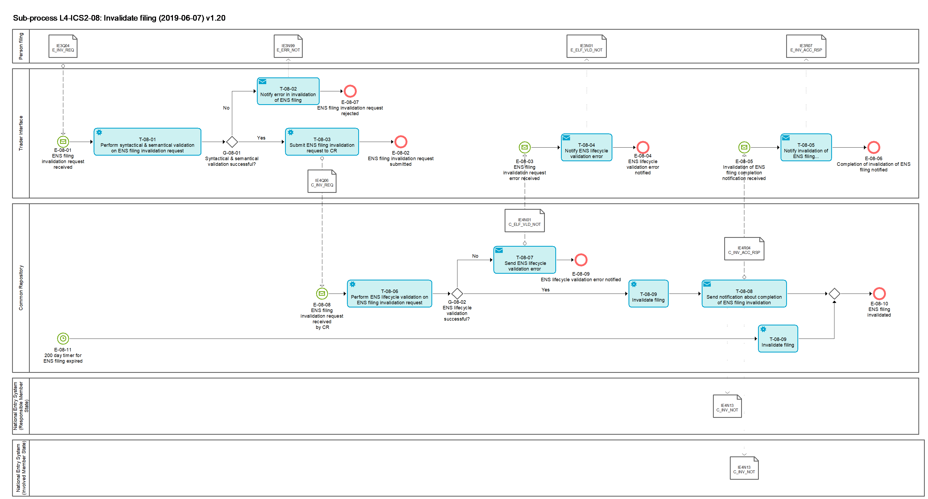
Figure 15: L4-ICS2-08 Invalidate filing sub-process

Tasks

T-08-01 – Perform syntactical and semantical validation on ENS filing invalidation request
Perform syntactical & semantical validation on ENS filing invalidation request | T-08-01
System component: TI
Input: ENS filing invalidation request received
Description:
The received ENS filing invalidation request is validated in an automated process. It comprises the validation against the message rules and conditions, as well as the relevant reference data which is valid at the date of the reception.
The messages rules and conditions and relevant reference data are defined in [R02] ICS2 Information Exchange Messages.
Output (Final situation):
The validation will have the following possible outcomes:
- Successful;
- Unsuccessful, in which case the error description will be generated.

T-08-02 – Notify error in invalidation of ENS filing
Notify error in invalidation of ENS filing | T-08-02
System component: TI
Input: Unsuccessful ENS filing invalidation request validation results
Description:
The information about unsuccessful semantical and syntactical validation is sent to the Person filing the ENS filing invalidation request via the message IE3N99 [Msg: E_ERR_NOT].
Output (Final situation):
The Person filing the invalidation request is informed about unsuccessful semantical and syntactical validation.

T-08-03 – Submit ENS filing invalidation request to CR
Submit ENS filing invalidation request to CR | T-08-03
System component: TI
Input: Positively validated ENS filing invalidation request
Description:
The ENS filing invalidation request is submitted to the CR via the message IE4Q06 [Msg: C_INV_REQ].
Output (Final situation):
The ENS filing invalidation request is available at the CR.

T-08-04 – Notify ENS lifecycle validation error
Notify ENS lifecycle validation error | T-08-04
System component: TI
Input: ENS filing invalidation request error received from CR.
Description:
The information about unsuccessful semantical and syntactical validation or ENS lifecycle validation is sent to the Person filing the ENS filing invalidation request via the message IE3N01 [Msg: E_ELF_VLD_NOT].
Output (Final situation):
The Person filing the invalidation request is informed about unsuccessful semantical and syntactical validation or ENS lifecycle validation.

T-08-05 - Notify invalidation of ENS filing completion
Notify invalidation of ENS filing completion | T-08-05
System component: TI
Input: Invalidation of ENS filing completion notification received
Description:
The message IE3R07 [Msg: E_INV_ACC_RSP] is generated and sent to the Person filing the invalidation request. It informs about successful invalidation of the ENS filing.
Output (Final situation):
The Person filing is notified that the invalidation of ENS filing was processed successfully.

T-08-06 – Perform ENS-lifecycle validation on ENS filing invalidation request
Perform ENS-lifecycle validation on ENS filing invalidation request | T-08-06
System component: CR
Input: ENS filing invalidation request
Description
The ENS lifecycle validation for the ENS filing invalidation request comprises the following checks:
- The ENS filing with the same MRN as the MRN [R02: IE4Q06 / MRN] contained in the received message IE4Q06 [Msg: C_INV_REQ] exists.
- The ENS filing and the corresponding ENS are in an appropriate state.
The person filing the invalidation request needs to be the declarant [R02: IE3Fxx / Declarant] or the representative [R02: IE3Fxx / Representative] of the original ENS filing.
If the ENS lifecycle validation is successful, the original ENS filing is invalidated.
If the ENS lifecycle validation fails, the original ENS filing remains as is.
Output (Final situation):
The original ENS filing will either be invalidated or it will not be affected at all.

T-08-07 – Send ENS lifecycle validation error
Send ENS lifecycle validation error | T-08-07
System component: CR
Input: Outcome of Task: T-08-06 – Perform ENS-lifecycle validation on ENS filing invalidation request
Description:
The TI is notified of the ENS lifecycle validation error via the message IE4N01 [Msg: C_ELF_VLD_NOT].
Output (Final situation):
The notification of ENS lifecycle validation is generated and sent to the TI.

T-08-08 - Send notification about completion of ENS filing invalidation
Send notification about completion of ENS filing invalidation | T-08-08
System component: CR
Input: Invalidated ENS filing from Task T-08-09
Description:
The message IE4R04 [Msg: C_INV_ACC_RSP] is generated and sent to the TI to inform about successful invalidation of the ENS filing by the CR. In case a house level ENS filing is invalidated after the ENS is instantiated and the risk analysis is triggered, the message IE4N13 [Msg: C_INV_NOT] is generated and sent to the NES (RMS) and where applicable to the NES (IMSs) of the corresponding ENS with the MRN of the invalidated ENS filing.
Output (Final situation):
The TI, NES (RMS) and where applicable the NES (IMSs) are notified that the invalidation of ENS filing was processed successfully by the CR.

T-08-09 – Invalidate filing
Invalidate filing | T-08-09
System component: CR
Input: Accepted ENS filing invalidation request or 200 day timer expiry
Description:
The ENS filing is invalidated and obtains the state 'Invalidated'.
Output (Final situation):
The ENS filing is invalidated.

Events

E-08-01 – ENS filing invalidation request received
ENS filing invalidation request received | E-08-01
System component: TI
Description:
An ENS filing invalidation request is received from Person filing via the message IE3Q04 [Msg: E_INV_REQ].

E-08-02 – ENS filing invalidation request submitted
ENS filing invalidation request submitted | E-08-02
System component: TI
Description:
An ENS filing invalidation request is submitted to the CR.

E-08-03 – ENS filing invalidation request error received
ENS filing invalidation request error received | E-08-03
System component: TI
Description:
ENS filing invalidation request error received by the TI.

E-08-04 - ENS lifecycle validation error notified
ENS lifecycle validation error notified | E-08-04
System component: TI
Description:
Error notification was sent to person filing.

E-08-05 – Invalidation of ENS filing completion notification received
Invalidation of ENS filing completion notification received | E-08-05
System component: TI
Description:
TI received information that the related ENS filing was invalidated in the CR.

E-08-06 – Completion of invalidation of ENS filing notified
Completion of invalidation of ENS filing notified | E-08-06
System component: TI
Description:
The completion of invalidation of ENS filing was notified to the Person filing.

E-08-07 – ENS filing invalidation request rejected
ENS filing invalidation request rejected | E-08-07
System component: TI
Description:
ENS filing invalidation request was rejected and notified to the Person filing.

E-08-08 - ENS filing invalidation request received by CR
ENS filing invalidation request received by CR | E-08-08
System component: TI
Description:
An invalidation of ENS filing request is received from TI via the message IE4Q06 [Msg: C_INV_REQ].

E-08-09 - ENS lifecycle validation error notified
ENS lifecycle validation error notified | E-08-09
System component: CR
Description:
Error notification was sent to TI.

E-08-10 – ENS filing invalidated
ENS filing invalidated | E-08-10
System component: CR
Description:
The filing was invalidated.

E-08-11 – 200 day timer for ENS filing expired
200 day timer for ENS filing expired | E-08-11
System component: CR
Description:
The 200 day timer which was started after registration of the ENS filing has expired and the relevant house consignments have not obtained the state 'Arrived' or a later state.

Gateways

G-08-01 – Syntactical & semantical validation successful?
Syntactical & semantical validation successful? | G-08-01
System component: CR
Input: Syntactical & semantical validation results
Description:
In case the validation results were positive, the answer is 'Yes'; Otherwise it is 'No'.

G-08-02 – ENS lifecycle validation successful?
ENS lifecycle validation successful? | G-08-02
System component: CR
Input: ENS lifecycle validation results
Description:
In case the validation results were positive, the answer is 'Yes'; Otherwise it is 'No'.

L4-ICS2-09 – e-Screening by OMS
e-Screening by OMS | L4-ICS2-09
Organisation: National Customs Administration of Other Member State
Input: Relevant parameters based on the national knowledge
Description:
There will be circumstances where a MS does not act as a RMS or IMS, but holds nationally a specific relevant risk information in relation to a presence of security and safety risks (for example in the case a DNL was issued by that MS when previously acting as a RMS, and there is a need to immediately identify goods/consignments with similar characteristics in the supply chain, or that MS have a specific information or intelligence in relation to the CRC category 2 but the goods are likely to be moved in a route that would exclude it from being the RMS or IMS).
In order to cover such critical gaps this particular MS may e-screen ENS data made available to it via the CR by application of narrowly defined targeted and time-defined parameters, and provide relevant outcomes to the RMS. Once the implemented parameters produce an automated hit, that OMS becomes an IMS and is given on this basis access to the relevant ENS data. The MS needs to finalise e-screening process as per the rules applicable for the IMS e-screening.
Output (Final situation):
The Member State submitting the risk related parameters is either involved in an on-going risk analysis process or potentially involved in a future one.

Business Process Model
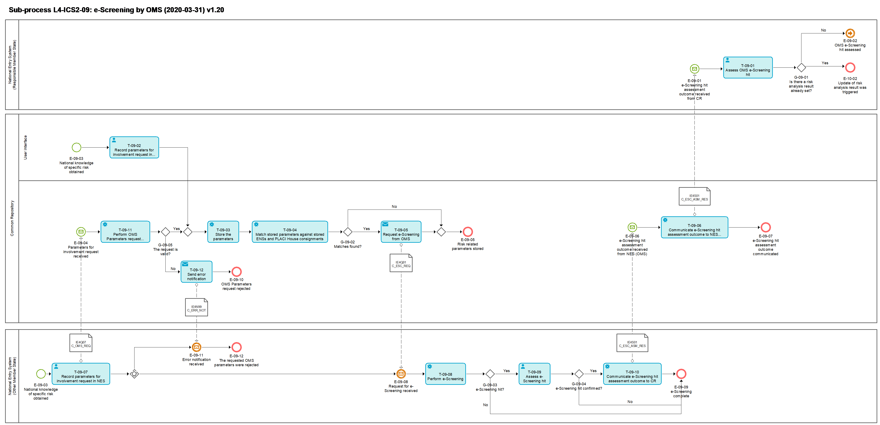
Figure 16: L4-ICS2-09 e-Screening by OMS sub-process

Tasks

T-09-01 - Assess OMS e-Screening hit
Assess OMS e-Screening hit | T-09-01
System component: NES (RMS)
Input: e-Screening hit assessment outcome communicated by the OMS
Description:
A confirmed e-Screening hit was communicated by the OMS and is now assessed by the risk analyst of the RMS.
The outcome of this assessment performed by the risk analyst can be a decision either to update the already set risk analysis result, for the cases that it is has been already set, or to leave it as is.
The possible options for setting (or updating) a risk analysis result are specified in Task: T-03-12 - Record RA result and control recommendation.
Output (Final situation):
The assessment of a confirmed e-Screening hit that was communicated by an Other Member State was completed and any necessary risk mitigation actions were decided.

T-09-02 – Record parameters for involvement request in CR
Record parameters for involvement request in CR | T-09-02
System component: CR
Input: Risk related national knowledge
Description:
The risk analyst of a Member State records parameters and thereby defines specific cases when the Member State (OMS) requests to become involved in e-Screening even if normally this Member State would not be an IMS according to the rules on determination of the roles of the MSs in the risk analysis process, as defined in Tasks: T-02-11 – Determine MSs roles for air pre-loading risk analysis and T-02-17 – Determine MSs roles for full risk analysis of the Sub-process: L4-ICS2-02 - Prepare ENS for risk analysis.
Example: In order to become involved the OMS records a specific container number and a defined time frame the container would have to appear in an ENS filing. When the defined parameters match an ENS filing the OMS becomes an IMS and receives a request for e-Screening for the matched filing.
Output (Final situation):
The parameters are recorded in the CR.

T-09-03 – Store parameters
Store parameters | T-09-03
System component: CR
Input: Parameters for involvement request received
Description:
The submitted parameters are stored in the CR.
Output (Final situation):
The stored parameters are available at the CR.

T-09-04 – Match stored parameters against stored ENSs
Match stored parameters against stored ENSs and PLACI house consignments | T-09-04
System component: CR
Input: Stored risk related parameters
Description:
The CR checks whether any ENS or PLACI house consignment matches the stored parameters.
The system will only take into account those parameters whose validity period matches the current date.
The system will only look for ENS(s) or PLACI house consignments for which the Member State that submitted the parameters is not assigned the role of the Responsible or Involved Member State, hence it is considered to be an OMS.
A stored ENS or PLACI house consignment must be in an applicable state for the OMS to be involved in the risk analysis process.
The Member State that submitted the risk related parameters will be considered an Involved Member State.
Output (Final situation):
ENS(s) or PLACI house consignment(s) that match the parameters are identified and the Member State is considered an Involved Member State for the risk analysis process for these ENS(s) PLACI house consignment(s).

T-09-05 - Request e-Screening from OMS
Request e-Screening from OMS | T-09-05
System component: CR
Input: Outcome of Task: T-09-04 – Match stored parameters against stored ENSs and PLACI house consignment(s)
Description:
A request for e-Screening is communicated to the NES (OMS) via the message IE4Q01 [Msg: C_ESC_REQ].
Output (Final situation):
Request for e-Screening is communicated to the NES (OMS).

T-09-06 – Communicate e-Screening hit assessment outcome to NES (RMS)
Communicate e-Screening hit assessment outcome to NES (RMS) | T-09-06
System component: CR
Input: Outcome of Task: T-09-09 - Assess e-Screening hit
Description:
The assessment outcome from the e-Screening hit (true positive) of an OMS is communicated by CR to the NES (RMS) via the message IE4S01 [Msg: C_ESC_ASM_RES].
Output (Final situation):
The e-Screening hit assessment outcome of the OMS is made available to the RMS.

T-09-07 – Record parameters for involvement request in NES
Record parameters for involvement request in NES | T-09-07
System component: NES (OMS)
Input: Risk related parameters to be recorded
Description:
The risk analyst of a Member State records parameters and thereby defines specific cases when the Member State (OMS) requests to become involved in e-Screening even if normally this Member State would not be an IMS according to the rules on determination of the roles of the MSs in the risk analysis process, as defined in Tasks: T-02-11 – Determine MSs roles for air pre-loading risk analysis and T-02-17 – Determine MSs roles for full risk analysis of the Sub-process: L4-ICS2-02 - Prepare ENS for risk analysis.
Example: In order to become involved the OMS records a specific container number and a defined time frame the container would have to appear in an ENS filing. When the defined parameters match an ENS filing the OMS becomes an IMS and receives a request for e-Screening for the matched filing.
The recorded parameters are submitted to the CR via the message IE4Q07 [Msg: C_OMS_REQ].
Output (Final situation):
The parameters are recorded in the NES and submitted to the CR.

T-09-08 - Perform e-Screening
Perform e-Screening | T-09-08
System component: NES (OMS)
Input: e-Screening request
Description:
Received ENS filing or ENS is electronically screened against CRC category 2 and any potential additional national security and safety related risk profiles not falling in the scope of the CRC category 2.
Output (Final situation):
e-Screening can result in a hit or no hit.

T-09-09 - Assess e-Screening hit
Assess e-Screening hit | T-09-09
System component: NES (OMS)
Input: e-Screening hit
Description:
Result of the e-Screening (i.e. match/hit of CRC category 2 / potential relevant national profiles and information applicable either for air cargo specific risks, or those applicable for customs security and safety risks) is presented to the risk analyst.
Customs risk analyst completes the e-Screening process through manual review and risk mitigation of the presented electronic result.
The e-Screening assessment result is either 'true positive' or 'false positive'.
Output (Final situation):
e-Screening result can be 'true positive' or 'false positive'.

T-09-10 – Communicate e-Screening hit assessment outcome to CR
Communicate e-Screening hit assessment outcome to CR | T-09-10
System component: NES (OMS)
Input: Outcome of Task: T-09-09 - Assess e-Screening hit
Description:
The assessment outcome from the e-Screening hit (true positive) of an OMS is communicated by NES (OMS) to the CR via the message IE4S01 [Msg: C_ESC_ASM_RES].
Output (Final situation):
The e-Screening hit assessment outcome of the IMS is made available to the CR.

T-09-11 – Perform OMS Parameters request validation
Perform OMS Parameters request validation | T-09-11
System component: CR
Input: OMS request to perform e-Screening
Description:
The received OMS request to perform e-Screening is validated in an automated process. It comprises the validation against the message rules and conditions, as well as the Combination ID and the relevant reference data which are valid at the date of the reception.
The messages rules and conditions and relevant reference data are defined in [R02] ICS2 Information Exchange Messages.
Output (Final situation):
In case the validation results were positive, the answer is 'Yes'; Otherwise it is 'No'.

T-09-12 – Send Error notification
Send Error notification | T-09-12
System component: CR
Input: Outcome of Task: 2.1.15.2.11T-09-11 – Perform OMS Parameters request validation
Description:
When the CR is unable to identify the combination of parameters based on the identifier(s) submitted by the NES or CR identifies any other validation error (based on the rules and conditions validation and the technical validation), it will generate an error notification which will be sent to the NES via the message IE4N99 [Msg: C_ERR_NOT].
Output (Final situation):
The error notification was sent to the NES.

Events

E-09-01 - e-Screening hit assessment outcome received from CR
e-Screening hit assessment outcome received from CR | E-09-01
System component: NES (RMS)
Description:
An e-Screening hit assessment outcome was received from the CR.

E-09-02 - OMS e-Screening hit assessed
OMS e-Screening hit assessed | E-09-02
System component: NES (RMS)
Description:
The OMS's e-Screening hit was assessed.

E-10-02 – Update of risk analysis result was triggered
Update of risk analysis result was triggered | E-10-02
System component: NES (RMS)
Description:
The risk analyst of the RMS decides to update the previously set risk analysis result. This triggers the sub-process

L4-ICS2-10 – Update risk analysis result.

E-09-03 – National knowledge of specific risk obtained
National knowledge of specific risk obtained | E-09-03
System component: NES (OMS) or CR UI
Description:
New knowledge of specific risk was obtained by OMS.

E-09-04 – Parameters for involvement request received
Parameters for involvement request received | E-09-04
System component: CR
Description:
Parameters for involvement request were received from the NES (OMS).

E-09-05 – Risk related parameters stored
Risk related parameters stored | E-09-05
System component: CR
Description:
The received risk related parameters were stored in the CR.

E-09-06 - e-Screening hit assessment outcome received
e-Screening hit assessment outcome received from NES (OMS) | E-09-06
System component: CR
Description:
An e-Screening hit assessment outcome was received from the NES (OMS).

E-09-07 - e-Screening hit assessment outcome communicated
e-Screening hit assessment outcome communicated | E-09-07
System component: CR
Description:
An e-Screening hit assessment outcome was communicated to the NES (RMS).

E-09-08 – Request for e-Screening received
Request for e-Screening received | E-09-08
System component: NES (OMS)
Description:
An e-Screening request is received from the CR.

E-09-09 – e-Screening complete
e-Screening complete | E-09-09
System component: NES (OMS)
Description:
The e-Screening is complete.

E-09-10 – OMS Parameters request rejected
OMS Parameters request rejected | E-09-10
System component: CR
Description:
OMS Parameters request is rejected by CR.

E-09-11 – Error notification received
Error notification received | E-09-11
System component: NES (OMS)
Description:
Error is notified.

E-09-12 – The requested OMS parameters were rejected
The requested OMS parameters were rejected | E-09-12
System component: NES (OMS)
Description:
OMS Parameters request is rejected by CR.

Gateways

G-09-01 – Is there a risk analysis result already set?
Is there a risk analysis result already set? | G-09-01
System component: NES (RMS)
Input: Assessed IMS e-Screening hit
Description:
The answer is 'Yes' when the matched ENS has already had a risk analysis process completed and a result set, otherwise it is 'No'.

G-09-02 – Matches found?
Matches found? | G-09-02
System component: CR
Input: Outcome of Task: T-09-04 – Match stored parameters against stored ENSs
Description:
The answer is 'Yes' when at least one ENS or ENS filing matched the stored parameters, otherwise it is 'No'.

G-09-03 – e-Screening hit?
E-Screening hit? | G-09-03
System component: NES (OMS)
Input: Outcome of Task: T-09-08 - Perform e-Screening
Description:
The answer is 'Yes' when the e-Screening generated a hit, otherwise it is 'No'.

G-09-04 – e-Screening hit confirmed?
E-Screening hit confirmed? | G-09-04
System component: NES (OMS)
Input: Outcome of Task: T-09-09 - Assess e-Screening hit
Description:
The answer is 'Yes' when the risk analyst of the OMS considers the generated e-Screening hit a 'true positive', otherwise it is 'No'.

G-09-05 – The request is valid?
The request is valid? | G-09-05
System component: CR
Input: Outcome of Task: T-09-11 – Perform OMS Parameters request validation
Description:
In case the validation results were positive, the answer is 'Yes'; Otherwise it is 'No'.

L4-ICS2-10 – Update risk analysis result
Update risk analysis result | L4-ICS2-10
Organisation: National Customs Administration of Responsible Member State
Input: e-risk analysis was re- triggered or risk analysis result was updated
Description:
The risk analyst of the Responsible Member State may
- trigger the e-risk analysis to be repeated and subsequently update an already set risk analysis result, if applicable, or
- update the risk analysis result that was already set.
Output (Final situation):
An already set risk analysis result was either updated or not.

Business Process Model
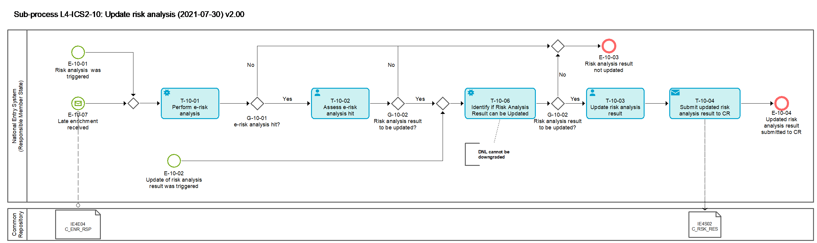
Figure 17: L4-ICS2-10 Update risk analysis result sub-process

Tasks

T-10-01 – Perform e-risk analysis
Perform e-risk analysis | T-10-01
System component: NES (RMS)
Input: e-risk analysis was re-triggered
Description:
Received ENS or PLACI House consignment is electronically analysed against CRC category 1, CRC category 2 and any potential additional national security and safety related risk profiles not falling in the scope of the CRCs.
Electronic risk analysis (e-risk analysis) either results in an automated ‘match / hit’ of a given CRC / national risk profile or not.
Output (Final situation):
e-risk analysis hit or no hit.

T-10-02 - Assess e-risk analysis hit
Assess e-risk analysis hit | T-10-02
System component: NES (RMS)
Input: e-risk analysis result
Description:
The risk analyst assesses the e-risk analysis hit by confirming as a true positive or rejecting it as a false positive. He also decides whether this affects the already set risk analysis result, in which case he proceeds with updating of the risk analysis result.
Output (Final situation):
The e-risk analysis hit was characterized as true or false positive.
Decision was made on whether the already set risk analysis result should be updated.

T-10-03 - Update risk analysis result
Update risk analysis result | T-10-03
System component: NES (RMS)
Input: Assessed e-risk analysis hit
Description:
The risk analysis result for risk analysis is updated by the risk analyst of the RMS.
The possible risk analysis results are specified in Task: T-03-12 - Record RA result and control recommendation of Sub-process: L4-ICS2-03 – Perform risk analysis.
Output (Final situation):
The risk analysis result is updated.

T-10-04 – Submit updated risk analysis result to CR
Submit updated risk analysis result to CR | T-10-04
System component: NES (RMS)
Input: Outcome of Task: T-10-03 - Update risk analysis result
Description:
The updated risk analysis result is submitted to the CR via the message IE4S02 [Msg: C_RSK_RES].
Output (Final situation):
The updated risk analysis result is available in the CR.

T-10-06 – Identify if risk analysis result can be updated
Identify if risk analysis result can be updated | T-10-06
System component: NES (RMS)
Input: T-10-02 Assess e-risk analysis hit
Description:
The NES (RMS) identifies whether the risk analysis result can be updated.
Output (Final situation): It is known whether the risk analysis result can be updated or not.

Events

E-10-01 – Risk analysis was triggered
Risk analysis was triggered | E-10-01
System component: NES (RMS)
Description:
The risk analyst of the RMS decides to re-perform the e-risk analysis.

E-10-02 – Update of risk analysis result was triggered
Update of risk analysis result was triggered | E-10-02
System component: NES (RMS)
Description:
The risk analyst of the RMS decides to update the previously set risk analysis result.

E-10-03 – Risk analysis result not updated
Risk analysis result not updated | E-10-03
System component: NES (RMS)
Description:
The risk analysis result was not updated.

E-10-04 – Updated RA result submitted to CR
Updated risk analysis result submitted to CR | E-10-04
System component: NES (RMS)
Description:
The updated risk analysis results are submitted to CR by the NES (RMS).

E-10-07 – Late enrichment received
Late enrichment received | E-10-07
System component: NES
Description:
High priority late enrichment is received by the RMS.

Gateways

G-10-01 – e-risk analysis hit?
e-risk analysis hit? | G-10-01
System component: NES (RMS)
Input: Outcome of Task: T-10-01 – Perform e-risk analysis
Description:
The answer is 'Yes' when the e-risk analysis generated a hit, otherwise it's 'No'.

G-10-02 – Risk analysis result to be updated?
Risk analysis result to be updated? | G-10-02
System component: NES (RMS)
Input: Outcome of Task: T-10-02 - Assess e-risk analysis hit
Description
The answer is 'Yes' if the risk analyst decided to update the risk analysis result, otherwise it's 'No'.

L4-ICS2-11 – Update e-Screening assessment
Update e-Screening assessment | L4-ICS2-11
Organisation: National Customs Administration of Involved Member State
Input: e-Screening hit assessment was updated or assessed e-Screening hit is available after expiration of timer
Description:
The risk analyst of an Involved Member State may
- update an assessment of an e-Screening hit, or
- complete the assessment of an e-Screening hit after the expiration of the timer for completion of the IMS e-Screening task;
The timer for completion of the e-Screening is specified in Tasks: T-02-12 – Start timers for the completion of e-Screening by IMS(s) for air pre-loading risk analysis and T-02-19 – Start timers for the completion of e-Screening by IMS(s) for full risk analysis of Sub-process: L4-ICS2-02 - Prepare ENS for risk analysis.
Output (Final situation):
An e-Screening hit was either re-assessed or was assessed and communicated outside the expected time window.

Business Process Model
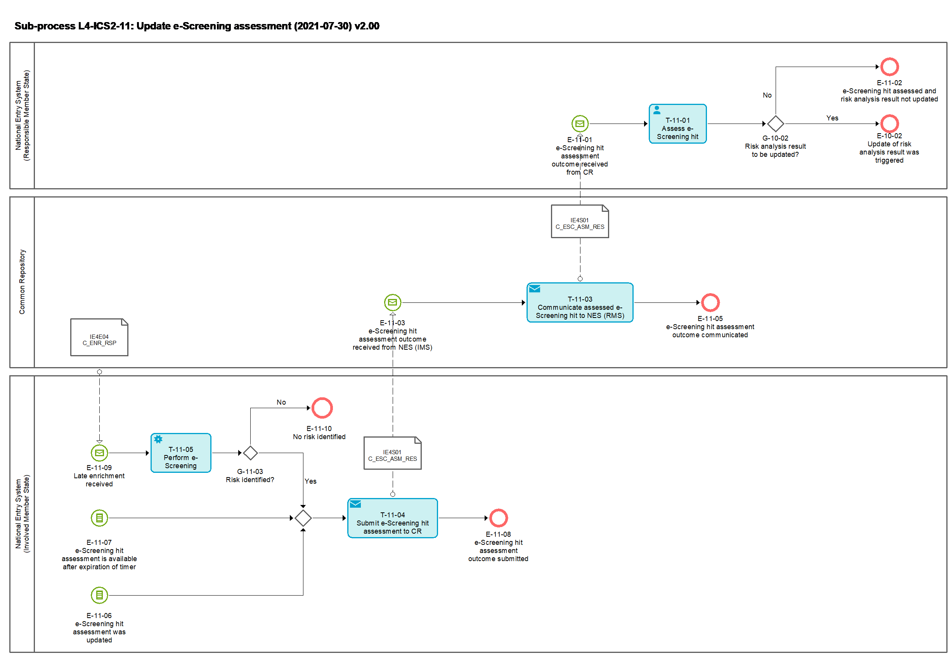
Figure 18: L4-ICS2-11 Update e-Screening assessment sub-process

Tasks

T-11-01 - Assess IMS e-Screening hit
Assess IMS e-Screening hit | T-11-01
System component: NES (RMS)
Input: e-Screening hit assessment outcome received from CR
Description:
The risk analyst of the RMS assesses the e-Screening hit received from the IMS and decides whether this affects an already set risk analysis result or not.
Output (Final situation):
Decision was made on whether an already set risk analysis result should be updated.

T-11-03 – Communicate e-Screening hit assessment outcome to NES (RMS)
Communicate e-Screening hit assessment outcome to NES (RMS) | T-11-03
System component: CR
Input: e-Screening hit assessment outcome received from NES (IMS)
Description
The assessment outcome from the e-Screening hit (true positive) of an IMS is communicated by the CR to the NES (RMS) via the message IE4S01 [Msg: C_ESC_ASM_RES].
Output (Final situation):
The e-Screening hit assessment outcome of the IMS is made available to the RMS.

T-11-04 – Communicate assessed e-Screening hit to CR
Communicate assessed e-Screening hit to CR | T-11-04
System component: NES (IMS)
Input: e-Screening hit assessment was updated or e-Screening hit assessment is available after expiration of timer
Description
The outcome of the assessment of the e-Screening hit (true positive) of an IMS is communicated by NES (IMS) to the CR via the message IE4S01 [Msg: C_ESC_ASM_RES].
Output (Final situation):
The e-Screening hit assessment outcome of the IMS is available at the CR.

T-11-05 – Perform e-Screening
Perform e-Screening | T-11-05
System component: NES (IMS)
Input: Late enrichment received
Description
The IMS performs an e-Screening assessment due to the received late enrichment.
Output (Final situation):
The outcome is positive if risk is identified and negative if no risk is identified.

Events

E-11-01 - e-Screening hit assessment outcome received from CR
e-Screening hit assessment outcome received from CR | E-11-01
System component: NES (RMS)
Description:
An e-Screening hit assessment outcome was received from CR.

E-11-02 - e-Screening hit assessed and risk analysis result not updated
e-Screening hit assessed and risk analysis result not updated | E-11-02
System component: NES (RMS)
Description:
An e-Screening hit is assessed by the risk analyst of RMS. The e-Screening hit does not affect the final risk analysis result, thus it is not updated.

E-10-02 – Update of risk analysis result was triggered
Update of risk analysis result was triggered | E-10-02
System component: NES (RMS)
Description:
The risk analyst of the RMS decides to update the previously set risk analysis result. This triggers the sub-process:

L4-ICS2-10 – Update risk analysis result.

E-11-03 - e-Screening hit assessment outcome received from NES (IMS)
e-Screening hit assessment outcome received from NES (IMS) | E-11-03
System component: CR
Description:
An e-Screening hit assessment outcome was received from NES (IMS).

E-11-05 - e-Screening hit assessment outcome communicated
e-Screening hit assessment outcome communicated | E-11-05
System component: CR
Description:
An e-Screening hit assessment outcome was communicated to NES (RMS).

E-11-06 –e-Screening hit assessment was updated
Already assessed e-Screening hit was updated | E-11-06
System component: NES (IMS)
Description:
The risk analyst of the IMS decides to update the e-Screening assessment after the original assessment was communicated to CR.

E-11-07 – e-Screening hit assessment is available after expiration of timer
e-Screening hit assessment is available after expiration of timer | E-11-07
System component: NES (IMS)
Description:
The assessment of an e-Screening hit was delayed or took longer than the agreed time for the given mode of transport and it was communicated late.

E-11-08 –e-Screening hit assessment submitted
e-Screening hit assessment submitted | E-11-08
System component: NES (IMS)
Description:
The assessment of an e-Screening hit was communicated to CR.

E-11-09 – Late enrichment received
Late enrichment received | E-11-09
System component: NES
Description:
High priority late enrichment is received by the IMS.

E-11-10 – No risk identified
No risk identified | E-11-10
System component: NES
Description:
No risk was identified by the IMS.

Gateways

G-10-02 – Risk analysis result to be updated?
Risk analysis result to be updated? | G-10-02
System component: NES (RMS)
Input: Outcome of Task: T-11-01 - Assess IMS e-Screening hit
Description:
The answer is 'Yes' if the risk analyst decided to update an already set risk analysis result, otherwise it's 'No'.

G-10-03 – Risk identified?
Risk identified? | G-10-03
System component: NES (IMS)
Input: Outcome of Task: T-11-01 - Assess IMS e-Screening hit
Description:
The answer is 'Yes' if risk was identified, otherwise it is 'No'.

L4-ICS2-12 – Revoke presentation of goods
Revoke presentation of goods | L4-ICS2-12
Organisation: National Customs Administration of Presentation/Control (at final destination)
Input: The goods were erroneously presented
Description:
This process covers a case where the goods were presented at a wrong customs office and it is necessary to revoke this presentation and to roll-back the state of the relevant House consignments to their former one. The identifiers of the specific House consignments for which the presentation has to be revoked will be submitted from the NES of the MS of Presentation/Control (at final destination).
The system will identify the relevant House consignments and, if applicable, will rollback their state to the previous one. If the House consignments are not in a relevant state an error notification will be sent to NES.
Output (Final situation):
The presentation of the house consignments was revoked.

Business Process Model
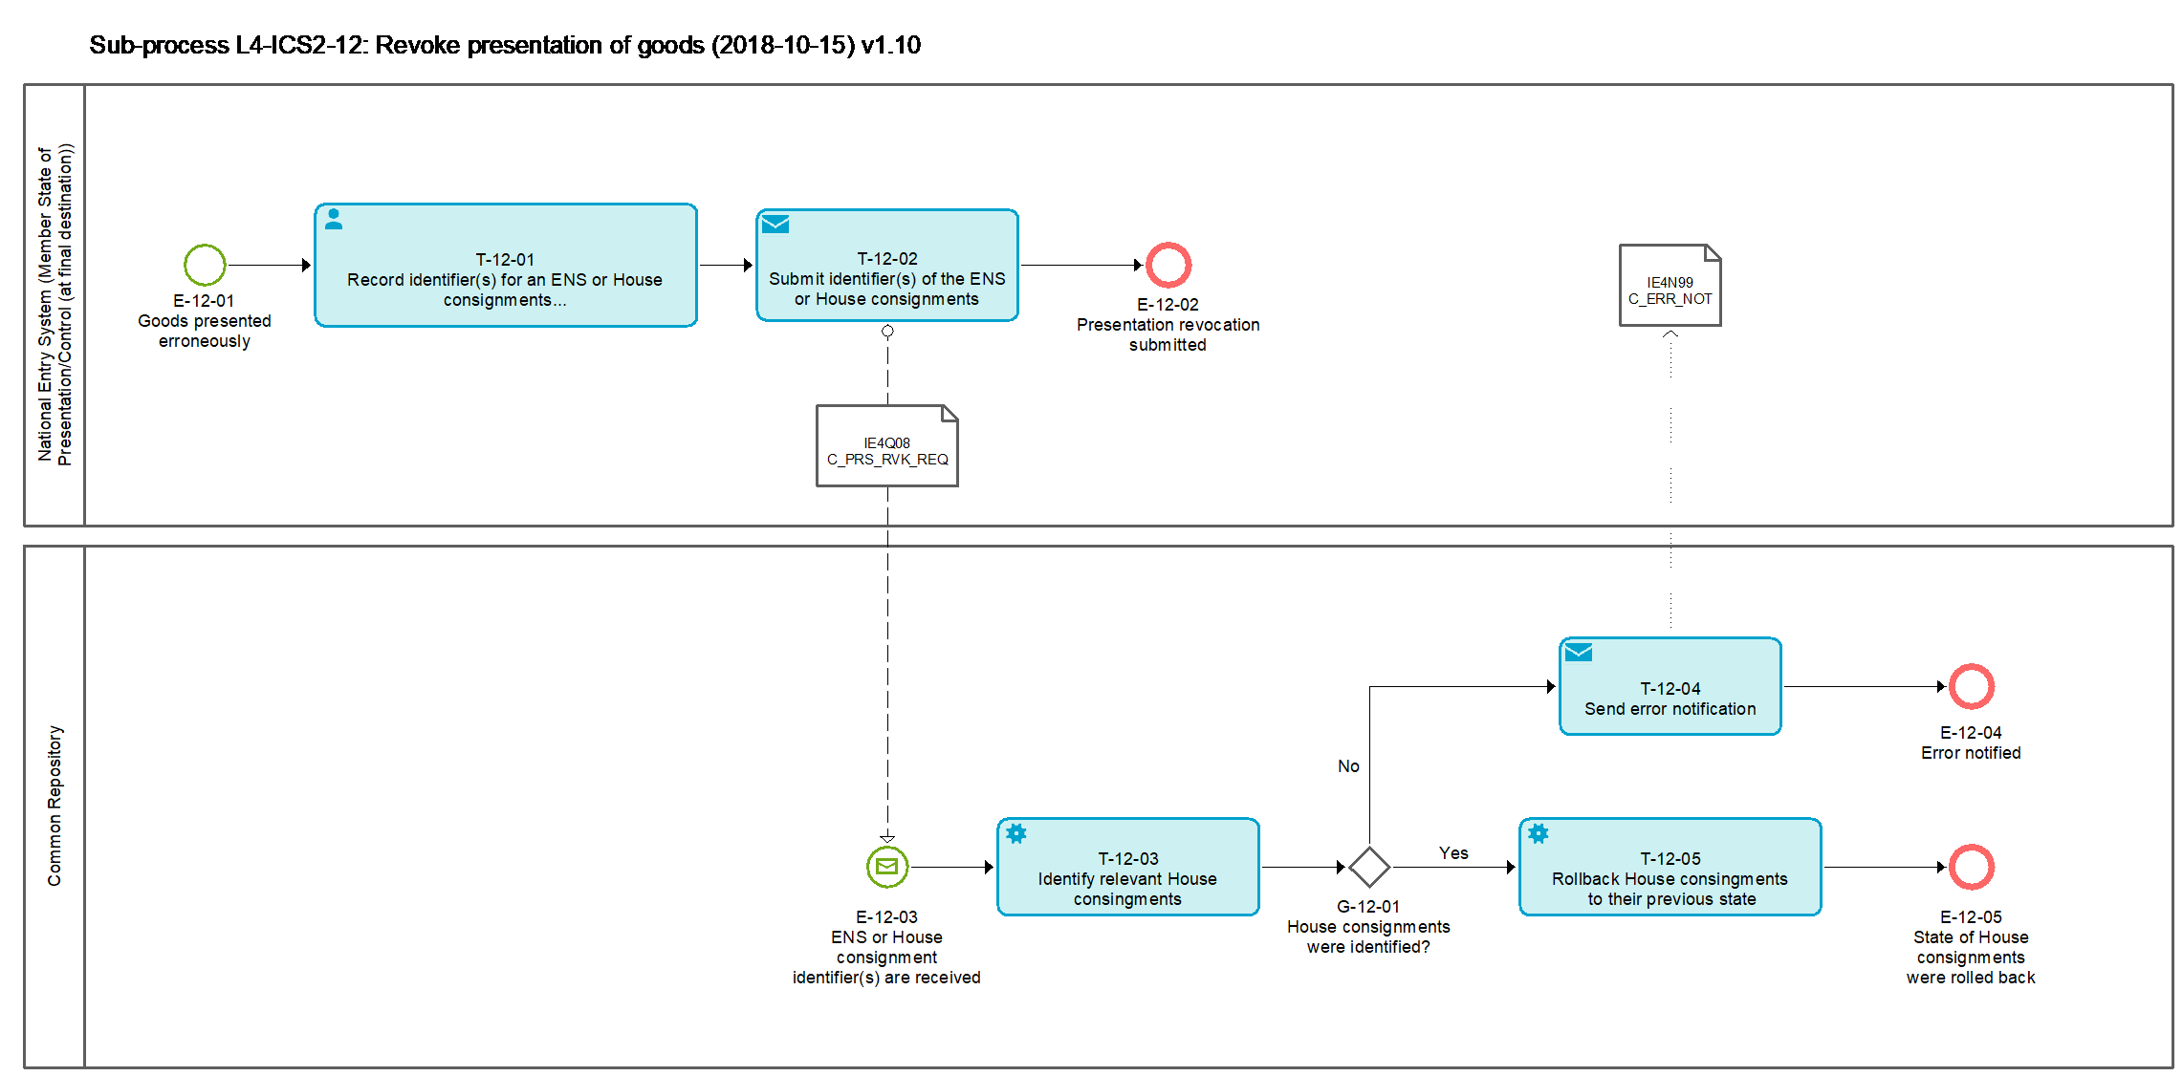
Figure 19: L4-ICS2-12 Revoke presentation of goods sub-process

Tasks

T-12-01 - Record identifier(s) for an ENS or House consignments presentation to be revoked
Record identifier(s) for an ENS or House consignments presentation to be revoked | T-12-01
System component: NES (Member State of Presentation/Control (at final destination))
Input: Revocation of presentation of goods is required
Description:
The identifier(s) for an ENS or specific House Consignment of an ENS is/are recorded in the NES in order to revoke the presentation.
Output (Final situation):
The identifier(s) for ENS or Consignment (House level) of an ENS are recorded in the NES.

T-12-02 – Submit identifier(s) of the ENS or ENS Consignment (House level)
Submit identifier(s) of the ENS or House consignments | T-12-02
System component: NES (Member State of Presentation/Control (at final destination))
Input: Outcome of Task: T-12-01 - Record identifier(s) for an ENS or House consignments presentation to be revoked
Description:
The identifier(s) of the ENS or House consignment are submitted to the CR via the message IE4Q08 [Msg: C_PRS_RVK_REQ].
Output (Final situation):
The identifier(s) for ENS or House consignment of an ENS are submitted to the CR.

T-12-03 – Identify relevant House consignments
Identify relevant House consignment | T-12-03
System component: CR
Input: ENS or House consignment identifier(s) are received
Description:
The CR will identify the relevant House consignments based on the identifier(s) received.
Output (Final situation):
The relevant House consignments of an ENS are identified.

T-12-04 – Send error notification
Send error notification | T-12-04
System component: CR
Input: Outcome of Task: T-12-03 Identify relevant House consignments
Description:
When the CR is unable to identify a House consignment of an ENS based on the identifier(s) submitted by the NES, it will generate an error notification which will be sent to the NES via the message IE4N99 [Msg: C_ERR_NOT].
Output (Final situation):
The error notification was sent to the NES.

T-12-05– Rollback House consignments to their previous state
Rollback House consignments to their previous state | T-12-05
System component: CR
Input: Outcome of Task: T-12-03 Identify relevant House consignments
Description:
The state of the identified House consignments of an ENS will be rolled back to the state that they had before the presentation event was triggered.
Output (Final situation):
The state of the relevant House consignments of an ENS were rolled back.

Events

E-12-01 – Goods presented erroneously
Goods presented erroneously | E-12-01
System component: NES (Member State of Presentation/Control (at final destination))
Description:
Goods presented erroneously and their presentation needs to be revoked.

E-12-02 – Presentation revocation submitted
Presentation revocation submitted | E-12-02
System component: NES (Member State of Presentation/Control (at final destination))
Description:
Presentation revocation submitted to the CR.

E-12-03 – ENS or House consignment identifier(s) are received
ENS or House consignment identifier(s) are received | E-12-03
System component: CR
Description:
ENS or House consignment identifier(s) are received by the CR.

E-12-04 – Error notified
Error notified | E-12-04
System component: CR
Description:
Error was notified.

E-12-05 – State of House consignments were rolled back
State of House consignments were rolled back | E-12-05
System component: CR
Description:
State of House consignments were rolled back to previous one.

Gateways

G-12-01 – House consignments were identified?
House consignments were identified? | G-12-01
System component: NES (Member State of Presentation/Control (at final destination))
Description:
House consignments were identified, the answer is 'Yes'; Otherwise it's 'No'.

Events

E-00-01 – ENS filing received
ENS filing received | E-00-01
Organisation: National Customs Administration of the Responsible Member State
Description:
A person filing lodges an ENS filing.

E-00-02 – Amendment of ENS filing received
Amendment of ENS filing received | E-00-02
Organisation: National Customs Administration of the Responsible Member State
Description:
A person filing lodges an amendment for an already lodged ENS filing.

E-00-03 – Timer for completion of linking expired
Timer for completion of linking expired | E-00-03
Organisation: National Customs Administration of the Responsible Member State
Description:
Timer to complete the linking of the partial ENS filings expires.

E-00-04 – Entry process completed
Entry process completed | E-00-04
Organisation: National Customs Administration of the Responsible Member State
Description:
The entire entry process is completed.

E-00-05 – Invalidation request received
Invalidation request received | E-00-05
Organisation: National Customs Administration of the Responsible Member State
Description:
An invalidation request is received.

E-00-06 – 200 day timer expired
200 day timer expiry | E-00-06
Organisation: National Customs Administration of the Responsible Member State
Description:
The 200 day timer which was started after registration of the ENS filing has expired.

E-00-07 – ENS filing invalidated
ENS filing invalidated | E-00-07
Organisation: National Customs Administration of the Responsible Member State
Description:
The filing was invalidated. The process ends.

E-00-08 – Risk analysis was re-triggered
Risk analysis was re-triggered | E-00-08
Organisation: National Customs Administration of the Responsible Member State
Description:
The risk analysis is re-triggered.

E-00-09 – Risk analysis result updated
Risk analysis result updated | E-00-09
Organisation: National Customs Administration of the Responsible Member State
Description:
The risk analysis result is updated.

E-00-10 – Arrival notification received
Arrival notification received | E-00-10
Organisation: National Customs Administration of the Member State of Actual First Entry
Description:
Arrival notification is received.

E-00-11 – Arrival notification processed
Arrival notification processed | E-00-11
Organisation: National Customs Administration of the Member State of Actual First Entry
Description:
Arrival notification was processed.

E-00-12 – Goods presented
Goods presented | E-00-12
Organisation: National Customs Administration of the Member State of presentation/control (at final destination)
Description:
The person presenting the goods presents the goods to the Member State of presentation/control (at final destination).

E-00-13 – Erroneous presentation of goods
Erroneous presentation of goods | E-00-13
Organisation: National Customs Administration of the Member State of Presentation/Control (at final destination)
Description:
Erroneous presentation of goods occurred.

E-00-14 – Goods presented and controlled
Goods presented and controlled | E-00-14
Organisation: National Customs Administration of the Member State of Presentation/Control (at final destination)
Description:
Control of goods was performed and control results were documented.

E-00-15 – State of House consignments rolled back
State of ENS rolled back | E-00-15
Organisation: National Customs Administration of the Member State of Presentation/Control (at final destination)
Description:
Presentation of goods is revoked and the state of the relevant House consignments is rolled back to the previous one.

E-00-16 – e-Screening hit assessment was updated or submitted out of time
e-Screening hit assessment was updated or submitted out of time | E-00-16
Organisation: National Customs Administration of the Involved Member State
Description:
e-Screening hit assessment is updated or submitted after expiration of timer.

E-00-17 – e-Screening updated or completed
e-Screening updated or completed | E-00-17
Organisation: National Customs Administration of the Involved Member State
Description:
e-Screening result is updated or completed.

E-00-18 – Involvement in e-Screening requested
Involvement in e-Screening requested | E-00-18
Organisation: National Customs Administration of the Other Member State
Description:
Involvement in e-Screening is requested by the OMS, which is different from the Responsible and Involved Member State.

E-00-19 – e-Screening completed
e-Screening completed | E-00-19
Organisation: National Customs Administration of Other Member State
Description:
e-Screening is completed by OMS.

Supporting processes

L4-ICS2-13 – Consult ENS
Consult ENS | L4-ICS2-13
Description:
This service will be offered to the Economic Operators and the TI helpdesk.
Its purpose is to enable the requesting party to look for information about a specific ENS filing and/or an ENS that this filing concerns.
The information that will be provided will depend on the access rights that each requesting party has.
Output (Final situation):
The relevant ENS information will be provided.

Business Process Model
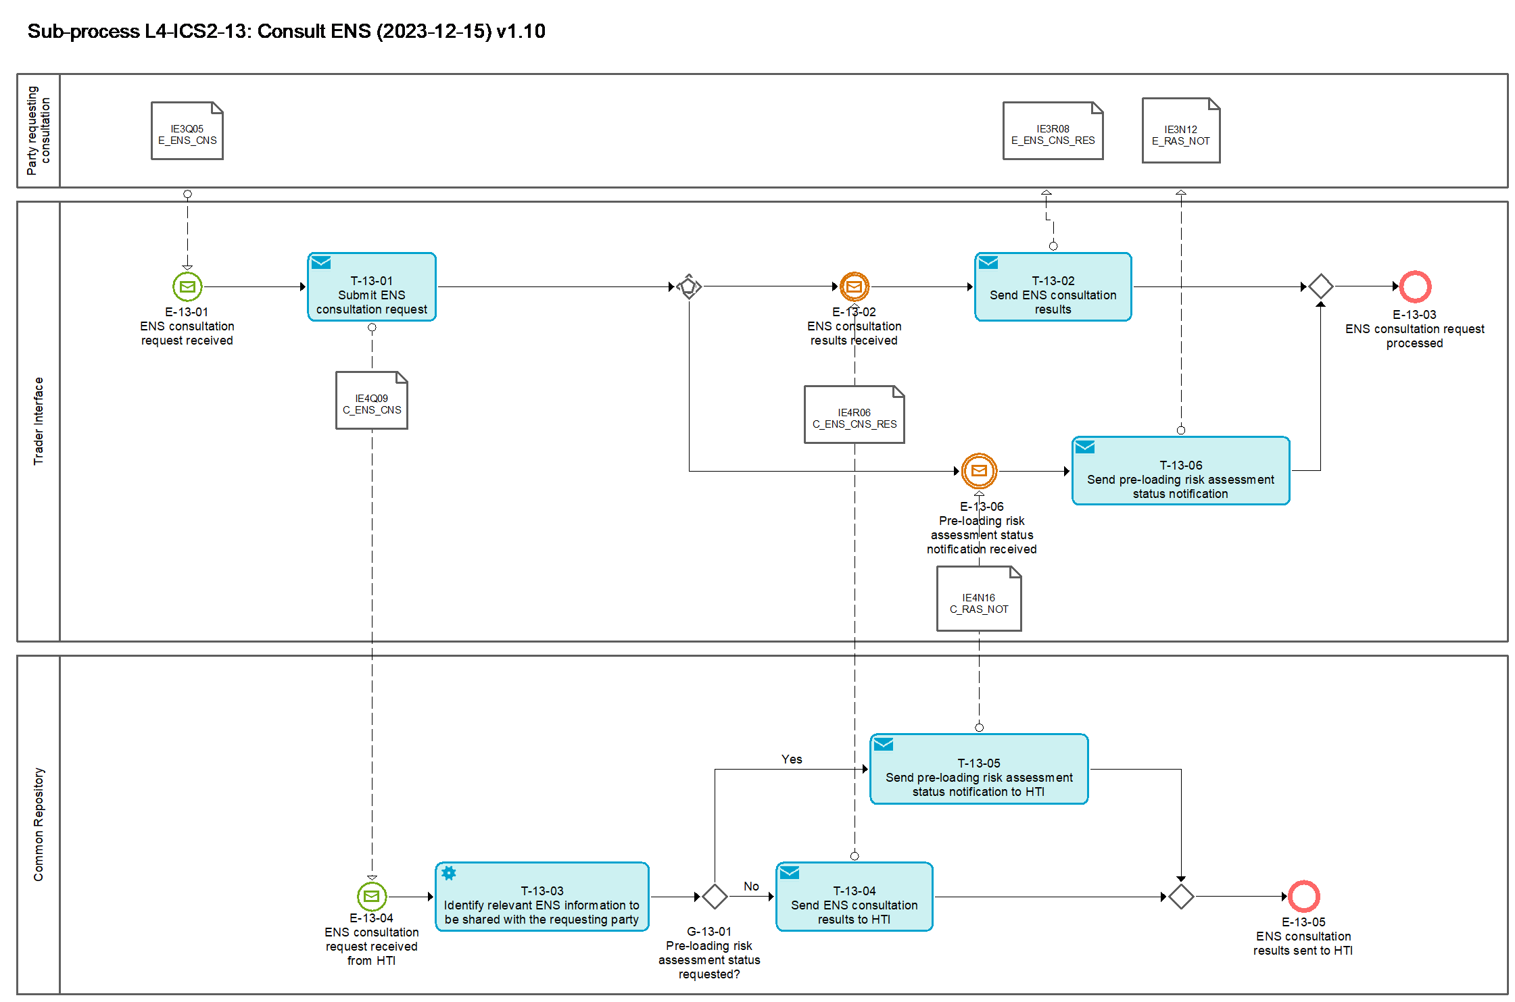
Figure 20: L4-ICS2-13 Consult ENS sub-process

Tasks

T-13-01 – Submit ENS consultation request
Submit ENS consultation request | T-13-01
System component: TI
Input: ENS consultation request received
Description:
The TI will submit the ENS consultation request to the CR via the message IE4Q09 [Msg: C_ENS_CNS].
Output (Final situation):
The ENS consultation request was submitted to the CR

T-13-02 – Send ENS consultation results
Send ENS consultation results | T-13-02
System component: TI
Input: ENS consultation results received from CR
Description:
The TI will send the ENS consultation results to the party that requested the consultation, via the message IE3R08 [Msg: E_ENS_CNS_RES].
If the Economic operator requesting the ENS consultation has indicated as “True” the “Request notifications” data, then the following list of notifications related to the requested MRN/Master level transport document/House level transport document needs to be provided (in case available).
Based on the ENS Consultation request information (MRN, Master level transport document or House level transport document) the CR identifies the related entities and forwards the related identifiers to the STI (IE4R06). The STI retrieves the following stored notifications and forwards them to the EO – ENS lifecycle validation error notification, ENS not complete notification, Assessment complete notification, Additional information request notification, HRCM screening request notification, Control notification, AEO control notification (if authorized), Amendment notification, DNL, Additional information request, HRCM screening request and Invalidation acceptance response.
When an MRN is provided in the ENS Consultation the CR identifies the ENS Filing to which the MRN was generated. The CR forwards to the STI the related identification information for the STI to retrieve the relevant notifications to the MRN (and the related ENS entities) for which the EO sending the ENS Consultation is the recipient.
When a Master level or House level Transport document reference number is provided in the ENS Consultation the CR identifies the ENS Filing via which the Transport document was registered. The CR forwards to the STI the related identification information for the STI to retrieve the relevant notifications to the Master level or House level transport document (and the related ENS entities) for which the EO sending the ENS Consultation is the recipient.
The retrieved notifications (and the related ENS entities) per House consignment, Master consignment or ENS Filing are forwarded to the requesting EO in accordance with its data access rights.
When the consultation is for a House consignment, the notifications (and the related ENS entities) only related to the House consignment should be retrieved and forwarded (not the notifications in general related to the ENS to which this House consignments belongs).
When the consultation is for a Master consignment, the notifications (and the related ENS entities) only related to the Master ENS Filing are retrieved and forwarded (not the notifications related to the linked House consignments).
 | House Consignment  (identified by the House level transport document ) | Master Consignment  (identified either by the Master level transport document or the Master ENS Filing MRN) | ENS Filing MRN  (not Master Consignment)
ENS lifecycle validation error notification | - | X | X
ENS not complete notification | - | X | X
Assessment complete notification | X | X | X
Additional information request | X | X | X
Additional information request notification | X | X | X
HRCM screening request | X | - | X
HRCM screening request notification | X | - | X
Control notification | X | X | X
AEO control notification (if authorized) | X | X | X
Amendment notification | - | X | X
DNL | X | X | X
Invalidation acceptance response | - | X | X

Output (Final situation):
The ENS consultation results were sent to the party that requested the consultation.

T-13-03 – Identify relevant ENS information to be shared with the requesting party
Identify relevant ENS information to be shared with the requesting party | T-13-03
System component: CR
Input: Received ENS consultation request
Description:
The CR identifies the relevant ENS information that matches the inserted criteria and at the same time complies with the access rights that the party requesting the consultation has.
In case the pre-loading risk assessment status information is requested, then the provided identifiers are checked and, if applicable, the pre-loading risk assessment status information is extracted for the identified receptacles and the linked to them house consignment(s) and communicated.
Output (Final situation):
The relevant ENS information was identified.
The task has the following possible outcomes:
- Pre-loading risk assessment status information identified;
- ENS Consultation results sent.

T-13-04 – Send ENS consultation results to TI
Send ENS consultation results to TI | T-13-04
System component: CR
Input: Identified relevant ENS information
Description:
The CR sends the identified relevant ENS information to the TI, via the message IE4R06 [Msg: C_ENS_CNS_RES].
Output (Final situation):
The ENS consultation results were sent to the TI.

T-13-05 – Send pre-loading risk assessment status notification to HTI
Send pre-loading risk assessment status notification to HTI | T-13-05
System component: CR
Input: Identified relevant pre-loading risk assessment status information
Description:
The CR sends the identified relevant pre-loading risk assessment status information to the HTI, via the message IE4N16 [Msg: C_RAS_NOT].
Output (Final situation):
The pre-loading risk assessment status notification sent to the HTI.

T-13-06 – Send pre-loading risk assessment status notification to HTI
Send pre-loading risk assessment status notification | T-13-06
System component: TI
Input: Identified relevant pre-loading risk assessment status information received from CR
Description:
The TI will send the pre-loading risk assessment status notification to the requesting party, via the message IE3N12 [Msg: E_RAS_NOT].
Based on the valid identifiers (MRN, master transport document reference or receptacles) provided in the corresponding ENS consultation request IE3Q05/IE4Q09, the status of the pre-loading risk assessment for each of the identified related house transport documents is checked and communicated via IE3N12.
Output (Final situation):
The requested pre-loading risk assessment status notification sent to the requesting party.

Events

E-13-01 – ENS consultation request received
ENS consultation request received | E-13-01
System component: TI
Description:
An ENS consultation request was received.

E-13-02 – ENS consultation results received
ENS consultation results received | E-13-02
System component: TI
Description:
The ENS consultation results were received.

E-13-03 – ENS consultation request processed
ENS consultation request processed | E-13-03
System component: TI
Description:
The ENS consultation request was processed.

E-13-04 – ENS consultation request received from TI
ENS consultation request received from TI | E-13-04
System component: CR
Description:
The ENS consultation request was received.

E-13-05 – ENS consultation results sent to TI
ENS consultation results sent to TI | E-13-05
System component: CR
Description:
The ENS consultation results were sent to TI.

E-13-06 – Pre-loading risk assessment status notification received
Pre-loading risk assessment status notification received | E-13-06
System component: TI
Description:
Pre-loading risk assessment status notification was received.

Gateways

G-13-01 – Pre-loading risk assessment status requested?
Pre-loading risk assessment status requested? | G-13-01
System component: CR
Input: Outcome of Task: T-13-03 – Identify relevant ENS information to be shared with the requesting party
Description:
In case pre-loading risk assessment status information was requested, the answer is 'Yes', otherwise it is 'No'.

L4-ICS2-14 – Query ENS
Query ENS | L4-ICS2-14
Description:
This service will be offered to the Member State Administrations.
Its purpose is to enable a Member State to look for information about an ENS.
The information that will be provided will depend on the access rights that each Member State has on a matched ENS.
Output (Final situation):
The relevant ENS information will be provided.

Business Process Model
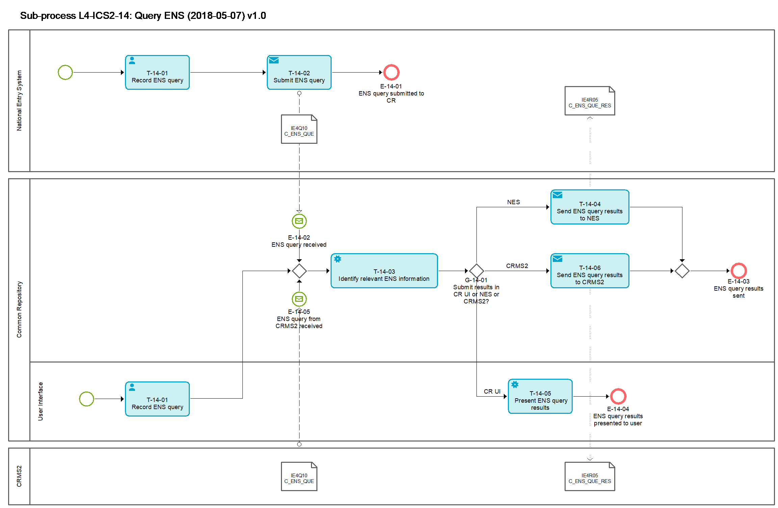
Figure 21: L4-ICS2-13 Query ENS sub-process

Tasks

T-14-01 – Record ENS query
Record ENS query | T-14-01
System component: NES or CR UI
Input: ENS query
Description:
The customs officer will query for ENS information either via the NES or the CR UI.
The customs officer will record the criteria for his query. The available criteria are depicted in the message IE4Q10 [Msg: C_ENS_QUE].
Output (Final situation):
The ENS query was recorded either in the NES or the CR UI.

T-14-02 – Submit ENS query
Submit ENS query | T-14-02
System component: NES
Input: Recorded ENS query
Description:
The NES submits the ENS query to the CR, via the message IE4Q10 [Msg: C_ENS_QUE].
Output (Final situation):
The ENS query was submitted to the CR.

T-14-03 – Identify relevant ENS information to be shared with the Member State
Identify relevant ENS information | T-14-03
System component: CR
Input: Submitted ENS query
Description:
The CR identifies the relevant ENS information that matches the inserted criteria and at the same time complies with the access rights that the user and his national administration has.
Output (Final situation):
The relevant ENS information was identified.

T-14-04 – Send ENS query results to NES
Send ENS query results to NES | T-14-04
System component: CR
Input: Identified relevant ENS information
Description:
The CR sends the ENS query results to the NES, via the message IE4R05 [Msg: C_ENS_QUE_RES].
Output (Final situation):
The ENS query results were sent to the NES.

T-14-05 – Present ENS query results
Present ENS query results | T-14-05
System component: CR
Input: Identified relevant ENS information
Description:
The CR presents the ENS query results to the user via its UI.
Output (Final situation):
The ENS query results were presented to the user.

T-14-06 – Send ENS query results to CRMS2
Send ENS query results to CRMS2 | T-14-06
System component: CR
Input: Identified relevant ENS information
Description:
The CR sends the ENS query results to CRMS2 via the message IE4R05 [Msg: C_ENS_QUE_RES].
Output (Final situation):
The ENS query results were sent to CRMS2.

Events

E-14-01 – ENS query submitted to CR
ENS query submitted to CR | E-14-01
System component: NES
Description:
An ENS query was submitted to the CR.

E-14-02 – ENS query received
ENS query received | E-14-02
System component: CR
Description:
An ENS query was received from the NES.

E-14-03 – ENS query results sent
ENS query results sent | E-14-03
System component: CR
Description:
The ENS query results were sent to NES or CRMS2.

E-14-04 – ENS query results presented to user
ENS query results presented to user | E-14-04
System component: CR
Description:
The ENS query results were presented to the user.

E-14-05 – ENS query from CRMS2 received
ENS query from CRMS2 received | E-14-05
System component: CR
Description:
An ENS query was received from CRMS2.

Gateways

G-14-01 – Submit results in CR UI or NES or CRMS2?
Submit results in CR UI or NES or CRMS2? | G-14-01
System component: CR
Input: Origin of ENS query
Description:
The answer depends on the point of origin of the ENS query. Whether it originates from the NES, CRMS2 or the CR UI.

Annexes

Annex 1 – ENS filing types
F10 | Sea and inland waterways – Complete dataset – Straight bill of lading containing the necessary information from consignee
F11 | Sea and inland waterways – Complete dataset – Master bill of lading with underlying house bill(s) of lading containing the necessary information from consignee at the level of the lowest house bill of lading
F12 | Sea and inland waterways – Partial dataset – Master bill of lading only
F13 | Sea and inland waterways – Partial dataset – Straight bill of lading only
F14 | Sea and inland waterways – Partial dataset – House bill of lading only
F15 | Sea and inland waterways – Partial dataset – House bill of lading with the necessary information from consignee
F16 | Sea and inland waterways – Partial dataset – Necessary information required to be provided by consignee at the lowest level of transport contract (the lowest house bill of lading)
F17 | Sea and inland waterways – Partial dataset – Necessary information required to be provided by consignee at the lowest level of transport contract (straight bill)
F20 | Air cargo (general) – Complete dataset lodged pre-loading
F21 | Air cargo (general) – Partial dataset – Master air waybill lodged pre-arrival
F22 | Air cargo (general) – Partial dataset – House air waybill lodged pre-arrival
F23 | Air cargo (general) — Partial dataset — Minimum dataset lodged pre- loading in accordance with Article 106(1) second subparagraph of Delegated Regulation (EU) 2015/2446 without master air waybill reference number
F24 | Air cargo (general) — Partial dataset — Minimum dataset lodged pre- loading in accordance with Article 106(1) second subparagraph of Delegated Regulation (EU) 2015/2446 with master air waybill reference number
F25 | Air cargo (general) — Partial dataset — Master air waybill reference number lodged pre-loading in accordance with Article 106(1) second subparagraph of Delegated Regulation (EU) 2015/2446
F26 | Air cargo (general) — Partial dataset — Minimum dataset lodged pre- loading in accordance with Article 106(1) second subparagraph of Delegated Regulation (EU) 2015/2446 and containing additional house air waybill information
F27 | Air cargo (general) — Complete dataset lodged pre-arrival
F28 | Air cargo (general) — Complete dataset lodged pre-loading – Direct air waybill
F29 | Air cargo (general) — Complete dataset lodged pre-arrival – Direct air waybill
F30 | Express consignments — Complete dataset lodged pre-arrival
F31 | Express consignments on air cargo general – Complete dataset lodged pre-arrival by the express operator
F32 | Express consignments — Partial dataset — Minimum dataset lodged pre-loading in accordance with Article 106(1) second subparagraph of Delegated Regulation (EU) 2015/2446
F33 | Express consignments on air cargo general – Partial dataset – House air waybill lodged pre-arrival by a person pursuant to Article 127(6) of the Code and in accordance with Article 113(1)
F34 | Express consignments on road – Complete dataset lodged pre-arrival
F40 | Postal consignments – Partial dataset – Road Master bill of lading
F41 | Postal consignments – Partial dataset – Rail master transport document information
F42 | Postal consignments – Partial dataset - Master air waybill containing necessary postal air waybill information lodged in accordance with the time-limits applicable for the mode of transport concerned
F43 | Postal consignments — Partial dataset — Minimum dataset lodged pre- loading in accordance with Article 106(1) second subparagraph of Delegated Regulation (EU) 2015/2446
F44 | Postal consignment — Partial dataset — Receptacle identification number lodged pre-loading in accordance with Article 106(1) second subparagraph of Delegated Regulation (EU) 2015/2446
F45 | Postal consignments – Partial dataset – Sea and inland waterways
F50 | Road mode of transport
F51 | Rail mode of transport
F52 | Rail mode of transport – Partial dataset – Rail master transport document information only
F53 | Rail mode of transport – Partial dataset – House level transport document information with the necessary information from consignee
F54 | Rail mode of transport – Partial dataset – House level transport document information only
F55 | Rail mode of transport – Partial dataset – Necessary information required to be provided by consignee at the lowest level of transport contract
F56 | Road mode of transport – Partial dataset – Road master transport document information only
F57 | Road mode of transport – Partial dataset – House level transport document information with the necessary information from consignee
F58 | Road mode of transport – Partial dataset – House level transport document information only
F59 | Road mode of transport – Partial dataset – Necessary information required to be provided by consignee at the lowest level of transport contract

Annex 2 – Information exchange messages

External domain
Message ID | Message Name | Message name full | Process where it is used
IE3Fxx | E_ENS_xxx_DEC | ENS filing | L4-ICS2-01 Register filing
IE3Axx | E_ENS_xxx_AMD | ENS filing amendment | L4-ICS2-07 Amend filing
IE3Q01 | E_DNL_REQ | Do Not Load request | L4-ICS2-03 Perform risk analysis
IE3Q02 | E_REF_RFI_REQ | Additional information request | L4-ICS2-03-01 Send referral
IE3Q03 | E_REF_RFS_REQ | High Risk Cargo & Mail screening request | L4-ICS2-03-01 Send referral
IE3Q04 | E_INV_REQ | Invalidation Request | L4-ICS2-08 Invalidate filing
IE3Q05 | E_ENS_CNS | ENS Consultation | L4-ICS2-13 Consult ENS
IE3R01 | E_ENS_REG_RSP | ENS Registration Response | L4-ICS2-01 Register filing
IE3R02 | E_REF_RFI_RSP | Additional information response | L4-ICS2-03-01 Send referral
IE3R03 | E_REF_RFS_RSP | High Risk Cargo & Mail screening response | L4-ICS2-03-01 Send referral
IE3R04 | E_ARV_REG_RSP | Arrival Registration Response | L4-ICS2-04 Process arrival of means of transport
IE3R07 | E_INV_ACC_RSP | Invalidation Acceptance Response | L4-ICS2-08 Invalidate filing
IE3R08 | E_ENS_CNS_RES | ENS Consultation results | L4-ICS2-13 Consult ENS
IE3N01 | E_ELF_VLD_NOT | ENS lifecycle validation error notification | L4-ICS2-01 Register filing
IE3N02 | E_ENS_NCP_NOT | ENS Not complete notification | L4-ICS2-02-01 Relate ENS filings
IE3N03 | E_ASM_CMP_NOT | Assessment complete notification | L4-ICS2-03 Perform risk analysis
IE3N04 | E_REF_RFI_NOT | Additional information request notification | L4-ICS2-03-01 Send referral
IE3N05 | E_REF_RFS_NOT | High Risk Cargo & Mail screening request notification | L4-ICS2-03-01 Send referral
IE3N06 | E_ARV_NOT | Arrival notification | L4-ICS2-04 Process arrival of means of transport
IE3N07 | E_HCS_INC_NOT | House consignment in incorrect state notification | L4-ICS2-04 Process arrival of means of transport
IE3N08 | E_CON_NOT | Control notification | L4-ICS2-04 Process arrival of means of transport
IE3N09 | E_AEO_CON_NOT | Authorised Economic Operator control notification | L4-ICS2-06-01 Handle AEO notification
IE3N10 | E_AMD_NOT | Amendment Notification | L4-ICS2-07 Amend filing
IE3N11 | E_ENS_PND_NOT | ENS pending notification | L4-ICS2-02-01 Relate ENS filings
IE3N12 | E_RAS_NOT | Pre-loading risk assessment status notification | L4-ICS2-13 Consult ENS
IE3N99 | E_ERR_NOT | Error notification | L4-ICS2-01 Register filing
IE3N99 | E_ERR_NOT | Error notification | L4-ICS2-04 Process arrival of means of transport
IE3N99 | E_ERR_NOT | Error notification | L4-ICS2-07 Amend filing
IE3N99 | E_ERR_NOT | Error notification | L4-ICS2-08 Invalidate filing

Common domain
Message ID | Message Name | Message name full | Process where it is used
IE4Fxx | C_ENS_xxx_DEC | ENS filing | L4-ICS2-01 Register filing
IE4Axx | C_ENS_xxx_AMD | ENS filing amendment | L4-ICS2-07 Amend filing
IE4Q01 | C_ESC_REQ | e-Screening request | L4-ICS2-03 Perform risk analysis
IE4Q02 | C_ERA_REQ | e-risk analysis request | L4-ICS2-03 Perform risk analysis
IE4Q03 | C_DNL_REQ | Do Not Load request | L4-ICS2-03 Perform risk analysis
IE4Q04 | C_REF_RFI_REQ | Additional information request | L4-ICS2-03-01 Send referral
IE4Q05 | C_REF_RFS_REQ | High Risk Cargo & Mail screening request | L4-ICS2-03-01 Send referral
IE4Q06 | C_INV_REQ | Invalidation request | L4-ICS2-08 Invalidate filing
IE4Q07 | C_OMS_REQ | OMS request to perform e-Screening | L4-ICS2-09 e-Screening by OMS
IE4Q08 | C_PRS_RVK_REQ | Presentation revocation request | L4-ICS2-12 Revoke presentation of goods
IE4Q09 | C_ENS_CNS | ENS consultation | L4-ICS2-13 Consult ENS
IE4Q10 | C_ENS_QUE | Query for ENS | L4-ICS2-14 Query for ENS
IE4R01 | C_ENS_ACC_RSP | ENS acceptance response | L4-ICS2-02 Prepare ENS for risk analysis
IE4R02 | C_REF_RFI_RSP | Additional information response | L4-ICS2-03-01 Send referral
IE4R03 | C_REF_RFS_RSP | High Risk Cargo & Mail screening response | L4-ICS2-03-01 Send referral
IE4R04 | C_INV_ACC_RSP | Invalidation acceptance response | L4-ICS2-08 Invalidate filing
IE4R05 | C_ENS_QUE_RES | ENS query results | L4-ICS2-14 Query for ENS
IE4R06 | C_ENS_CNS_RES | ENS consultation results | L4-ICS2-13 Consult ENS
IE4S01 | C_ESC_ASM_RES | e-Screening results | L4-ICS2-03 Perform risk analysis
IE4S02 | C_RSK_RES | Risk analysis results | L4-ICS2-03 Perform risk analysis
IE4S03 | C_CON_RES | Control results | L4-ICS2-04 Process arrival of means of transport
IE4S03 | C_CON_RES | Control results | L4-ICS2-06 Process control decision and results
IE4N01 | C_ELF_VLD_NOT | ENS lifecycle validation error notification | L4-ICS2-02 Prepare ENS for risk analysis
IE4N02 | C_ENS_NCP_NOT | ENS not complete notification | L4-ICS2-02-01 Relate ENS filings
IE4N03 | C_ERA_HIT_NOT | Risk hit notification | L4-ICS2-03 Perform risk analysis
IE4N04 | C_ASM_CMP_NOT | Assessment complete notification | L4-ICS2-03 Perform risk analysis
IE4N05 | C_CON_RCM_NOT | Control recommendation notification | L4-ICS2-03 Perform risk analysis
IE4N05 | C_CON_RCM_NOT | Control recommendation notification | L4-ICS2-04 Process arrival of means of transport
IE4N05 | C_CON_RCM_NOT | Control recommendation notification | L4-ICS2-05 Process presentation of goods
IE4N05 | C_CON_RCM_NOT | Control recommendation notification | L4-ICS2-06 Process control decision and results
IE4N06 | C_REF_AMD_NOT | Amendment after referral reception notification | L4-ICS2-03-01 Send referral
IE4N07 | C_ARV_NOT | Arrival notification | L4-ICS2-04 Process arrival of means of transport
IE4N08 | C_HCS_INC_NOT | House consignment in incorrect state notification | L4-ICS2-04 Process arrival of means of transport
IE4N09 | C_CON_NOT | Control notification | L4-ICS2-04 Process arrival of means of transport
IE4N10 | C_PRS_INF | Presentation information | L4-ICS2-05 Process presentation of goods
IE4N11 | C_AEO_CON_NOT | Authorised Economic Operator control notification | L4-ICS2-06-01 Handle AEO notification
IE4N12 | C_AMD_NOT | Amendment completion notification | L4-ICS2-07 Amend filing
IE4N13 | C_INV_NOT | ENS filing invalidation notification | L4-ICS2-08 Invalidate filing
IE4N14 | C_HCS_NOT | ENS House consignment state notification | L4-ICS2-04 Process arrival of means of transport
IE4N14 | C_HCS_NOT | ENS House consignment state notification | L4-ICS2-05 Process presentation of goods
IE4N15 | C_CON_CHA_NOT | MS of control change notification | L4-ICS2-03 Perform risk analysis
IE4N16 | C_RAS_NOT | Pre-loading risk assessment status notification | L4-ICS2-13 Consult ENS
IE4N17 | C_REF_RFI_NOT | Additional information request notification | L4-ICS2-03-01 Send referral
IE4N18 | C_REF_RFS_NOT | HRCM Screening request notification | L4-ICS2-03-01 Send referral
IE4N99 | C_ERR_NOT | Error notification | L4-ICS2-07 Amend filing
IE4N99 | C_ERR_NOT | Error notification | L4-ICS2-08 Invalidate filing
IE4N99 | C_ERR_NOT | Error notification | L4-ICS2-12 Revoke presentation of goods
IE4E01 | C_ENR_MSL_REQ | SSA MS Involvement list request | L4-ICS2-02-02 SSA MS Involvement List
IE4E02 | C_ENR_MSL_RSP | SSA MS Involvement list response | L4-ICS2-02-02 SSA MS Involvement List
IE4E03 | C_ENR_REQ | SSA Enrichment request | L4-ICS2-02-03 SSA Enrichment
IE4E04 | C_ENR_RSP | SSA Enrichment response | L4-ICS2-02-03 SSA Enrichment
IE4E04 | C_ENR_RSP | SSA Enrichment response | L4-ICS2-02-04 Late enrichment response

Annex 3 – Entities and states
In this annex, the most significant, business wise, entities are listed along with their possible states.

ENS
State | Triggering sub-process | Triggering task
Pending completeness | L4-ICS2-02 - Prepare ENS for risk analysis | T-02-13 – Link or associate related House consignments and check ENS completeness
Complete | L4-ICS2-02 - Prepare ENS for risk analysis | T-02-13 – Link or associate related House consignments and check ENS completeness
Complete | L4-ICS2-02-01 – Relate ENS with House consignments | T-02-01-04 – Relate ENS
Considered complete | L4-ICS2-02-01 – Relate ENS with House consignments | T-02-01-04 – Relate ENS

ENS filing
State | Triggering sub-process | Triggering task
Registered | L4-ICS2-01 - Register filing | T-01-01 – Perform syntactical and semantical validation
Registered | L4-ICS2-01 - Register filing | T-07-07 Amend filing
Rejected | L4-ICS2-01 - Register filing | T-01-01 – Perform syntactical and semantical validation
Rejected | L4-ICS2-02 - Prepare ENS for risk analysis | T-02-03 - Perform ENS lifecycle validation on stored ENS filing
Accepted | L4-ICS2-02 - Prepare ENS for risk analysis | T-02-03 - Perform ENS lifecycle validation on stored ENS filing
Accepted | L4-ICS2-02 - Prepare ENS for risk analysis | T-07-06 Perform ENS-lifecycle validation on amendment of ENS filing
Invalidated | L4-ICS2-08 – Invalidate filing | T-08-09 – Invalidate filing

House consignment
State | Triggering sub-process | Triggering task
Pending linking | L4-ICS2-02 - Prepare ENS for risk analysis | T-02-13 – Link or associate related House consignments and check ENS completeness
Linked | L4-ICS2-02 - Prepare ENS for risk analysis | T-02-13 – Link or associate related House consignments and check ENS completeness
Linked | L4-ICS2-02 - Prepare ENS for risk analysis | T-12-05 Rollback House consignments to their previous state
Arrived | L4-ICS2-04 – Process arrival of the means of transport | T-04-09 – Check House consignments state correctness and update their state
Arrived | L4-ICS2-04 – Process arrival of the means of transport | T-12-05 Rollback House consignments to their previous state
Presented | L4-ICS2-05 – Process presentation of goods | T-05-05 – Update state of relevant Consignment (House level)
Controlled | L4-ICS2-06 – Process control decision and results | T-06-04 Store Control Decision and Results
Invalidated | L4-ICS2-08 – Invalidate filing | T-08-09 – Invalidate filing

PLACI House consignment
State | Triggering sub-process | Triggering task
Pending association | L4-ICS2-02 - Prepare ENS for risk analysis | T-02-13 – Link or associate related House consignments and check ENS completeness
Associated | L4-ICS2-02 - Prepare ENS for risk analysis | T-02-13 – Link or associate related House consignments and check ENS completeness
Invalidated | L4-ICS2-08 – Invalidate filing | T-08-09 – Invalidate filing

Air pre-loading risk analysis
State | Triggering sub-process | Triggering task
Initiated | L4-ICS2-03 – Perform risk analysis | T-03-15 - Request e-risk analysis
Timer stopped | L4-ICS2-03 – Perform risk analysis | T-03-14 - Stop timer for completion of risk analysis
Completed | L4-ICS2-03 – Perform risk analysis | T-03-17 – Store RA result

Full risk analysis
State | Triggering sub-process | Triggering task
Initiated | L4-ICS2-03 – Perform risk analysis | T-03-15 - Request e-risk analysis
Timer stopped | L4-ICS2-03 – Perform risk analysis | T-03-14 - Stop timer for completion of risk analysis
Completed | L4-ICS2-03 – Perform risk analysis | T-03-17 – Store RA result

Arrival notification
State | Triggering sub-process | Triggering task
Registered | L4-ICS2-04 – Process arrival of the means of transport | T-04-03 – Register arrival notification and assign MRN
Rejected | L4-ICS2-04 – Process arrival of the means of transport | T-04-01 - Perform syntactical and semantical validation on received arrival notification

Goods shipment
State | Triggering sub-process | Triggering task
Pending linking | L4-ICS2-02 - Prepare ENS for risk analysis | T-02-13 – Link or associate related House consignments and check ENS completeness
Linked | L4-ICS2-02 - Prepare ENS for risk analysis | T-02-13 – Link or associate related House consignments and check ENS completeness
Invalidated | L4-ICS2-08 – Invalidate filing | T-08-09 – Invalidate filing

HRCM Screening Result
State | Triggering sub-process | Triggering task
Instantiated | L4-ICS2-02 - Prepare ENS for risk analysis | T-02-03 - Perform ENS lifecycle validation on stored ENS filing
Invalidated | L4-ICS2-07 – Amend filing | T-07-07 – Amend ENS filing
Invalidated | L4-ICS2-08 – Invalidate filing | T-08-09 – Invalidate filing

Master consignment
State | Triggering sub-process | Triggering task
Instantiated | L4-ICS2-02 - Prepare ENS for risk analysis | T-02-13 – Link or associate related House consignments and check ENS completeness
Invalidated | L4-ICS2-08 – Invalidate filing | T-08-09 – Invalidate filing

e-Screening request
State | Triggering sub-process | Triggering task
Sent | L4-ICS2-03 – Perform risk analysis | T-03-22 - Request e-Screening
Closed | L4-ICS2-03 – Perform risk analysis | T-03-24 - Stop timer for e-Screening

e-Risk analysis request
State | Triggering sub-process | Triggering task
Sent | L4-ICS2-03 – Perform risk analysis | T-03-15 - Request e-risk analysis
Closed | L4-ICS2-03 – Perform risk analysis | T-03-17 – Store RA result

Annex 4 – IE4N04 Assessment complete notification content

Postal
Air pre-loading
Per House consignment | F43 | F44
MRN | F43 MRN | -
Completion date | X | -
Assessment Complete/Receptacle | - | -
Assessment Complete/Transport document (house level) | X | -
Assessment Complete/transport equipment | - | -
Responsible Member State | X | -
Representative | X | -
Transport Document (Master level) | - | -
Carrier | - | -
Declarant | X | -
Pre-arrival
Per ENS | F43 | F44
MRN | - | -
Completion date | - | -
Assessment Complete/receptacle | - | -
Assessment Complete/Transport document (house level) | - | -
Assessment Complete/transport equipment | - | -
Responsible Member State | - | -
Representative | - | -
Transport Document (Master level) | - | -
Carrier | - | -
Declarant | - | -

Air cargo general
Air pre-loading
Per House consignment | F20 | F21 | F22 | F23 | F24 | F25 | F26 | F27 | F28 | F29
MRN | F20 MRN | - | - | F23 MRN | F24 MRN | - | F26 MRN | - | F28 MRN | -
Completion date | X | - | - | X | X | - | X | - | X | -
Assessment Complete/Receptacle | - | - | - | - | - | - | - | - | - | -
Assessment Complete/Transport document (house level) | X | - | - | X | X | - | X | - | X | -
Assessment Complete/transport equipment | - | - | - | - | - | - | - | - | - | -
Responsible Member State | X | - | - | X | X | - | X | - | X | -
Representative | X | - | - | X | X | - | X | - | X | -
Transport Document (Master level) | X | - | - | X** | X | - | - | - | X | -
Carrier | X | - | - | X** | X | - | - | - | X | -
Declarant | X | - | - | X | X | - | X | - | X | -
x** - when the assessment complete notification is sent to the carrier for a PLACI based on F23 and complemented by F25 then the carrier and the master transport document are used from the F25 but the MRN is from F23.
Pre-arrival
Per ENS | F20 | F21 | F22 | F23 | F24 | F25 | F26 | F27 | F28 | F29 | F42
MRN | F20 MRN | F21 MRN | F22 MRN | - | - | - | F26 MRN | F27 MRN | F28 MRN | F29 MRN | F42  MRN
Completion date | X | X | X | - | - | - | X | X | X | X | X
Assessment Complete/receptacle | - | - | - | - | - | - | - | - | - | - | All related receptacles
Assessment Complete/Transport document (house level) | x* | - | x* | - | - | - | x* | x* | - | x* | -
Assessment Complete/transport equipment | - | - | - | - | - | - | - | - | - | - | -
Responsible Member State | X | X | X | - | - | - | X | X | X | X | X
Representative | X | X | X | - | - | - | X | X | X | X | X
Transport Document (Master level) | X | X | X*** | - | - | - | X*** | X | X | X | X
Carrier | X | X | X*** | - | - | - | X*** | X | X | X | X
Declarant | X | X | X | - | - | - | X | X | X | X | X
x* - if everything is ok (no DNL), no list of house consignments to be returned (only the MRN of the ENS filing and Master transport document, if applicable). If there is a DNL with one of the house consignments, a list of the house consignments for which there is no DNL to be returned.
x*** - the current implementation is the following - in case there are house consignments for more than one master transport document and carrier (more than one ENS) in the house level ENS filing, then IE3N03/IE4N04 contains only the first master transport document reference and carrier identified.

Express
Air pre-loading
Per House consignment | F30 | F31 | F32 | F33
MRN | - | - | F32 MRN | -
Completion date | - | - | X | -
Assessment Complete/Receptacle | - | - | - | -
Assessment Complete/Transport document (house level) | - | - | X | -
Assessment Complete/transport equipment | - | - | - | -
Responsible Member State | - | - | X | -
Representative | - | - | X | -
Transport Document (Master level) | - | - | - | -
Carrier | - | - | - | -
Declarant | - | - | X | -
Pre-arrival
Per ENS | F30 | F31 | F32 | F33 | F34
MRN | F30 MRN | F31 MRN | - | F33 MRN | F34 MRN
Completion date | X | X | - | X | X
Assessment Complete/receptacle | - | - | - | - | -
Assessment Complete/Transport document (house level) | x* | - | - | x* | x*
Assessment Complete/transport equipment | - | - | - | - | -
Responsible Member State | X | X | - | X | X
Representative | X | X | - | X | X
Transport Document (Master level) | - | X | - | X*** | -
Carrier | X | X | - | X*** | X
Declarant | X | X | - | X | X
x* - if everything is ok (no DNL), no list of house consignments to be returned (only the MRN of the ENS filing and Master transport document, if applicable). If there is a DNL with one of the house consignments, a list of the house consignments for which there is no DNL to be returned.
x*** - the current implementation is the following - in case there are house consignments for more than one master transport document and carrier (more than one ENS) in the house level ENS filing, then IE3N03/IE4N04 contains only the first master transport document reference and carrier identified.

Maritime (Pre-arrival)
Per ENS | F10 | F11 | F12 | F13 | F14 | F15 | F16 | F17 | F45
MRN | F10  MRN | F11  MRN | F12  MRN | F13  MRN | F14  MRN | F15  MRN | - | - | F45  MRN
Completion date | X | X | X | X | X | X | - | - | X
Assessment Complete/Receptacle | - | - | - | - | - | - | - | - | All related receptacles
Assessment Complete/Transport document (house level) | - | - | - | - | - | - | - | - | -
Assessment Complete/Transport equipment | X* | X* | X* | X* | X* | X* | - | - | -
Responsible Member State | X | X | X | X | X | X | - | - | X
Representative | X | X | X | X | X | X | - | - | X
Transport Document (Master Level) | X | X | X | X | X*** | X | - | - | X
Carrier | X | X | X | X | X*** | X | - | - | X
Declarant | X | X | X | X | X | X | - | - | X
X* - A list of containers to be provided only if there is DNL issued for some of the containers - the list to contain the rest.
x*** - the current implementation is the following - in case there are house consignments for more than one master transport document and carrier (more than one ENS) in the house level ENS filing, then IE3N03/IE4N04 contains only the first master transport document reference and carrier identified.

Rail (Pre-arrival)
Per ENS | F41 | F51 | F52 | F53 | F54 | F55
MRN | F41  MRN | F51  MRN | F52  MRN | F53  MRN | F54  MRN | -
Completion date | X | X | X | X | X | -
Assessment Complete/Receptacle | All related receptacles | - | - | - | - | -
Assessment Complete/Transport document (house level) | - | - | - | - | - | -
Assessment Complete/Transport equipment | - | - | - | - | - | -
Responsible Member State | X | X | X | X | X | -
Representative | X | X | X | X | X | -
Transport Document (Master Level) | X | X | X | X*** | X*** | -
Carrier | X | X | X | X*** | X*** | -
Declarant | X | X | X | X | X | -
x*** - the current implementation is the following - in case there are house consignments for more than one master transport document and carrier (more than one ENS) in the house level ENS filing, then IE3N03/IE4N04 contains only the first master transport document reference and carrier identified.

Road (Pre-arrival)
Per ENS | F40 | F50 | F56 | F57 | F58 | F59
MRN | F40  MRN | F50 MRN | F56 MRN | F57 MRN | F58 MRN | -
Completion date | X | X | X | X | X | -
Assessment Complete/Receptacle | All related receptacles | - | - | - | - | -
Assessment Complete/Transport document (house level) | - | - | - | - | - | -
Assessment Complete/Transport equipment | - | - | - | - | - | -
Responsible Member State | X | X | X | X | X | -
Representative | X | X | X | X | X | -
Transport Document (Master level) | X | X | X | X*** | X*** | -
Carrier | X | X | X | X*** | X*** | -
Declarant | X | X | X | X | X | -
x*** - the current implementation is the following - in case there are house consignments for more than one master transport document and carrier (more than one ENS) in the house level ENS filing, then IE3N03/IE4N04 contains only the first master transport document reference and carrier identified.
End of document

NES is a generic name used in this document for the national applications of the Member States that cover the following functionalities: processing of the ENSs at the COFE, risk analysis, arrival of means of transport, presentation of goods, control of goods.
Characters from the following UnicodeBlocks are allowed: basic_latin, latin_1_supplement, latin_extended_a, latin_extended_b, greek, cyrillic, cyrillic_supplementary, phonetic_extensions, phonetic_extensions_supplement, latin_extended_additional, greek_extended, general_punctuation, superscripts_and_subscripts, currency_symbols, number_forms, cyrillic_extended_a
Characters from the following UnicodeBlocks are allowed: basic_latin, latin_1_supplement, latin_extended_a, latin_extended_b, greek, cyrillic, cyrillic_supplementary, phonetic_extensions, phonetic_extensions_supplement, latin_extended_additional, greek_extended, general_punctuation, superscripts_and_subscripts, currency_symbols, number_forms, cyrillic_extended_a
To be provided when communicated to this party.
To be provided when communicated to this party.
To be provided when communicated to this party.
To be provided when communicated to this party.
To be provided when communicated to this party.
To be provided when communicated to this party.
To be provided when communicated to this party.
To be provided when communicated to this party.
To be provided when communicated to this party.
To be provided when communicated to this party.
To be provided when communicated to this party.
To be provided when communicated to this party.
To be provided when communicated to this party.
To be provided when communicated to this party.
To be provided when communicated to this party.
To be provided when communicated to this party.
To be provided when communicated to this party.
To be provided when communicated to this party.
To be provided when communicated to this party.
To be provided when communicated to this party.
To be provided when communicated to this party.
To be provided when communicated to this party.

