OWNER:  DG TAXUD | ISSUE DATE:  07/03/2023 | VERSION:  5.15.1
Taxation and Customs Union DG
SUBJECT:

DDNXA FOR AES-P1

Appendix B: Transitional Analysis
(DDNXA_APP_B)
FRAMEWORK CONTRACT TAXUD/2021/CC/162
SPECIFIC CONTRACT 06
3
Table of Contents
1 Introduction 4
2 Scenarios Transition Analysis 5
2.1 Gap Analysis indicator (GAI) 7
2.2 IE Compatibility Indicator (IECI) 8
2.3 State Machine Compatibility Indicator (SMCI) 10
2.4 Transition Analysis Outcome 12
3 State Machine Transition Analysis 13
4 Information Exchange Reference Table (ECS-P2 and AES-P1) 17

Table of Tables
Table 1: Gap Analysis indicator (GAI) values 7
Table 2: IE Compatibility Indicator (IECI) values 9
Table 3: State Machine Compatibility Indicator (SMCI) values 11
Table 4: Transition Analysis Outcome values 12
Table 5: State Machines reference mapping table 14

Introduction
The purpose of this Appendix is to provide the approach followed for the transitional analysis.
The transitional analysis has been performed by analysing each message exchange protocol/scenarios (section III.4 of DDNXA main document) and state transition diagram (section III.5 of DDNXA main document) of AES-P1 against the respective of ECS-P2 [R4]. Therefore, the transitional analysis is a compatibility and gap analysis (comparison) between TO-BE (AES-P1) AS-IS (ECS-P2) message exchange protocol & state transition diagrams (Figure 1) from interoperability point of view (common domain exchanges). Consequently, the message exchange protocol & state transition diagrams are the key two elements for the compatibility analysis.
Figure 1: Transitional Analysis concept
The transitional analysis approach is further described in chapter 2 and the State Machine Transition Analysis in chapter 3.

Scenarios Transition Analysis
All the DDNXA message exchange protocols or scenarios (hereafter scenarios) defined in AES-P1 (section III.4) and ECS-P2 [R4] have been consolidated and a mapping is performed during this activity. The Scenario Transition Analysis is focused on the interoperability (common domain exchanges).
The output of Scenarios Transition Analysis is provided in the Appendix M excel file which accompanies DDNXA.
The Scenarios Transition Analysis defines the following three Compatibility Indicators to designate potential compatibility issues between TO-BE and AS-IS scenarios:
Figure 2: Scenarios Transition Analysis compatibility indicators
Each indicator has different range of values and meaning. Further information is provided below in sections 2.1, 2.2 and 2.3 respectively.
Apart from the above three indicators, the following information is defined for each analysed scenario in Scenarios Transition Analysis file:
- Transition Conflict Explanation: brief explanation of the conflict during Transition Period (if any)
- Transition Analysis Outcome (TAO): analysis result for the feasibility of a particular scenario during Transition Period. This is further explained and defined in 2.4.
- Precondition for use in AES: defines any precondition for executing the particular scenario in new phase. For instance, it might require one or more Roles to be in new phase so as its usage to be feasible during Transition Period
- Resolution for State Machine or for Common Domain exchanges: provide how it is expected to resolve a particular conflict (if Transition Analysis Outcome (TAO) = 1 or 2).
- Remark for ED exchanges: additional information for spotted discrepancies in External Domain exchanges during the analysis of particular scenario between TO-BE and AS-IS.
- Reference to Transitional Scenario: a Transitional Scenario is required to resolve a conflict (if Transition Analysis Outcome (TAO) = 2). Those scenarios will be defined in IV.3.5 of DDNXA Main Document.

Gap Analysis indicator (GAI)
One of the activities of transition analysis is to identify whether the TO-BE message exchange protocols exists or are new (Phase-In) compared to AS-IS phase. In addition, it is to identify which message exchange protocol of AS-IS is not anymore applicable in TO-BE phase (Phase-Out). Therefore, a gap analysis between the TO-BE phase and AS-IS phase in terms of message exchange protocols is performed.
The purpose of the Gap Analysis indicator (GAI) is to depict the outcome of the assessment of the aforementioned analysis.
The possible value of Gap Analysis indicator (GAI) and their meaning is shown in Table 1:
Value | Description
1 | Continuity: A message exchange protocol of previous phase also exists in new phase.
2 | Phase In: Particular functionality of the message exchange protocol introduced in new phase and has no previous equivalent in previous phase
3 | Phase Out: Particular functionality of the message exchange protocol of previous phase is discontinued.
Table 1: Gap Analysis indicator (GAI) values

IE Compatibility Indicator (IECI)
Each scenario is assessed from IE compatibility point of view. Figure 3 visualises the concept of IE compatibility analysis.
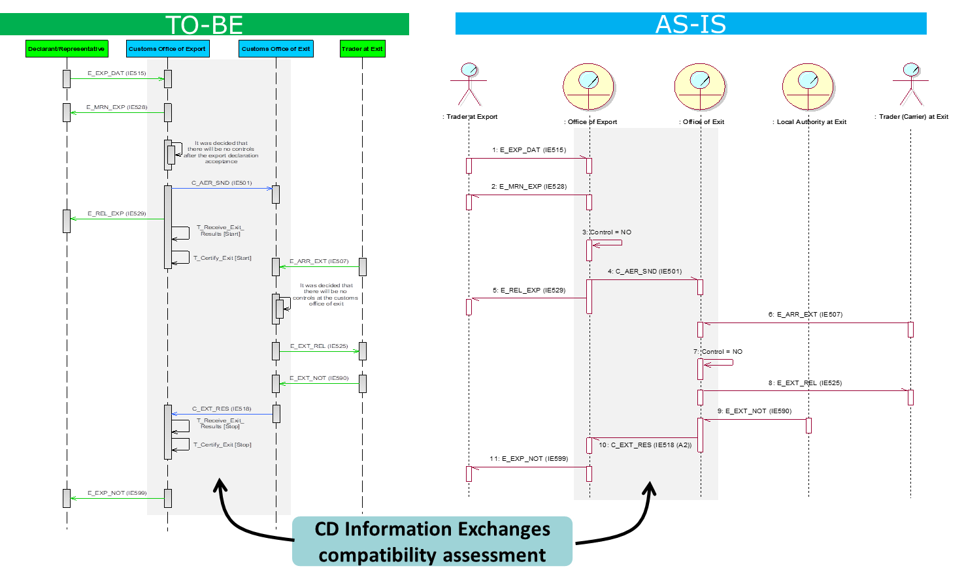
Figure 3: IE compatibility analysis concept
The purpose is to analyse the IEs involved in common domain exchanges (interoperability) for a particular scenario. The comparison is done between the AES-P1 scenario and its mapped ECS-P2 scenario.
The analysis concern whether the CD IEs exists in both phases
- If yes (Continuity), a further analysis is performed in order to identify the type of continuity (e.g. continuity is ensured via conversion), i.e. whether has:
  - the same message version,
  - different message version and same IE number, or
  - different IE number
- If not (Discontinuity), a further analysis is performed in order to identify the type of discontinuity since different resolution might be different per case, i.e. whether:
  - has a new CD IE has been added in AES-P1 (Phase In) or
  - a CD IE has been removed in AES-P1 (Phase Out), or
  - sequence of CD IEs exchanges is not the same or
  - a combination of above cases exist (Phase In & Phase Out).
This analysis use as reference to the Table 2 (IE Compatibility Indicator values) and the Chapter 4 (Information Exchange Reference Table (ECS-P2 and AES-P1)).
The outcome of the analysis in terms of IE compatibility is reflected in IE Compatibility Indicator (IECI). The possible value of IECI and their meaning is shown in Table 2 below:
CD IE compatibility Assessment for specific message exchange protocol
Continuity: Not Applicable / No impact on Common Domain | 0
Continuity: One or more CD IEs are present both in new and previous phase with the same structure (message version) in the particular message exchange protocol | 1
Continuity: One or more CD IE are present in both phases but with different structure (message version) in the particular message exchange protocol- Conversion is needed | 2
Continuity: One or more CD IE are present in both phases but different strcuture/IE number (message type) - Conversion is needed | 3
Discontinuity, Phase In: One or more CD IE appears in the message exchange protocol of new phase and has no previous equivalent in previous phase | 4
Discontinuity, Phase Out: One or more CD IE in the message exchange protocol of previous phase is discontinued from the corresponding message exchange protocol of new phase | 5
Discontinuity, sequencing or no conversion:  - CD IEs are present in message exchange protocol in both new phase and previous phase but with different sequence OR  - CD IEs exist in both phases, but no conversion is possible. | 6
Discontinuity, Phase In & Phase Out: In one message exchange protocol, one or more CD IE of previous phase are discontinued from the corresponding message exchange protocol of new phase AND One or more CD IE appears in the message exchange protocol of new phase and has no previous equivalent in previous phase | 7
Table 2: IE Compatibility Indicator (IECI) values

State Machine Compatibility Indicator (SMCI)
Each scenario is assessed from State Machine (CD states and transitions - interoperability) compatibility point of view. Figure 4 visualises the concept of State Machine compatibility analysis.
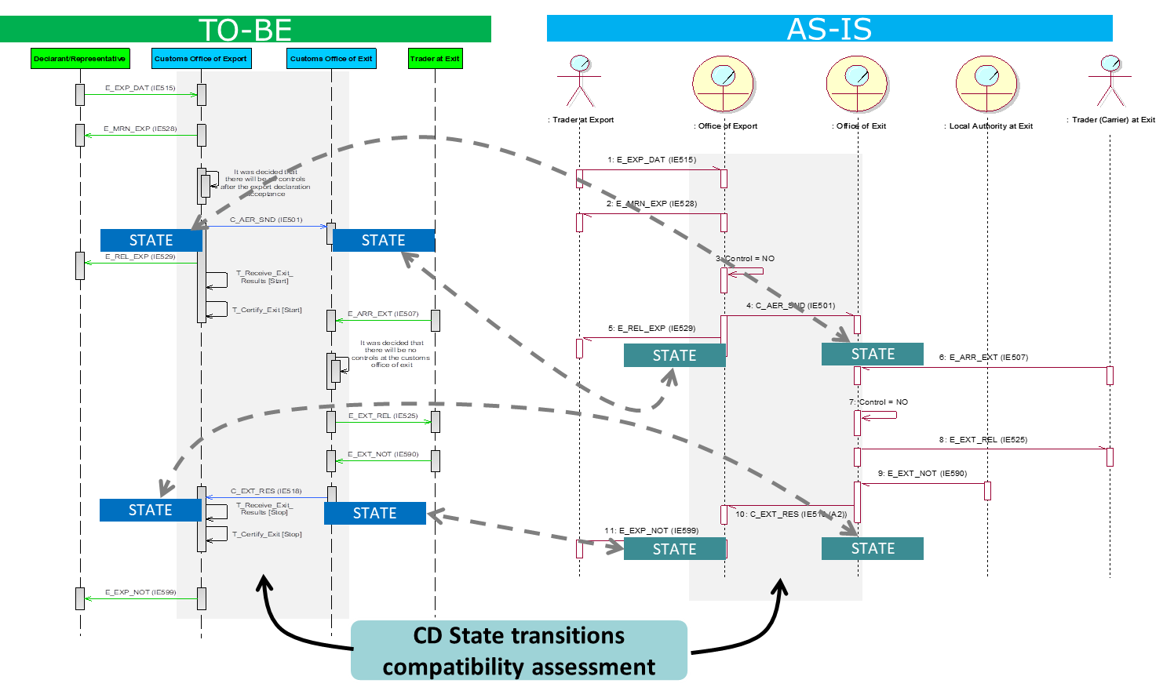
Figure 4: State Machine compatibility analysis concept
The purpose is to analyse the states involved in common domain exchanges for a particular scenario. The comparison is done between the AES-P1 scenario and its mapped ECS-P2 scenario and also based on corresponding state machines per phase.
The analysis concern whether there is a conflict in terms of movement state following CD IEs between two systems in different phases:
- Continuity is considered for the scenario during transition:
  - If particular scenario does not involve and CD IEs and therefore no impact on CD states
  - If one or more required CD states are present in both phases but possibly with different state name in the particular scenario - State mapping
- Discontinuity is considered for the scenario during transition, if:
  - one or more CD (Required) states or state transition are introduced in new phase and has no previous equivalent in previous phase (Phase In), or
  - one or more CD (Required) states or state transition of previous phase is discontinued from the corresponding scenario of new phase (Phase Out), or
  - a combination of above cases exists (Phase In & Phase Out).
This analysis uses as reference the Appendix N excel file (section 3).
The outcome of the analysis in terms of state machine compatibility is reflected in State Machine Compatibility Indicator (SMCI). The possible value of SMCI and their meaning is shown in Table 3 below:
State Machine compatibility Assessment for specific message exchange protocol
Continuity: No Changes on State Machine (CD States) | Continuity: One or more CD (Required) states are present in both phases but with different state name in the particular message exchange protocol - State mapping | Discontinuity, Phase In: One or more CD (Required) states or state transition appears in new phase and has no previous equivalent in previous phase | Discontinuity, Phase Out: One or more CD (Required) states or state transition in the message exchange protocol of previous phase is discontinued from the corresponding message exchange protocol of new phase | Discontinuity, Phase In & Phase Out: Discontinuity, Phase In AND AT THE SAME TIME Discontinuity, Phase Out
0 | 1 | 2 | 3 | 4
Table 3: State Machine Compatibility Indicator (SMCI) values

Transition Analysis Outcome
The Transition Analysis Outcome (TAO) is the analysis result for the feasibility of a particular scenario during Transition Period.
The TAO can have one of the following values:
Value | Description
1 | Feasible: Transition is feasible based on IE and STD continuity indicators
2 | Feasible with resolution: a special resolution/transitional message exchange protocol is necessary for resolving discontinuity.
3 | Blocking/Not Feasible: there is no resolution with transitional message exchange protocol for the particular scenario.
Table 4: Transition Analysis Outcome values
If TAO has value 1, then Resolution for State Machine or for Common Domain exchanges shall be provided.
If TAO has value 2, then a special resolution/transitional scenario is necessary for resolving discontinuity. The transitional scenarios will be defined in IV.3.5 of DDNXA Main Document.
In case of TAO value 3, then the particular scenario/functionality shall be excluded from the transition period (i.e. can be used only after the end of transition).

State Machine Transition Analysis
The State machines defined in AES-P1 (section III.5 of DDNXA main document) and ECS-P2 [R4] have been consolidated and a mapping is performed during this activity.
Table 5 presents a reference table for the mapping of state machines between phases.
The output of State Machine Transition Analysis is provided in the Appendix N excel file which accompanies DDNXA.
A column “Appendix N Worksheet Ref” has been added in Table 5 to indicate the worksheet where the pertinent comparison of state machine is located.
Customs Office | Declaration Type | AES-P1 | ECS-P2 | Appendix N Worksheet Ref
Customs Office of Export | Export Declaration | Export Declaration - Customs Office of Export After Movement Release | State Transition Diagram for Office of Export after movement released | EXP-OoExp-AMR
Customs Office of Export | Export Declaration | Export Declaration - Customs Office of Export Before Movement Release | State Transition Diagram for Office of Export up to the release of movement | EXP-OoExp-BMR
Customs Office of Export | Export Declaration | Invalidation - Customs Office of Export | State Transition Diagram for Office of Export – Cancellation | EXP-OoExp-AMR  EXP-OoExp-BMR
Customs Office of Exit | Export Declaration | Export Declaration - Customs Office of Exit | State Transition Diagram for Office of Exit | EXP-OoExt
Customs Office of Exit | Export Declaration | Invalidation - Customs Office of Exit | State Transition Diagram for Office of Exit – Cancellation | EXP-OoExt
Customs Office of Exit | Exit Summary Declaration | Exit Summary Declaration - Customs Office of Exit | State Transition Diagram for Office of Exit transition when processing an EXS | EXS-OoExt-OoLdg
Customs Office of Exit | Re-Export Notification | Re-Export Notification | N/A | REN-OoExt
Presentation Customs Office | Export Declaration | Export Declaration - Presentation Customs Office | N/A | EXP-PCO
Customs Office of Lodgement | Exit Summary Declaration | Exit Summary Declaration - Customs Office of Lodgement | State Transition Diagram for Office of Lodgement | EXS-OoExt-OoLdg
Table 5: State Machines reference mapping table
A side-by-side gap analysis performed per state machine to identify differences at the level of state transitions. The state transition attributes are:
- the state from which transition occurred (state before state transition)
- the state to which transition resulted (state after state transition)
- the triggers of state transition which are events or actions as well as conditions that must be fulfilled so as to active state transition
- Receiving IE(s) causing state transition
- Sending IE(s) because of state transition
The comparison per state transition considered all state transition attributes.
- If at least one of above state transition attributes are not the same for a particular state transition between two phases, then the particular attribute is highlighted with orange colour
  - If difference does not cause any problem in transition period (e.g. state name difference, SMCI with value 1 (Table 3) is expected in Scenarios Transition Analysis (section 1) on scenarios having such CD state transition (unless there is a CD state transition causing greater discontinuity - value > 1).
- If ECS-P2 information is empty for a specific state transition in Appendix Nfile, then it shall be understood that the corresponding AES state transition is new.
  - The Appendix N file shows those new state transitions with green colour;
  - In Scenarios Transition Analysis (section 1), SMCI with value 2 (Table 3) is expected on scenarios having at least one of such CD state transition (unless there is a CD state transition causing greater discontinuity - value > 2).
- If AES-P1 information is empty for a specific state transition in Appendix N file, then it shall be understood that ECS-P2 state transition is no more applicable in AES-P1.
  - The Appendix N file shows those removed state transitions with red colour;
  - In Scenarios Transition Analysis (section 1), SMCI with value 3 (Table 3) is expected on scenarios having at least one of such CD state transition (unless there is a CD state transition causing greater discontinuity - value > 3).
Figure 5 presents an example of State Machine Transition Analysis.

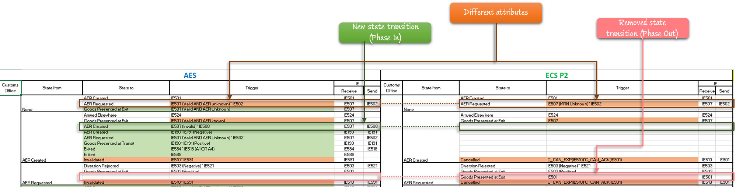
Figure 5: State Machine Transition Analysis example
The state machine transition analysis is presented below per process area and per role.

Information Exchange Reference Table (ECS-P2 and AES-P1)
Appendix A shall be used as a reference table providing per IE (IE No) the mapping of each IE version (message type) applicable to ECS-P2 and AES-P1. Therefore, it shall be used by the convertors (ieCA or national convertor) or NECAs for conversion purpose. Appendix A shall be used to facilitate Scenarios Transition Analysis (section 1) and IE Compatibility Indicator (IECI) (2.2).
- In most of the scenarios, same IE number exists in both phases with different message version. Therefore, scenarios in Scenarios Transition Analysis (section 1) involving only such CD IEs must have IECI with value 2 (Table 2). It means that the CD IEs conversion shall be performed based on the table below (e.g. upgrade from CD501B to CD501C).
- In some cases, IE number has changed from ECS-P2 to AES-P1 and therefore a reference/link to the New or Previous IE Number is provided Appendix A below. In Scenarios Transition Analysis (section 1), scenarios involving such CD IEs shall have IECI with value 3 (Table 2) unless there is a case causing greater discontinuity (value > 3). It means that the CD IEs conversion shall be performed based on the table below (e.g. upgrade from CD901B to CD591C).
- If ECS-P2 message version is empty for a specific IE in Appendix A, then it shall be understood that the corresponding AES-P1 message version is new. In Scenarios Transition Analysis (1), IECI with value 4 (Table 2) is expected on scenarios having at least one of such CD IE is involved (unless there is a CD IE causing greater discontinuity - value > 4).
- If AES-P1 message version is empty for a specific IE in Appendix A, then it shall be understood that ECS-P2 message is no more exchanged in AES-P1. In Scenarios Transition Analysis (1), IECI with value 5 (Table 2) is expected on scenarios having at least one of such CD IE is involved (unless there is a case causing greater discontinuity - value > 5).

