Emission data reporting by installation operators in accordance with Implementing Regulation (EU) 2023/1773 of 17 August 2023 and Regulation (EU) 2023/956 of 10 May 2023 (CBAM)
The goods from your production facility are imported into the customs territory of the European Union and are subject to Regulation (EU) 2023/956 of 10 May 2023 (CBAM).
For this purpose, the CBAM declarant (importer or indirect customs representative) subject to the reporting obligation requires the following data from you to fulfil its statutory reporting obligations in accordance with Implementing Regulation (EU) 2023/1773 of 17 August 2023:
- Information on the installation

- the name and contact details of the operator;
Klicken oder tippen Sie hier, um Text einzugeben.

- the name of the installation;
Klicken oder tippen Sie hier, um Text einzugeben.

- contact details for the installation;
Klicken oder tippen Sie hier, um Text einzugeben.

- the unique installation identifier, if available;
Klicken oder tippen Sie hier, um Text einzugeben.

- the applicable United Nations Code for Trade and Transport Location (UN/LOCODE) of the location;
Klicken oder tippen Sie hier, um Text einzugeben.

- an exact address and its English transcript;
Klicken oder tippen Sie hier, um Text einzugeben.

- geographical coordinates of the installation’s main emission source.
Klicken oder tippen Sie hier, um Text einzugeben

- For each of the aggregated goods category, the production processes and routes used as listed in Table 1 of Annex II of the Implementing Regulation (EU) 2023/1773:
Klicken oder tippen Sie hier, um Text einzugeben.

- For each of the goods, listed either for each CN code separately, or aggregated by aggregated goods category in accordance with Section 2 of Annex II of the Implementing Regulation (EU) 2023/1773:

- the specific direct embedded emissions of each of the goods;
Klicken oder tippen Sie hier, um Text einzugeben.
- information on the data quality and methods used;
Klicken oder tippen Sie hier, um Text einzugeben.
- the specific indirect embedded emissions of each of the goods, and the method how the emission factor was determined, and the information source used;
Klicken oder tippen Sie hier, um Text einzugeben.

- the emission factor used for electricity as imported goods, expressed as tonne CO₂e per MWh and the data source or method used for determining the emission factor of electricity, if different than the emission factors provided by the Commission in the CBAM Transitional Registry;
Klicken oder tippen Sie hier, um Text einzugeben .
- the sector-specific information in accordance with Section 2 of Annex IV of the Implementing Regulation (EU) 2023/1773, if relevant;
Klicken oder tippen Sie hier, um Text einzugeben .
- if applicable, the information on carbon price due. Where a carbon price due for precursors is obtained from other installations, any carbon price due for those precursors shall be listed separately per country of origin.
Klicken oder tippen Sie hier, um Text einzugeben .

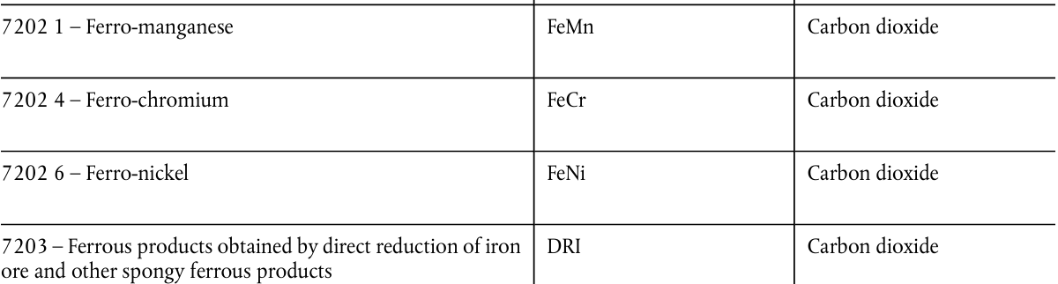
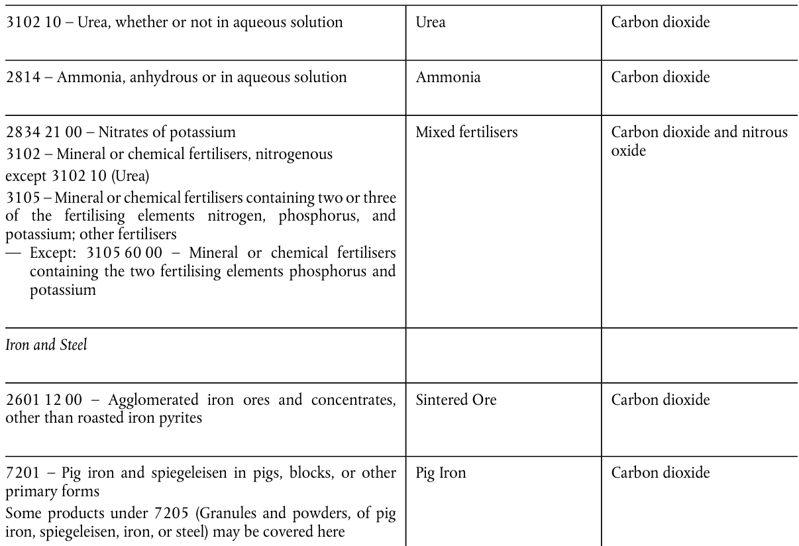
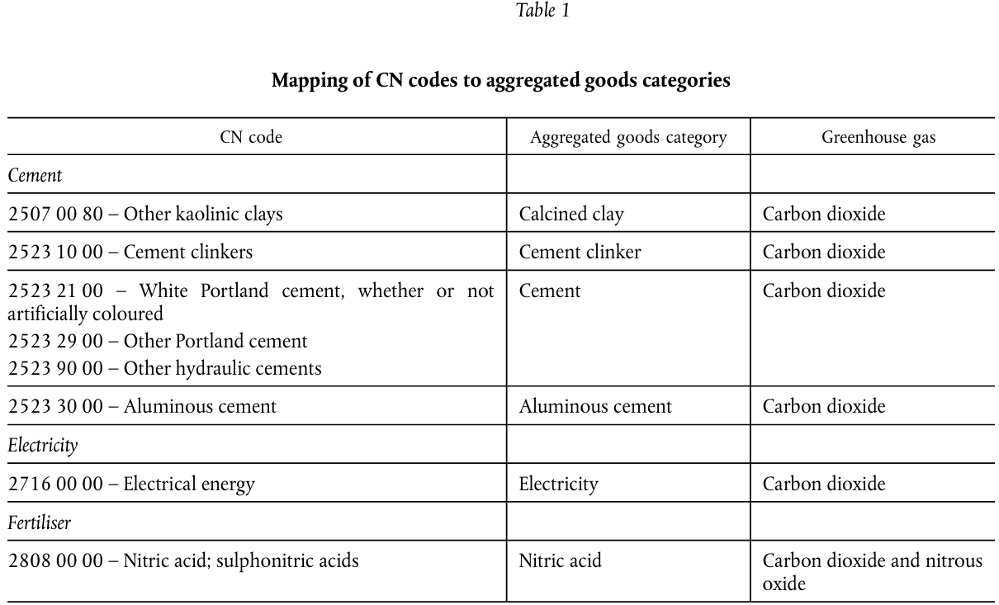
Table 1 of Annex II of the Implementing Regulation (EU) 2023/1773
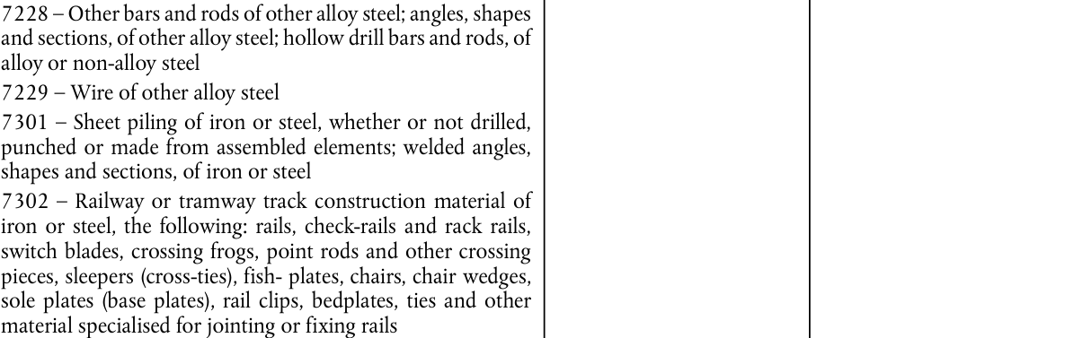
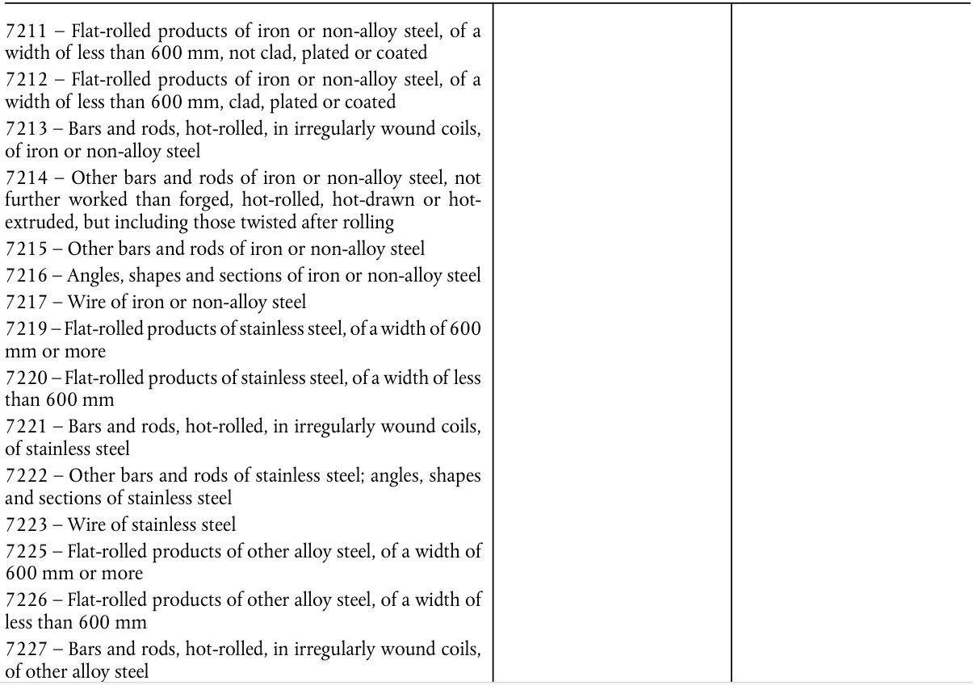
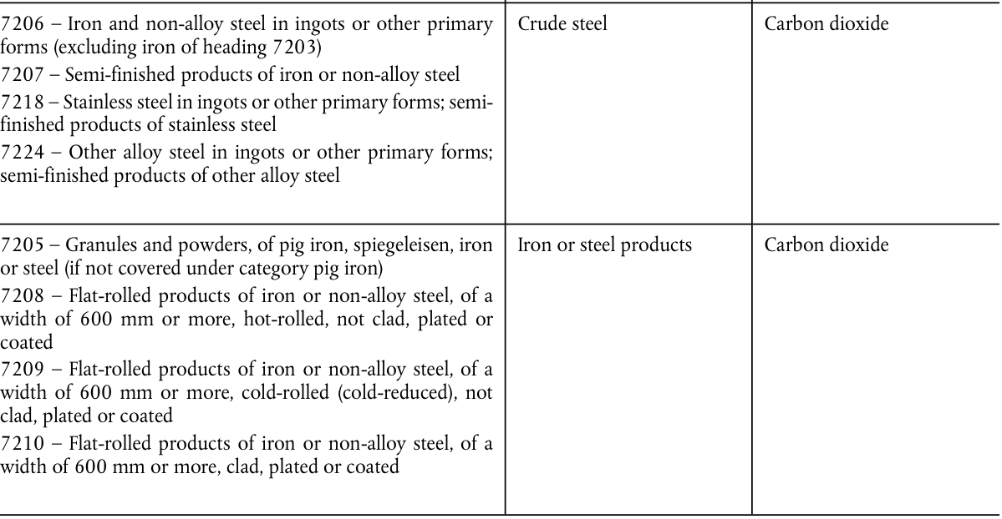
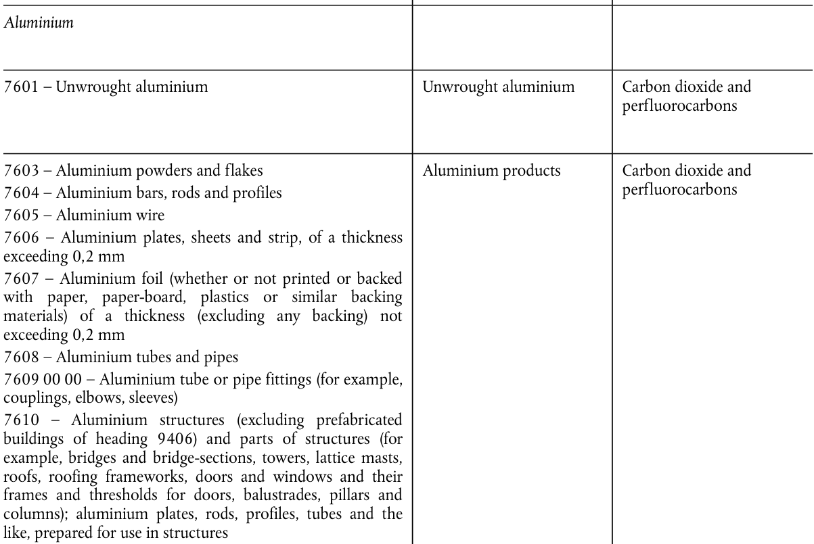
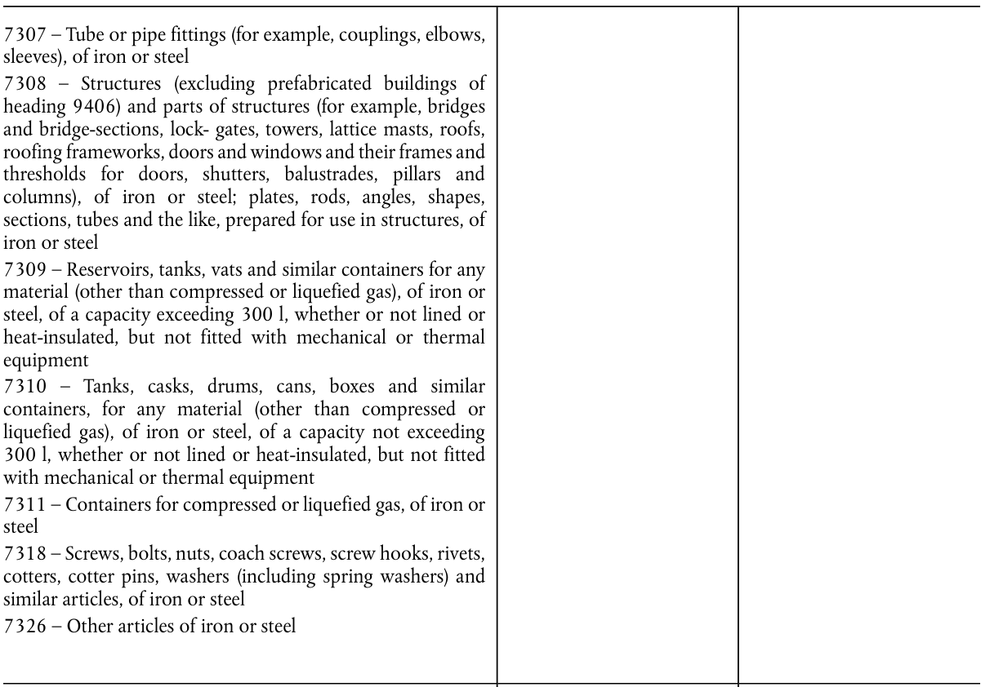
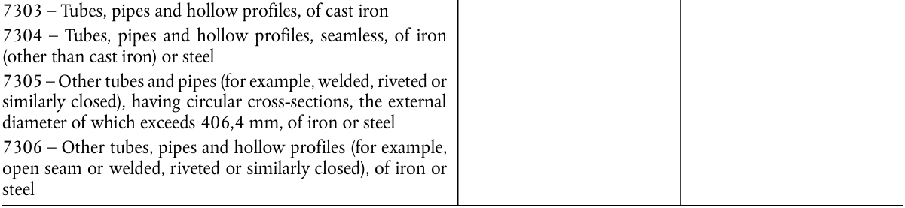
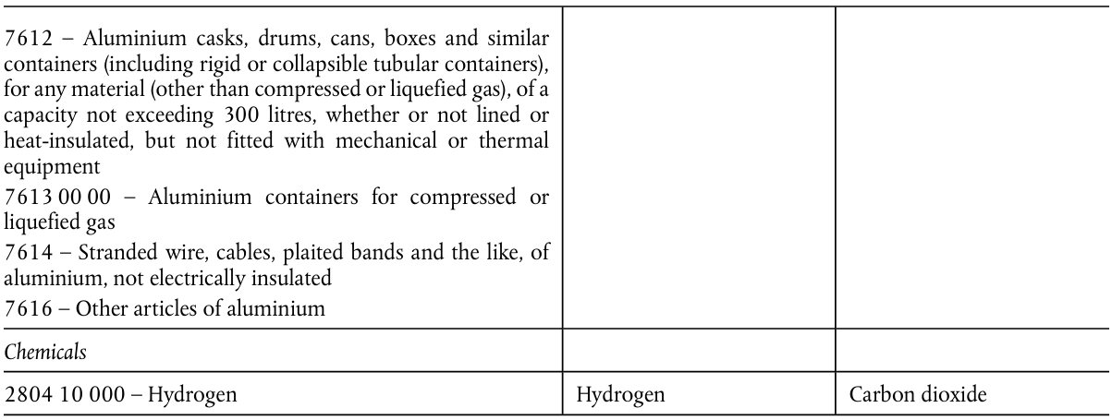
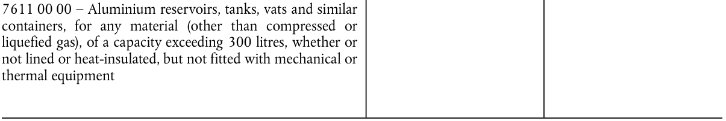

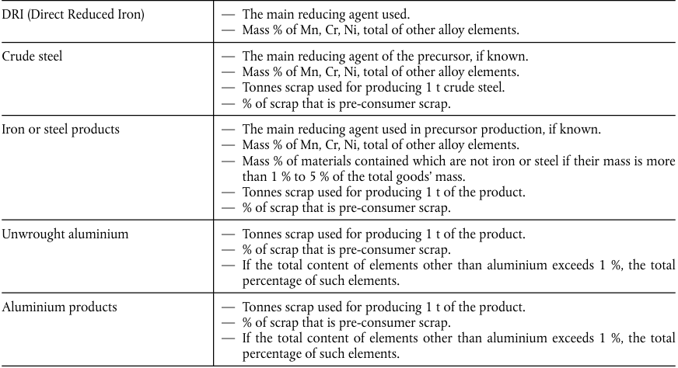
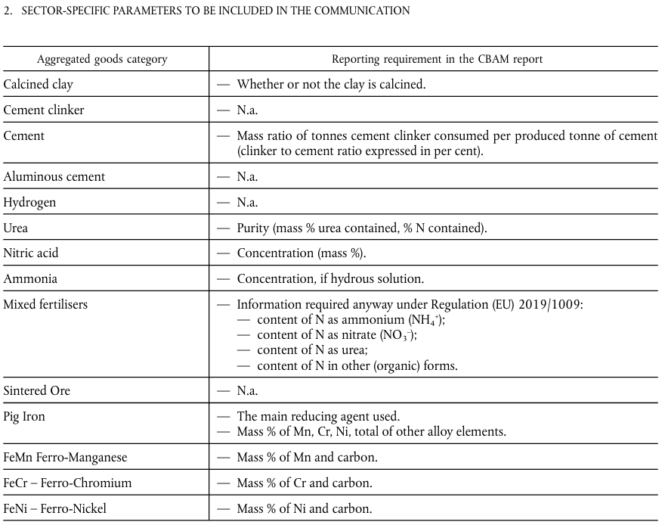
The sector-specific information in accordance with Section 2 of Annex IV of the Implementing Regulation (EU) 2023/1773

